14.3.2 Optional Lab: Share the All-in-one Printer/Scanner in Windows 7

Introduction

Print and complete this lab.

In this lab, you will share the All-in-one printer/scanner, configure the printer on a networked computer, and print a test page from the remote computer.

Recommended Equipment
- Two computers directly connected or connected through a hub or switch
- Windows 7 installed on both computers
- An All-in-one Printer/Scanner installed on one of the computers

Step 1
Click Start > Computer > Tools > Folder Options > View, and then uncheck Use Sharing Wizard (Recommended) if it is checked.

Click OK.

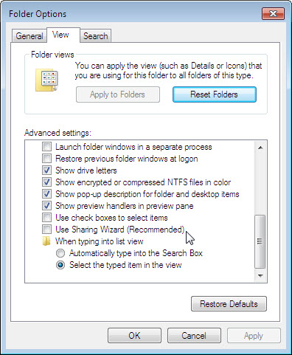

Step 2
Click Start > Network > Network and Sharing Center > Chose homegroup and sharing options > Change advanced sharing options > for the current profile, scroll down to Password protected sharing, and then check Turn off password protected sharing.

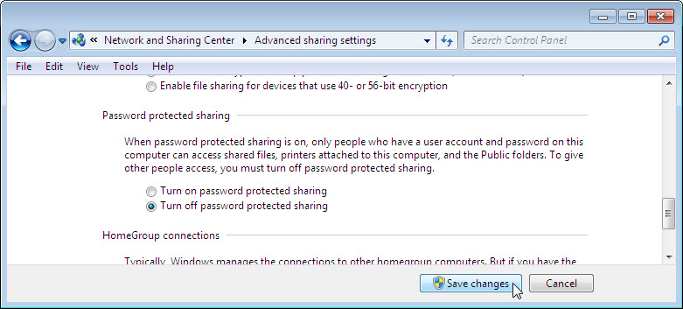

Click Save changes. Close any open windows.

Step 3
Choose Start > Control Panel > View devices and printers.
Right-click the All-in-one Printer/Scanner, and then choose Printer properties.
Click the Sharing tab.

Choose Share this printer. Name the new share All-in-One Printer, and then click OK.

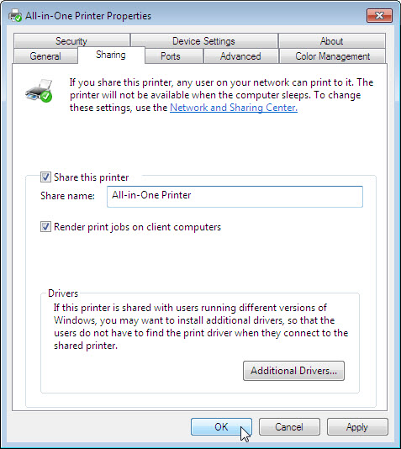

Step 4
Log on to the computer without the printer/scanner connected, and then choose Start > Control Panel > View devices and printers > Add a printer.

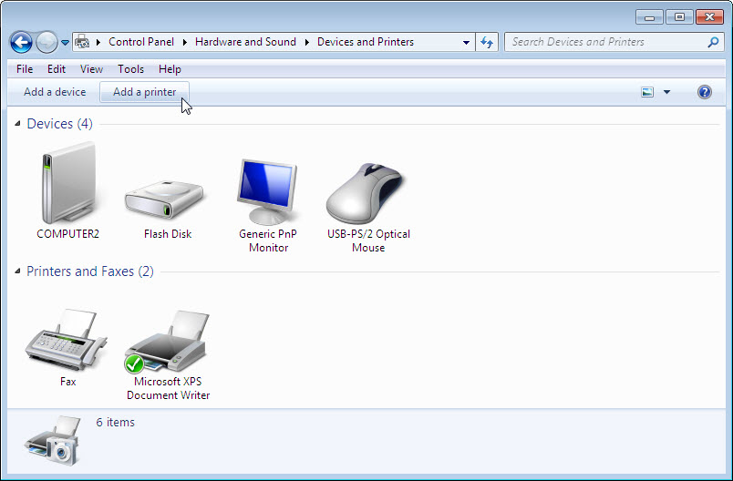

The “Add Printer” window appears.

Click Add a network, wireless or Bluetooth printer.

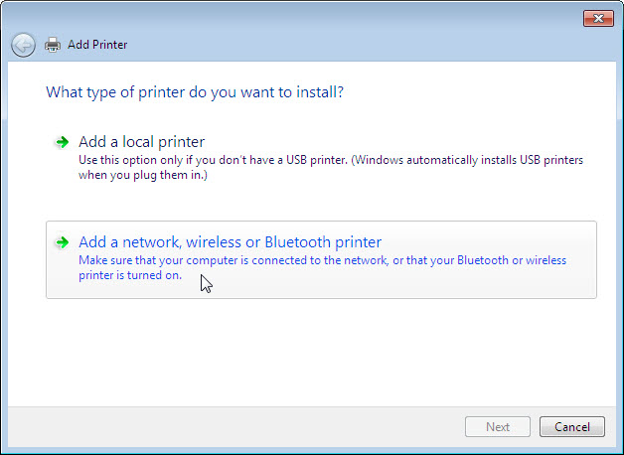

The “Searching for available Printers…” page appears.

If displayed in the search list, select Printer on Computername and then click Next.

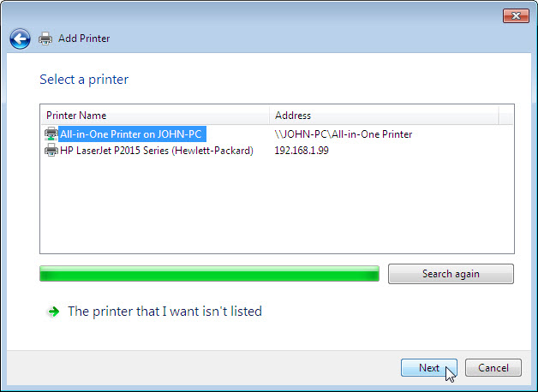

Or to find a printer by name or TCP/IP address, select The printer that I want isn’t listed.

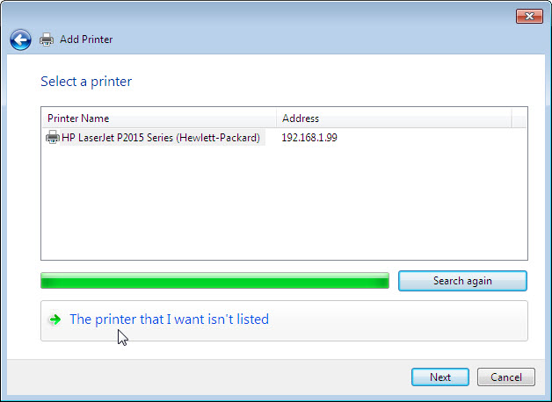

Select the radio button Select a shared printer by name and type \\computername\printer, where computername is the name of the computer with the connected printer/scanner and printer is the name of the printer/scanner.

Click Next.

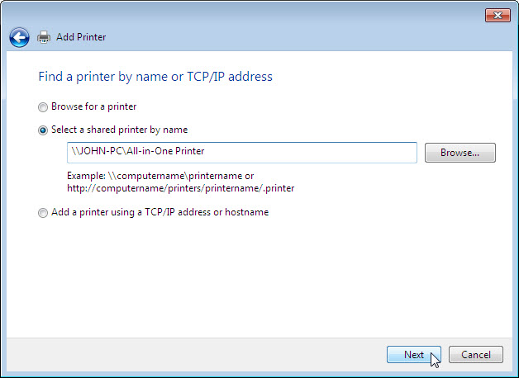

If prompted to install drivers, click Install driver. If User Account Control appears, click Continue.

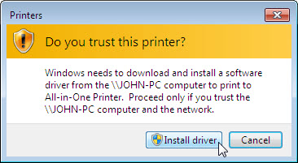

After the printer successfully installs, click Next.

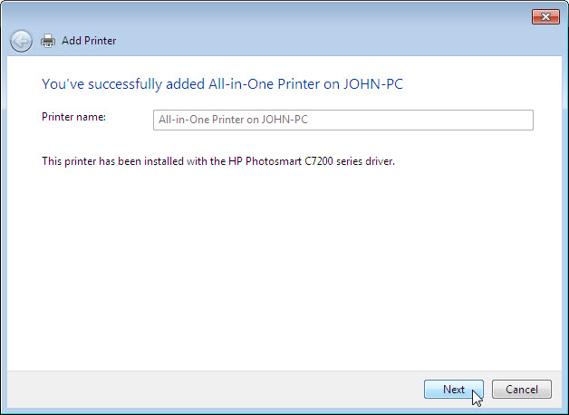

Click Finish to close the “Add Printer” window.

Step 5
In the Devices and Printers window, right-click the All-in-one Printer/Scanner, and then choose Printer properties.

Click the Print Test Page button.

