14.2.4 Lab: Install an All-in-one Printer/Scanner

Introduction

Print and complete this lab.

In this lab, you will check the Windows XP Hardware Compatibility List (HCL) for your All-in-one Printer/Scanner, install the all-in-one printer/scanner, upgrade the driver and any associated software, and test the printer and scanner.

Recommended Equipment
- A computer with the Windows XP operating system
- An available USB port on the computer
- All-in-one Printer/Scanner
- Printer/scanner installation CD
- An Internet connection

Step 1
Open Internet Explorer.

Search the Microsoft Website for “windows xp hcl”.

Choose “Windows XP”.

Choose “Devices”.

Choose the processor type used by the computer.

Select “Printers & Scanners”.

Choose “Start”.

Search the HCL for your All-in-one Printer/Scanner.

What Company manufactures this component?

For what operating system(s) was this component designed?

For what operating system(s) has this component been certified?

Step 2
Carefully unpack and assemble the printer/scanner if necessary. Follow the manufacturer’s instructions.
Plug the printer/scanner into a grounded wall outlet and turn on the unit. Do not attach the USB cable to the computer until instructed to do so.

Step 3
Insert the manufacturer’s software CD into the optical drive. If the installation program does not start automatically, select Start > My Computer, and then double-click the Epson CD-ROM icon.

The “Install Menu” window appears.

Click Install.

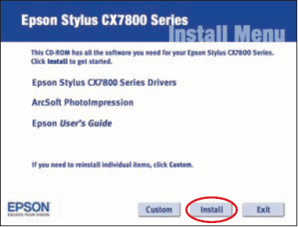

Connect the USB cable when instructed.

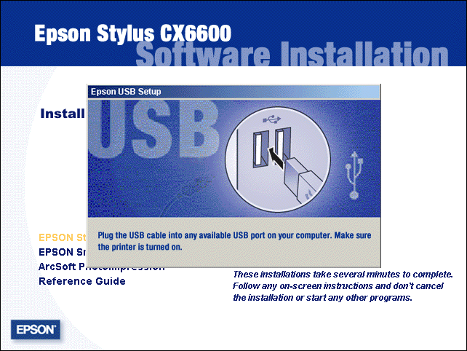

The “License Agreement” window appears.

Click Yes.
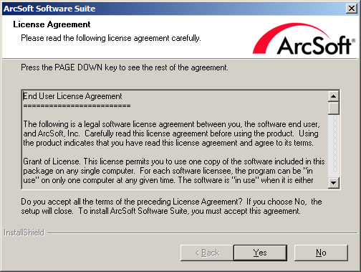

The “Epson Product Registration” window appears.

Click Cancel.

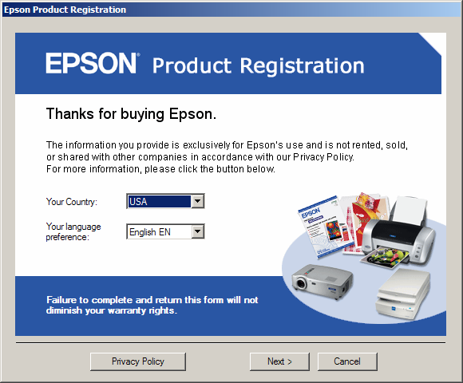

Step 4
Go to the All-in-one Printer/Scanner manufacturer’s website and download the newest drivers for the All-in-one Printer/Scanner.

Click Start, and then right-click My Computer. Choose Manage > Device Manager.

The Device Manager appears in the right column.

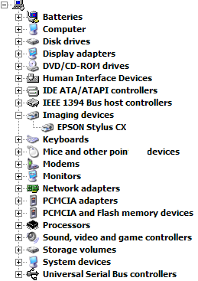

Double-click the All-in-one Printer/Scanner, and then select the Driver tab.

Choose Update Driver.

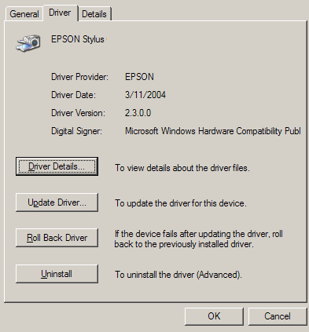

Follow the instructions to install the driver that was downloaded.
Choose Start > Printers and Faxes.

Right-click All-in-one Printer/Scanner, and then click Properties.

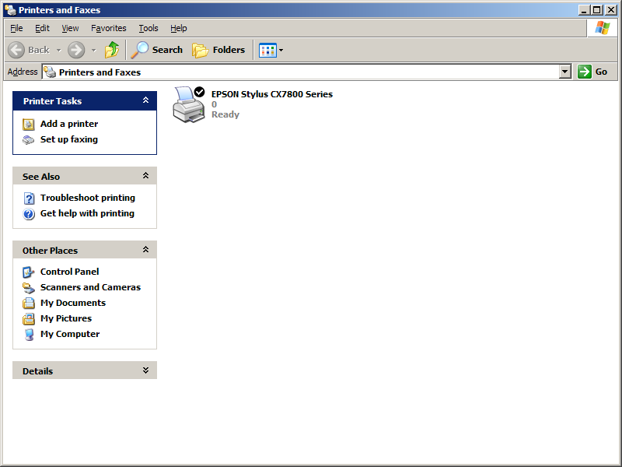

Click the Print Test Page button.

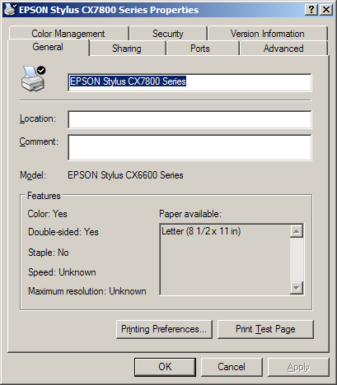

Step 5
Place a picture or document in the upper left corner of the scanner, face down.

Double-click the Epson Scan icon on the desktop or open the Epson SmartPanel using the Start menu.

Scan the image.

Print the scanned image.

