12.4.2 Optional Lab: Restore Points in Windows 7

Introduction

Print and complete this lab.

In this lab, you will create a restore point and return your computer back to that point in time.

Recommended Equipment
The following equipment is required for this exercise:
- A computer system running Windows 7

Step 1
Click Start > right-click Computer > Properties.
The “System” window appears.

To create a restore point, click System protection.

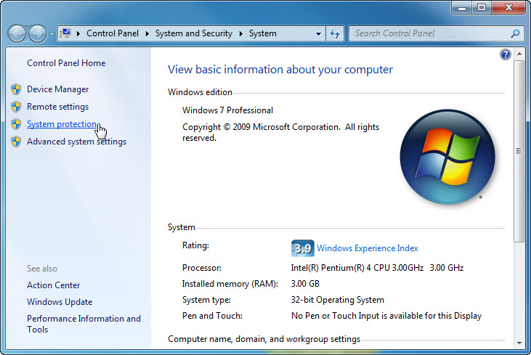

Step 2
The “System Properties” window appears.

In the “System Protection” tab, click Create.

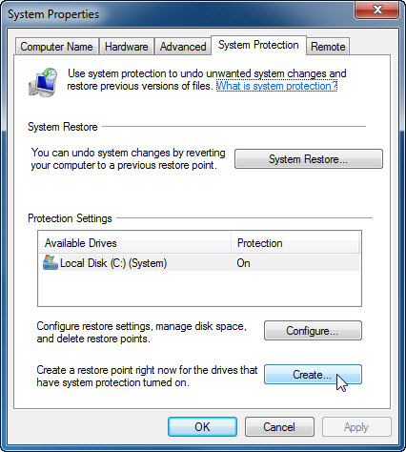

Step 3
In the “Create a restore point” description field, type Application Installed.

Click Create.

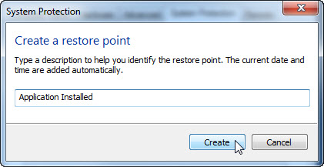

Step 4
After a period of time, a “The restore point was created successfully” message appears.

Click Close.

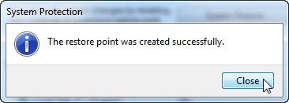

Click OK to close the “System Properties” window.

Step 5
Click Start > All Programs > Accessories > System Tools > System Restore.

When the “System Restore” Window appears, click Next.

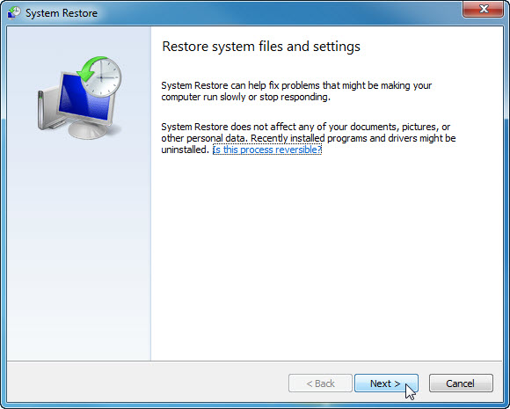

A list of restore points is displayed.

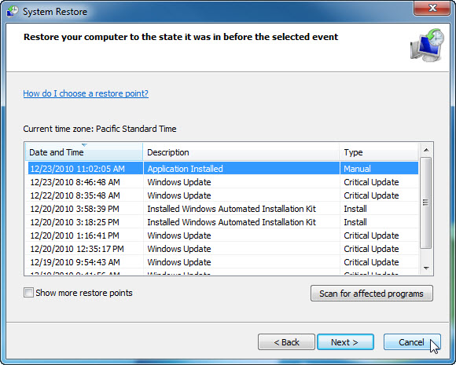

What “Type” is the restore point created by you?

Click Cancel.

Close all open windows.

Step 6
Click Start > Control Panel > Programs > Turn Windows features on or off.

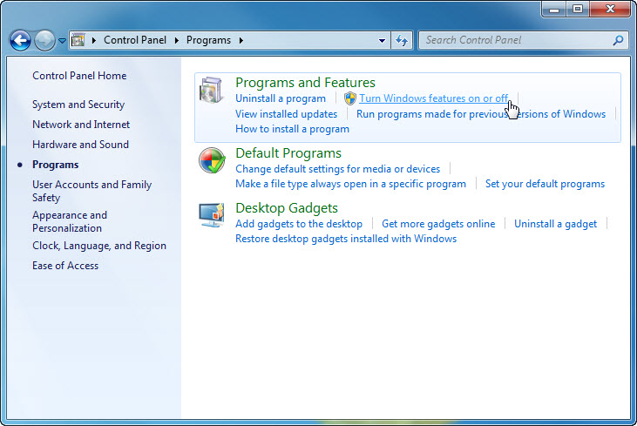

Step 7
The “Windows Features” window appears.

Click the Internet Information Services checkbox, and then click OK.

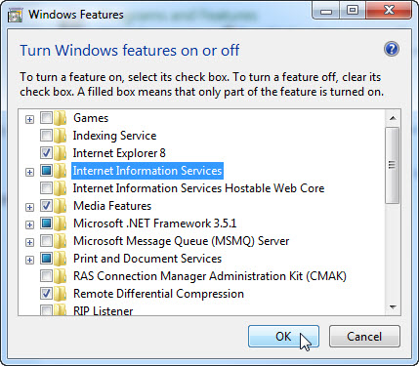

Step 8
The configuring features progress window appears.

The progress window will close on its own when the configuration is completed.



Step 9
When you navigate in a browser to localhost, you will see the new IIS default page.

Click Start > in “Search programs and files” type http://localhost.

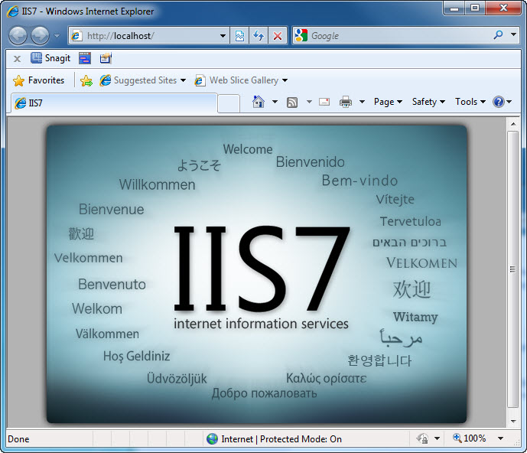

Close the browser.

Step 10
Open the Notepad application by clicking Start > All Programs > Accessories > Notepad.

Type This is a test for a Restore Point in the Notepad application.

Click File > Save As….

Click Documents.

Type Restore Point Test file in the “File Name:” field.

Click Save.

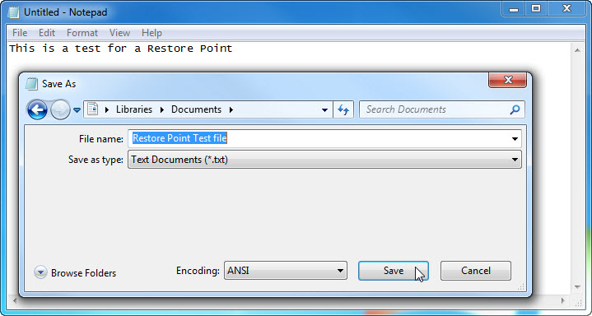

Click File > Exit.

Step 11
Open IIS to confirm that you have successfully installed this service.

Click Start > Control Panel > System and Security > Administrative Tools > Internet Information Services (IIS) Manager.

The “Internet Information Services (IIS) Manager” window appears.
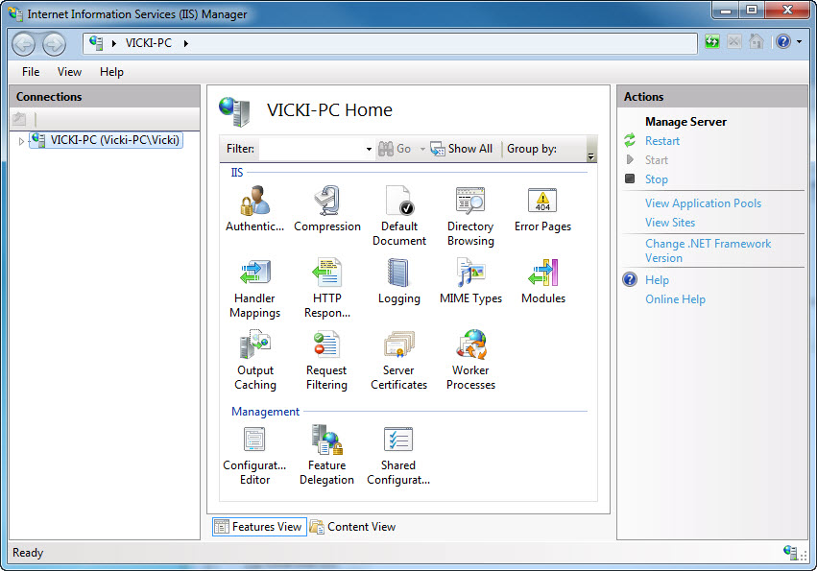

Click File > Exit.

Step 12
Click Start > All Programs > Accessories > System Tools > System Restore.
Select the Recommended restore radio button.

Click Next.

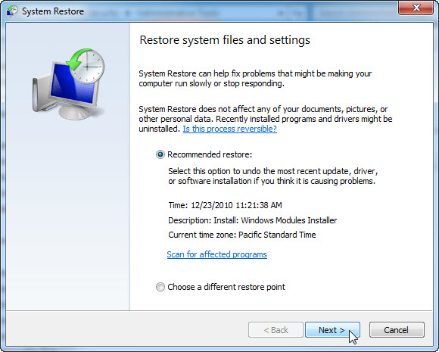

Step 13
The “Confirm your restore point” window appears.

Note: Close all applications before you click Finish. When you click Finish, Windows will restart the computer.

Click Finish.

Click Yes to confirm “System Restore”.

The operating system restores to the point before the IIS application was installed. This can take several minutes to complete.

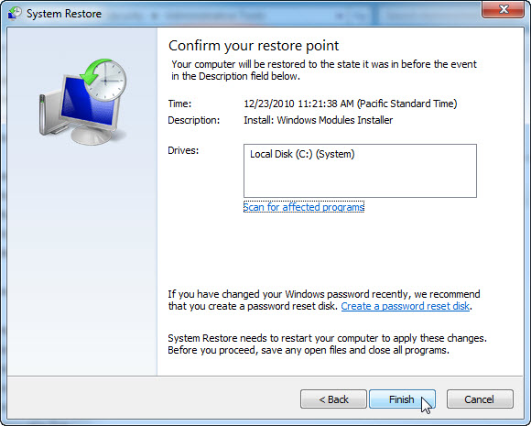

Step 14
Logon to the computer if required.

The “System Restore completed successfully” message window appears. Click Close.

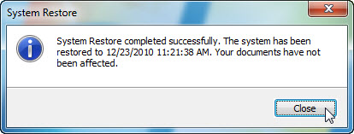

Step 15
Click Start > Control Panel > System and Security > Administrative Tools.

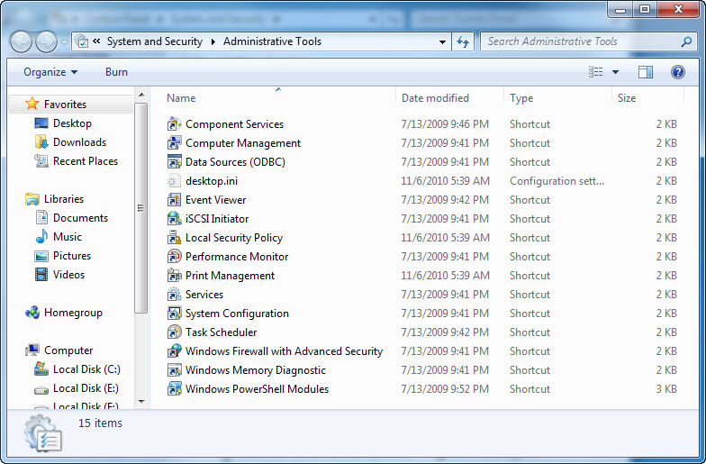

Is the IIS Manager application listed?

Step 16
Navigate to the “Documents” folder.

Open the “Restore Point Test file.txt” file.

Are the contents the same?

