12.4.1 Lab: Schedule Task Using GUI and “at” Command in Windows XP

Introduction

Print and complete this lab.

In this lab, you will schedule a task using the Windows XP GUI and schedule a task in a cmd window using the at command.

Recommended Equipment
- A computer running Windows XP

Step 1
Log on to Windows as an administrator.

Choose Start > Control Panel.

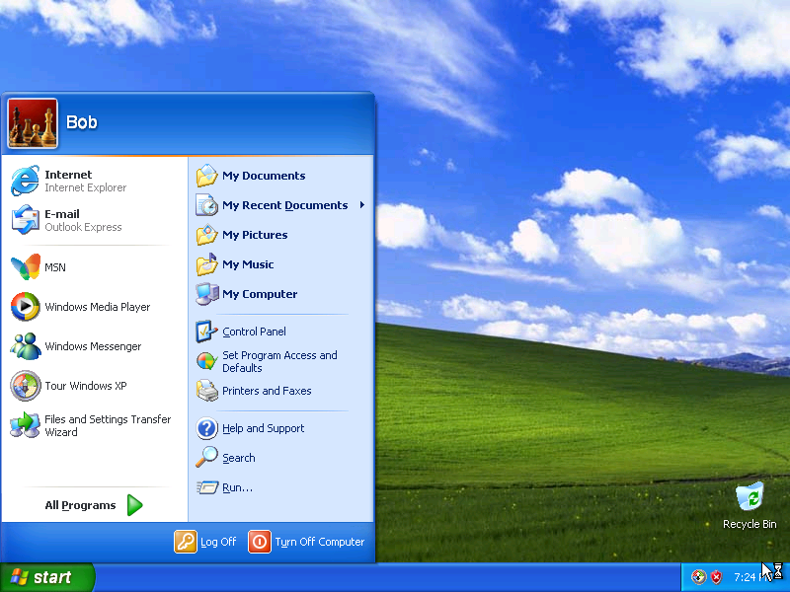

Step 2
The “Control Panel” window appears.

Click Performance and Maintenance.

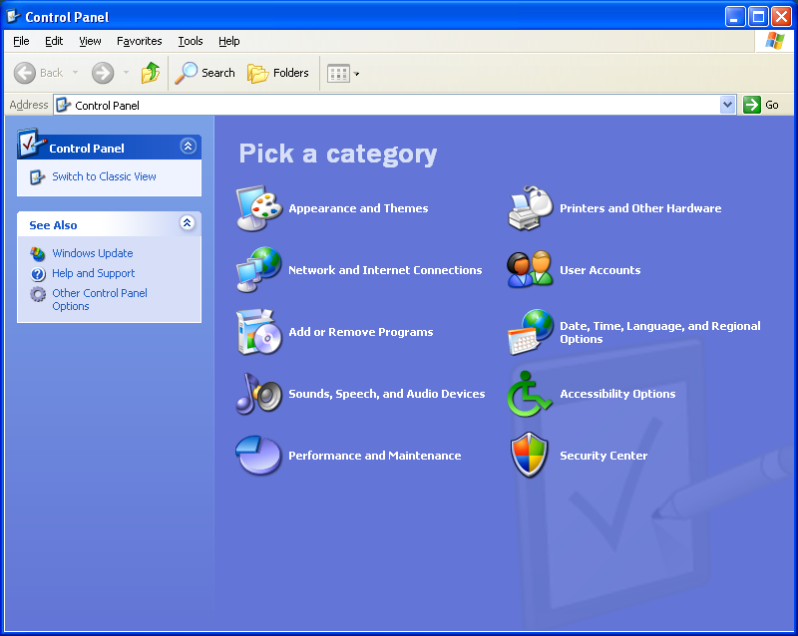

Step 3
The “Performance and Maintenance” window appears.

Click Scheduled Tasks.

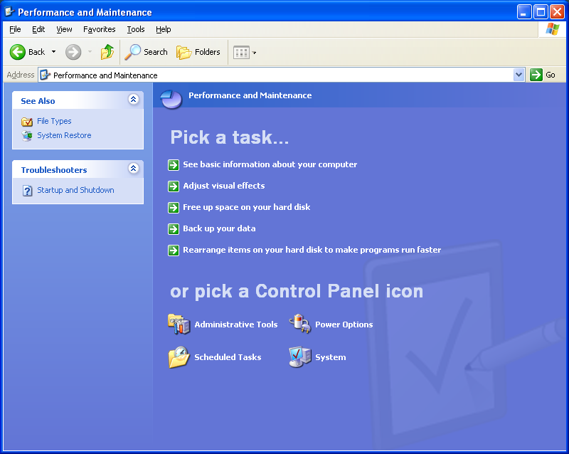

Step 4
The “Scheduled Tasks” window appears.

Double-click Add Scheduled Task.

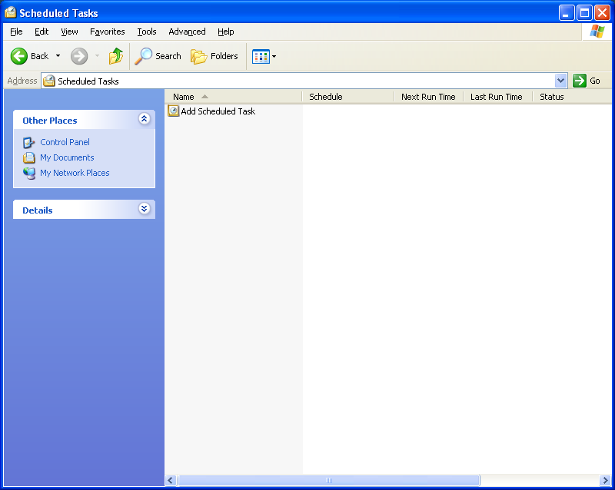

Step 5
The “Scheduled Task Wizard” appears.

Click Next.

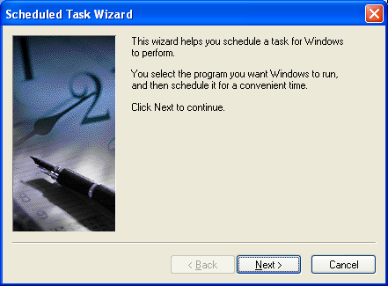

Scroll down the Application window, and then select Disk Cleanup.

Click Next.

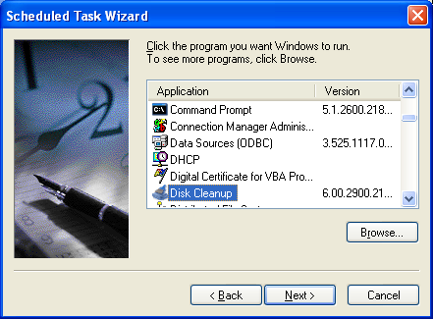
Type Disk Cleanup in the “Type a name for this task.” field.

Click the Weekly radio button, and then click Next.

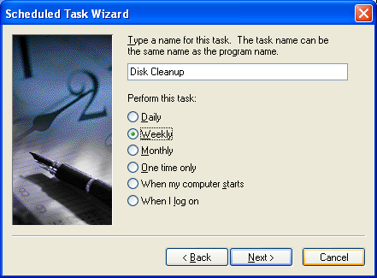

Use the scroll buttons in the “Start time:” field to select “6:00 PM”.

Use the scroll buttons in the “Every _ weeks” field to select “1”.

Check the “Wednesday” check box, and then click Next.

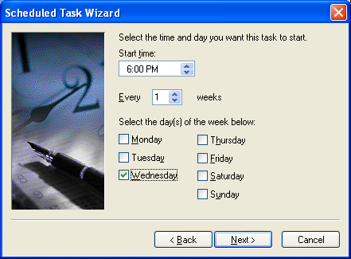
Enter your username and password in the appropriate fields.

Click Next.

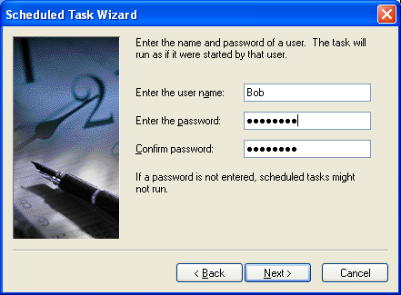

The “You have successfully scheduled the following task:” window appears.

Click Finish.

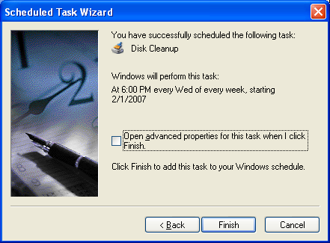

Step 6
The scheduled task that you created appears in the “Scheduled Tasks” window.

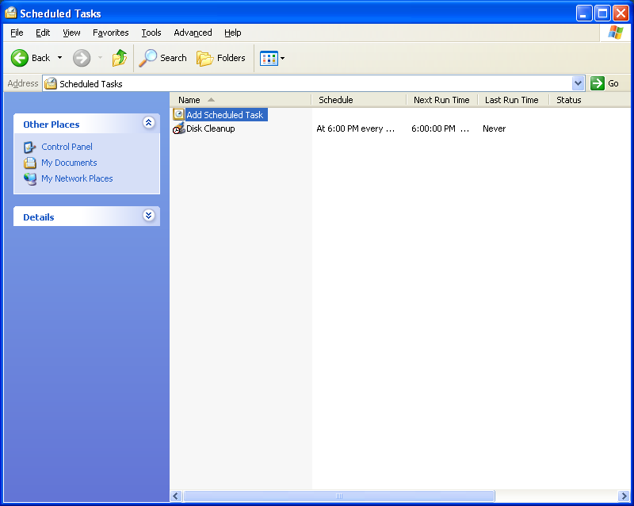

Step 7
Choose Start > Run.

Type cmd, and then click OK.

The “C:\WINDOWS\System32\cmd.exe” window appears.

Type at/?, and then press the Enter key.

The options for the at command are displayed.

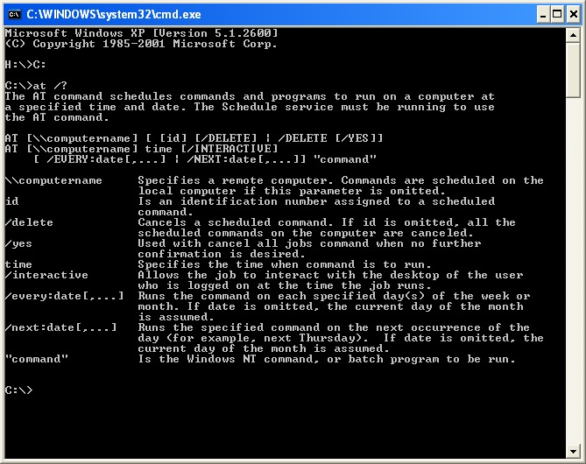

Type at 20:00 /every:W backup.

Note that the time must be military time.

“Added a new job with job ID = 1” is displayed.

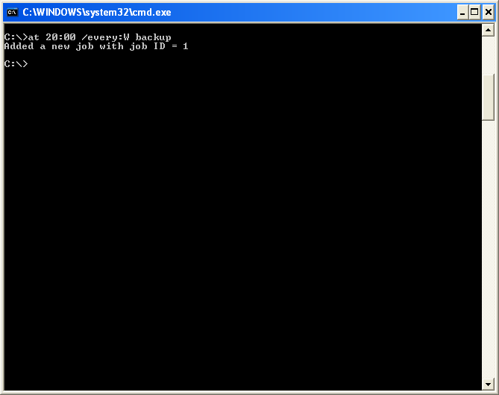
Type at \\computername. For example at \\labcomputer.

The scheduled job appears.

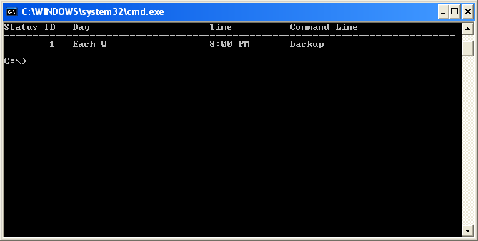

Which command would you enter to get the backup to run every Tuesday and Wednesday at 3:00 PM?

Type exit, and then press the Return key.

Step 8
Open the Scheduled Tasks window.

The task created using the at command is listed in the window.

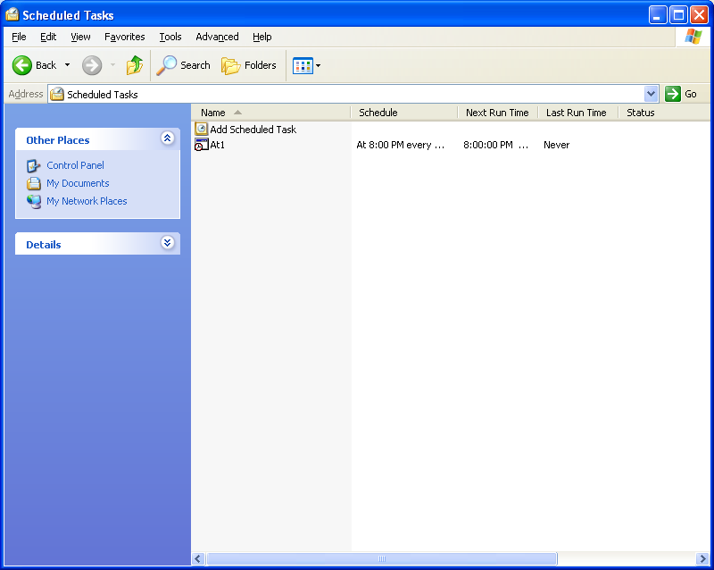

Step 9
Right-click your scheduled task.

Choose File > Delete.

The “Confirm File Delete” window appears.

Click Yes.

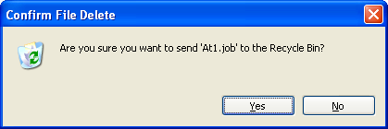

The task created using the at command is removed from the scheduled tasks window.

