12.4.1 Optional Lab: Schedule Task Using GUI and “at” Command in Windows Vista

Introduction

Print and complete this lab.

In this lab, you will schedule a task using the Windows XP GUI and schedule a task in a cmd window using the at command.

Recommended Equipment
- A computer running Windows Vista

Step 1
Log on to Windows as an administrator.

Click Start > Control Panel > Administrative Tools > Task Scheduler > Continue.

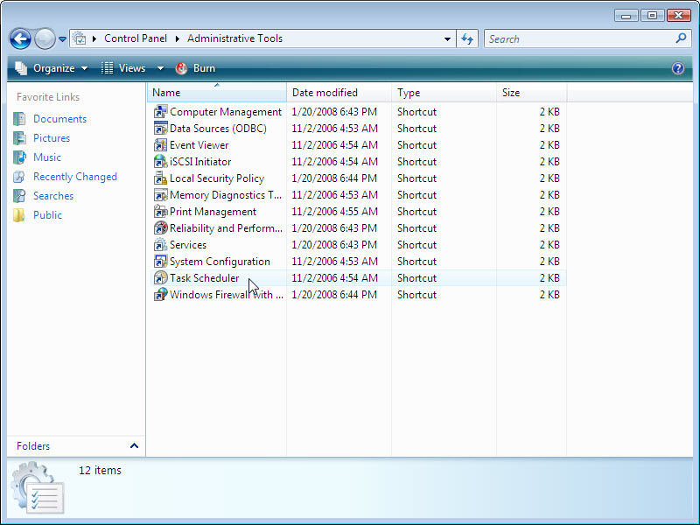

Step 2
The “Task Scheduler” window appears.

Click Create Basic Task in the Actions area.

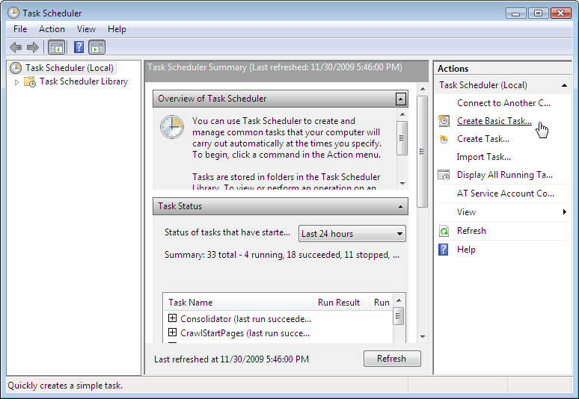

Step 3
The “Create Basic Task Wizard” appears.

Type Disk Cleanup in the “Name” field, and then click Next.

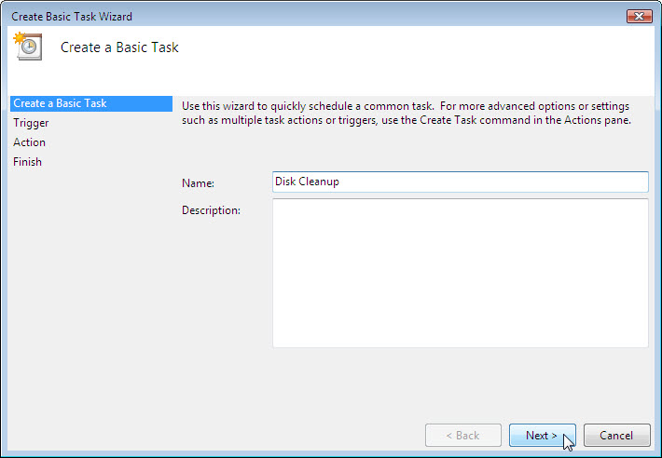

Click the Weekly radio button, and then click Next.

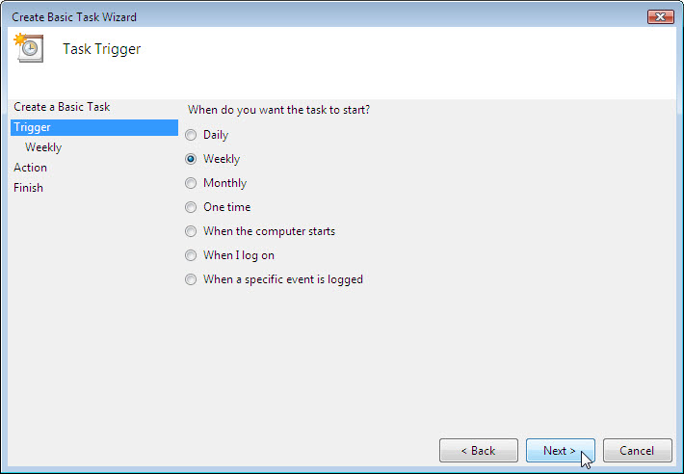

Click on the time field and select the hour, minute, seconds, and AM/PM. Use the scroll buttons in the “Start:” field to set the time to 6:00:00 PM.

Set the “Recur every _ weeks on:” field to 1.

Check the “Wednesday” check box, and then click Next.

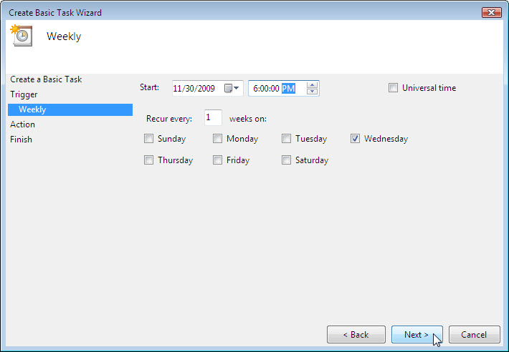

The “Action” screen opens.

Make sure Start a program is selected then click Next.

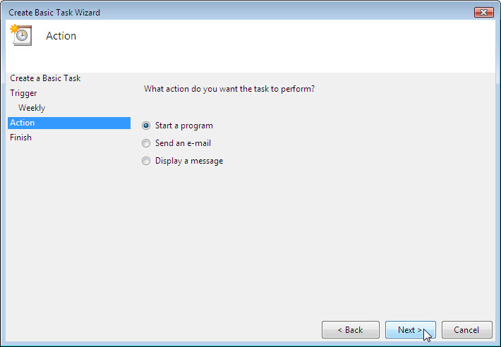

The “Start a Program” screen opens.

Click Browse.

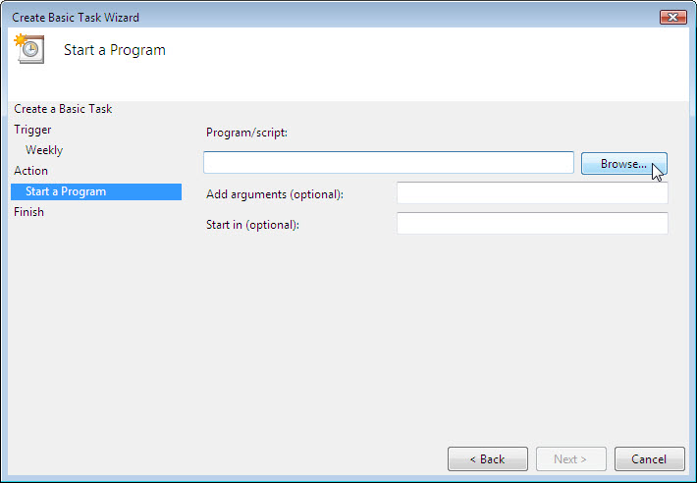

Type cle in the File name field, select cleanmge.exe, and then click Open.

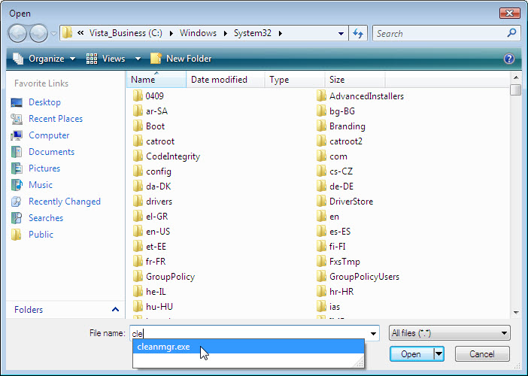

When the “Start a Program” screen re-opens click Next.

The “Summary” screen appears.

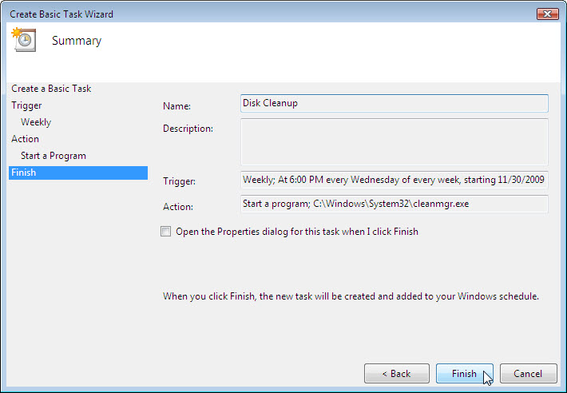

Click Finish.

Step 4
The “Task Scheduler” window appears.

Drag the center screen scroll bar to the bottom of the screen.

Next drag the “Task Name” scroll bar down until you see the task “Disk Cleanup” you created.

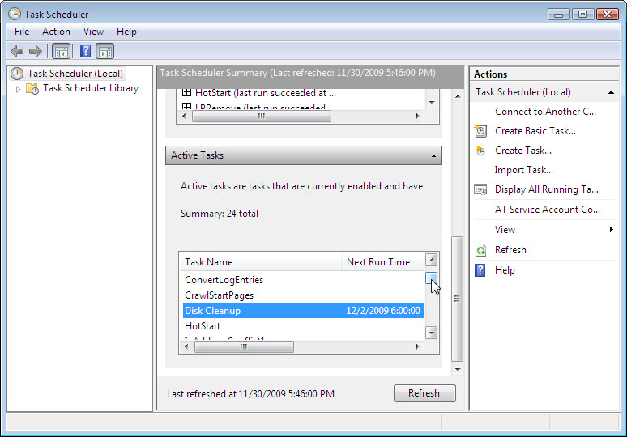

Minimize the “Task Scheduler” window and close all other windows.

Step 5
Click Start, and then in the “Start Search” field type cmd.

Right-click cmd and then click Run as administrator > Continue.

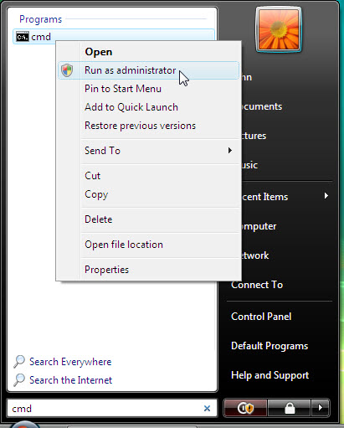

The “Administrator: C:\Windows\System32\cmd.exe” window appears.

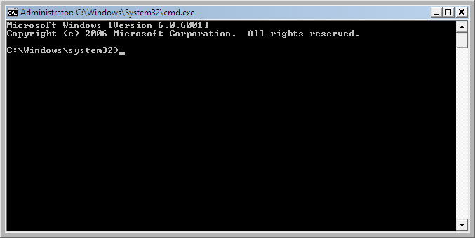

Type at/?, and then press the Enter key.

The options for the at command are displayed.

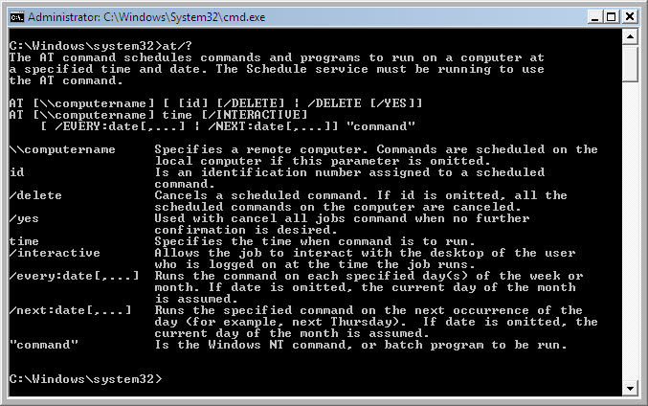

Type at 20:00:00 /every:W backup.

Note that the time must be military time.

Press Enter.

“Added a new job with job ID = 1” is displayed.

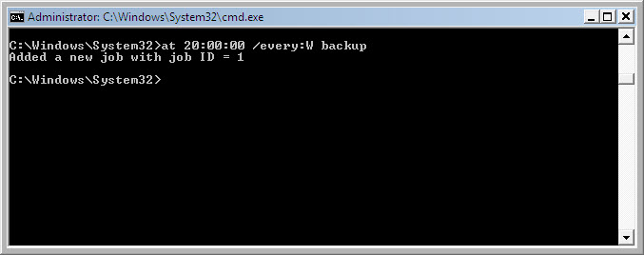

Type at \\computername. For example at \\computer1.

The scheduled job appears.

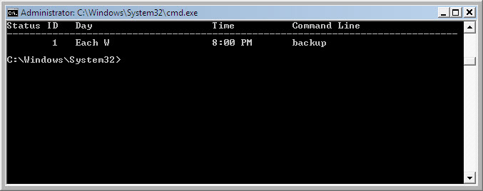

Which command would you enter to get the backup to run every Tuesday and Wednesday at 3:00 PM?

Type exit, and then press the Return key.

Step 6
Open the Scheduled Tasks window.

Click Task Scheduler Library.

The task created using the at command is listed in the window.

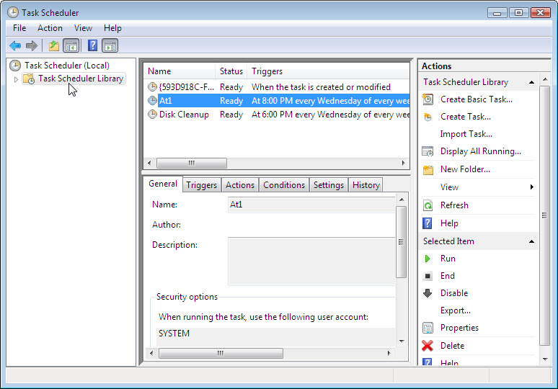

Step 7
For both the scheduled task you created right-click the scheduled task and then click Delete.

Click Yes confirm you want to delete the task.

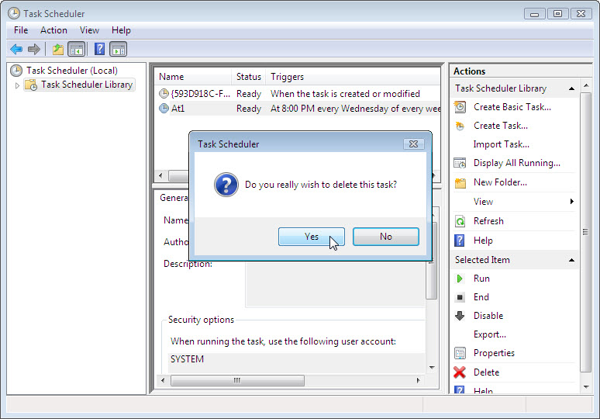

Both scheduled tasks created are removed from the scheduled tasks window.

