12.2.5 Optional Lab: Install an Alternate Browser

Introduction

Print and complete this lab.

In this lab, you will install the Mozilla Firefox Web Browser.

Recommended Equipment
- A computer running Windows
- Internet access

Step 1
Click Start > All Programs > Internet Explorer.

In the Address field, type www.mozilla.com.

Press Enter.

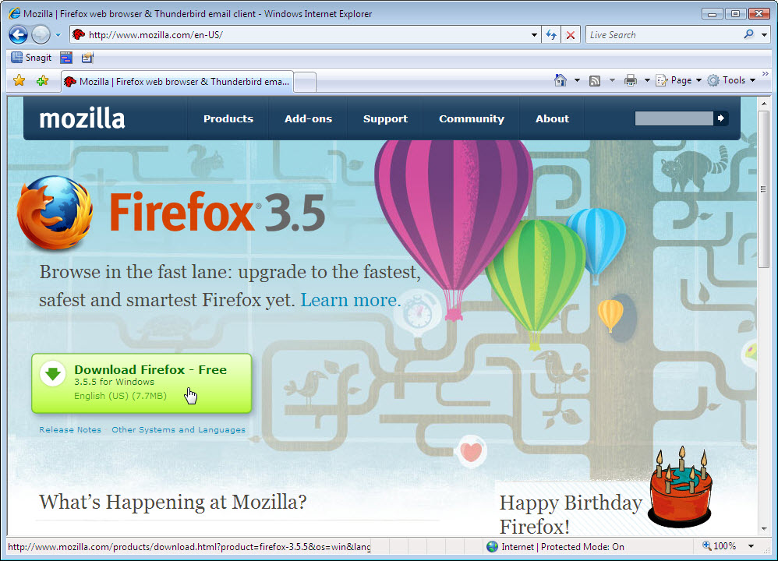

Click the Download Firefox – Free link.

Step 2
The File Download – Security Warning window appears.

Click Run.

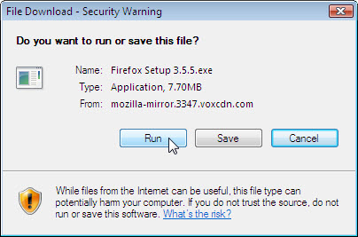

The Internet Explorer download window appears.

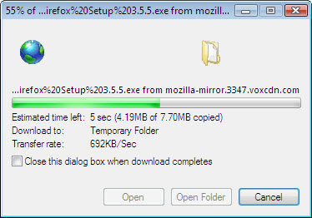

The Internet Explorer – Security Warning window may appear.

Click Run > Continue.

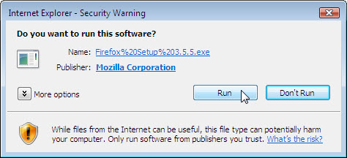

Step 3
The Mozilla Firefox Setup window appears.

Click Next.

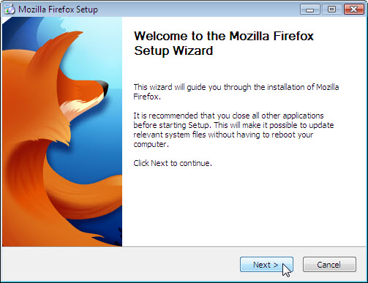

The Setup Type window appears. The default is Standard.

Click Next.

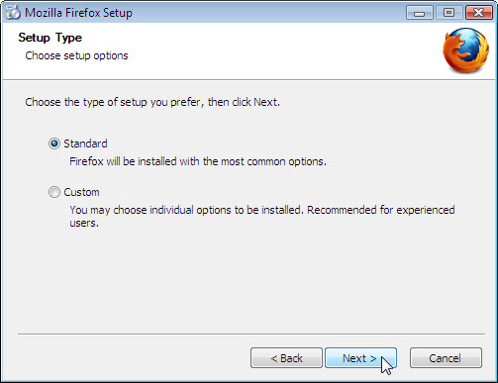

The Summary window appears.

Remove the check mark from Use Firefox as my default web browser, and then click Install.

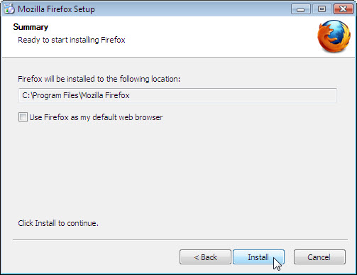

The Installing window appears.

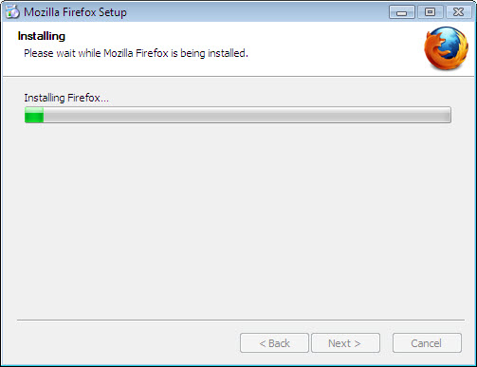

The Completing the Mozilla Firefox Setup Wizard window appears. The default is Launch Mozilla Firefox now.

Click Finish.

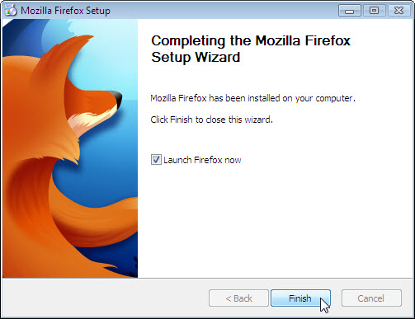

Step 4
The Import Wizard window appears. The default is Microsoft Internet Explorer.

Click Next.

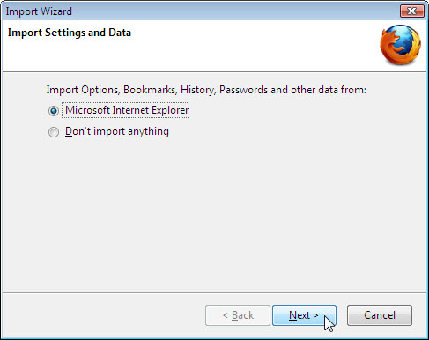

The Home Page Selection window appears. The default is Firefox Start, a fast home page with built-in search.

Click Next.

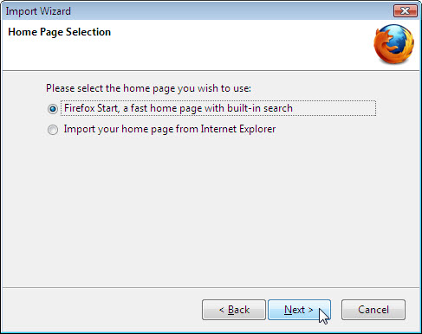

The Import Wizard window will appear.

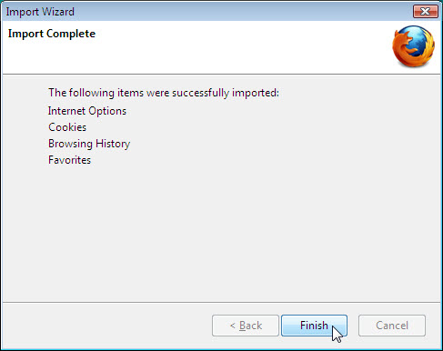

Click Finish.

Step 5
The Default Browser window appears. The default is Always perform this check when starting Firefox..

Click No.

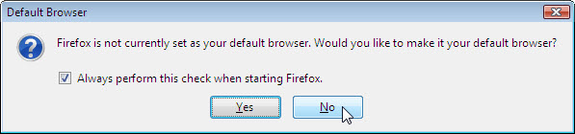

Click Tools > Options.

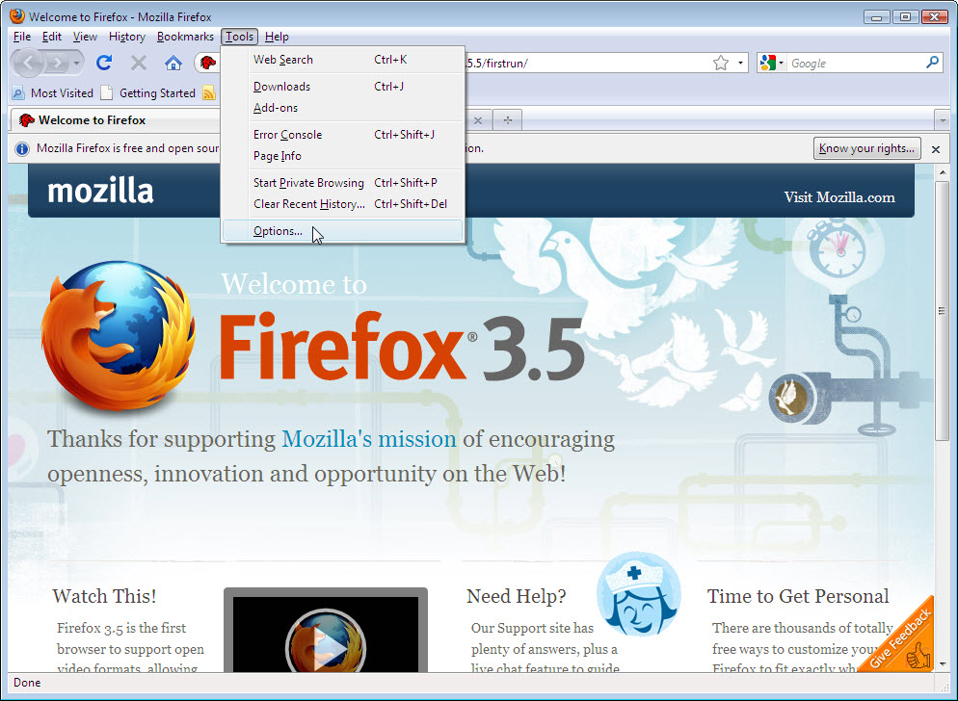

The Options window appears.

Click Browse in the Downloads area.

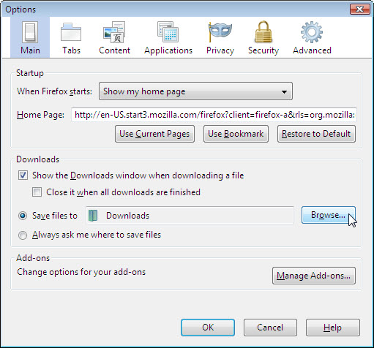

The Browse For Folder window appears.

Choose Documents, and then click OK.

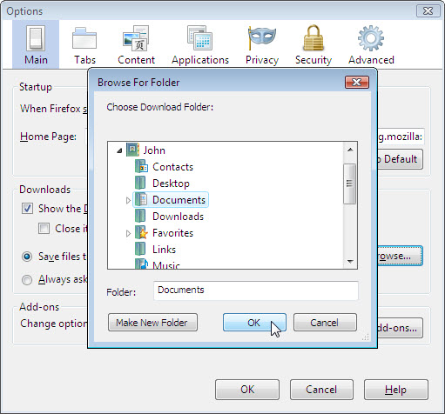

The Browse For Folder window closes.

Click OK.

Note the Mozilla Firefox icon on your desktop.

