11.4.1 Optional Lab: Install a NIC in Windows Vista

Introduction

Print and complete this lab.
In this lab, you will install a NIC, verify NIC operation, and manually configure an IP address, and set the NIC to use DHCP in Windows Vista.

Recommended Equipment
- Computer running Windows Vista
- PCI NIC
- Driver files for PCI NIC on CD or floppy disk
- Antistatic wrist strap
- Tool kit

Step 1: Open the Device Manager
- Log on to the computer as an Administrator.

- Click the Start button. Right-click Computer, and then choose Properties.

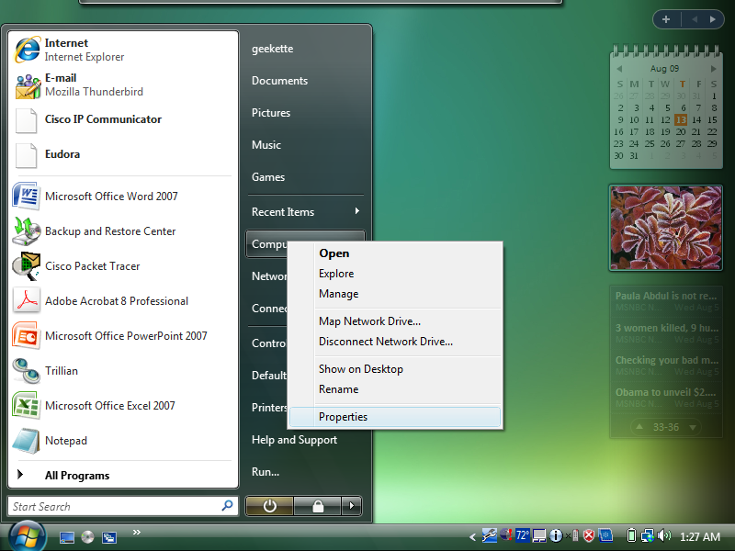
The “System” window appears.

- Choose the Device Manager link.

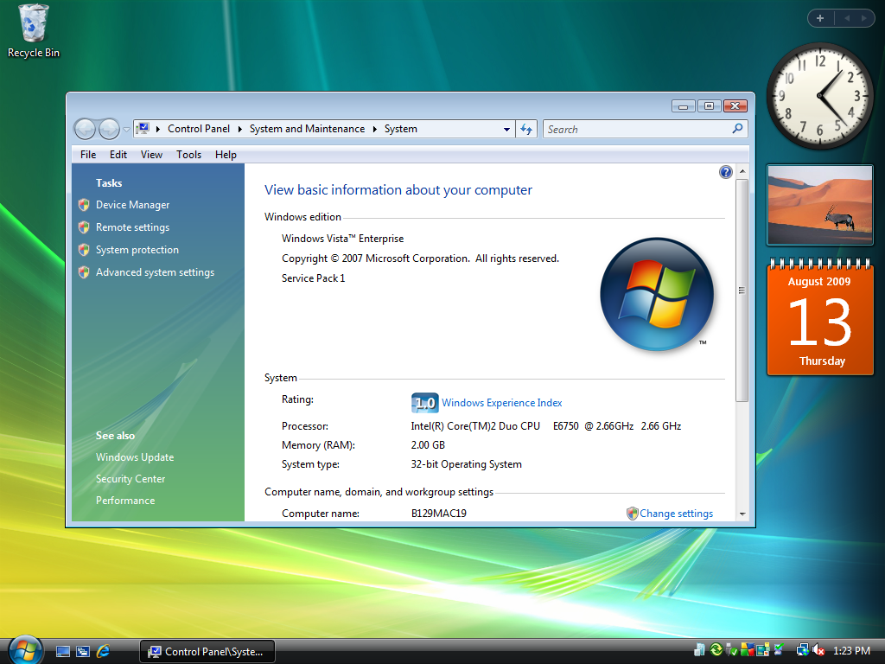

The Device Manager window appears.

Step 2: Disable the NIC
- Expand Network adapters.

- Right-click the NIC installed in your computer, and then choose Disable.

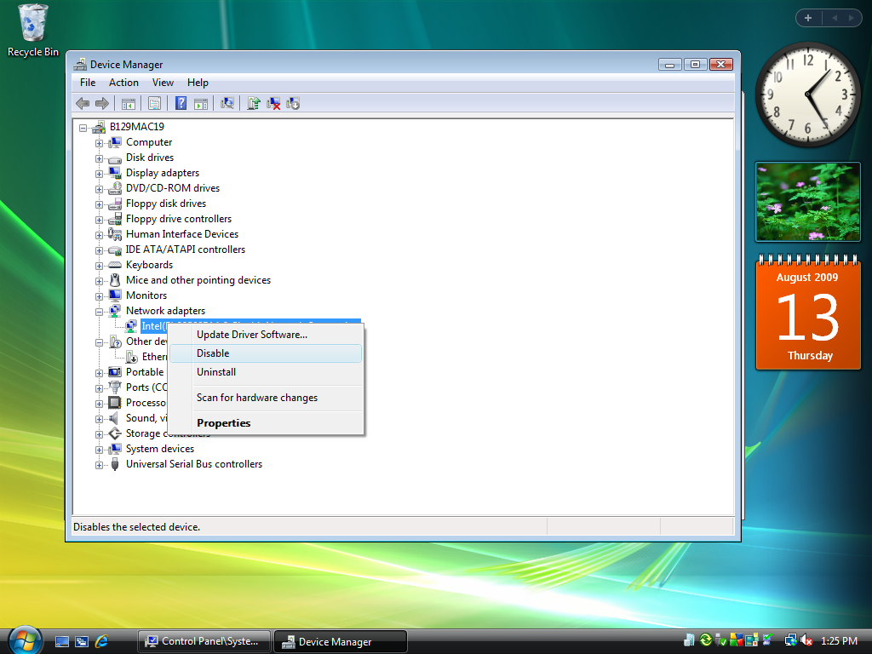
The “Disabling this device will cause it to stop functioning.” confirmation window appears.

- Click Yes.

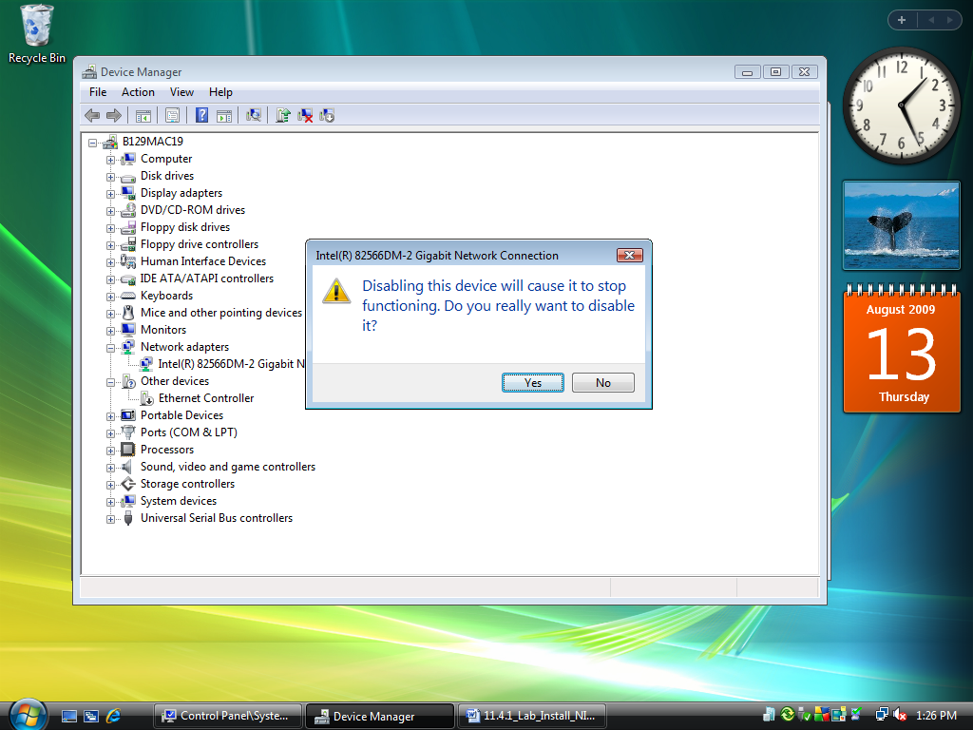

A black arrow () appears over the icon of the NIC installed in your computer.
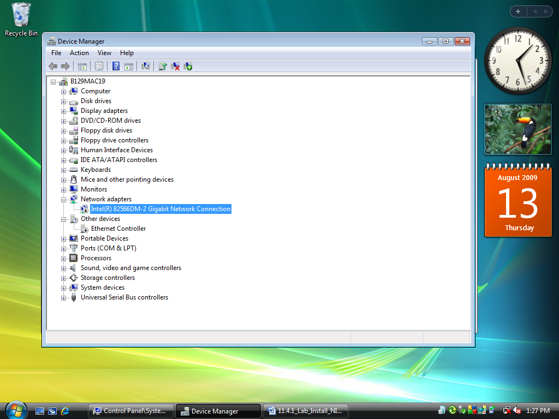

- Close the Device Manager window.
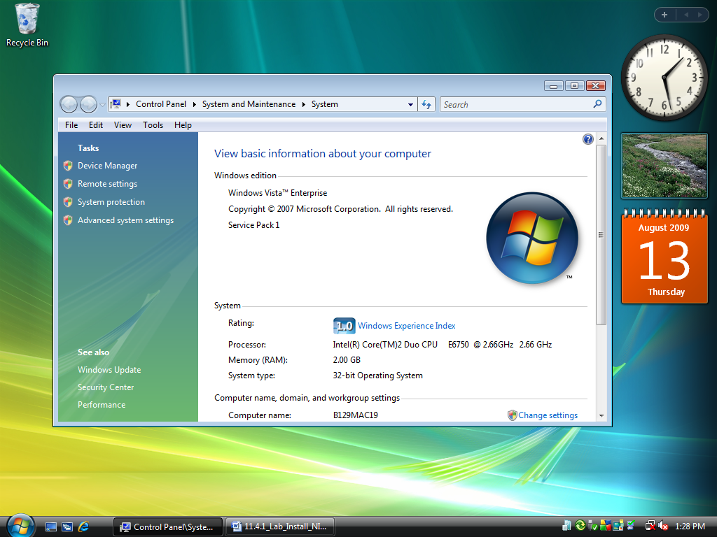

- Close the System window.

- Turn off your computer.

Who is the manufacturer of the new NIC?

What is the model number of the new NIC?

What slot type is used to connect the new NIC to the motherboard?

Step 3: Open the case
- If a switch is present on the power supply, set the switch to “0” or “OFF”.

- Unplug the computer from the AC outlet.

- Unplug the network cable from the computer.

- Remove the side panels from the case.

Step 4: Insert the NIC
- Choose an appropriate slot on the motherboard to install the new NIC. You may need to remove the metal cover near the slot on the back of the case.

- Make sure the NIC is properly lined up with the slot.

- Push down gently on the NIC.

- Secure the NIC mounting bracket to the case with a screw.

Step 5: Close case and restart the computer
- Replace the case panels.

- Plug the network cable into the new NIC.

- Plug the power cable into an AC outlet.

- If a switch is present on the power supply, set the switch to “1” or “ON”.

- Boot your computer, and then log on as an administrator.

- Choose Start. Right-click Computer, and then choose Properties.

- Click the Device Manager link.

Step 6: Install a new driver
The “Device Manager” window appears.

- Expand Network adapters.

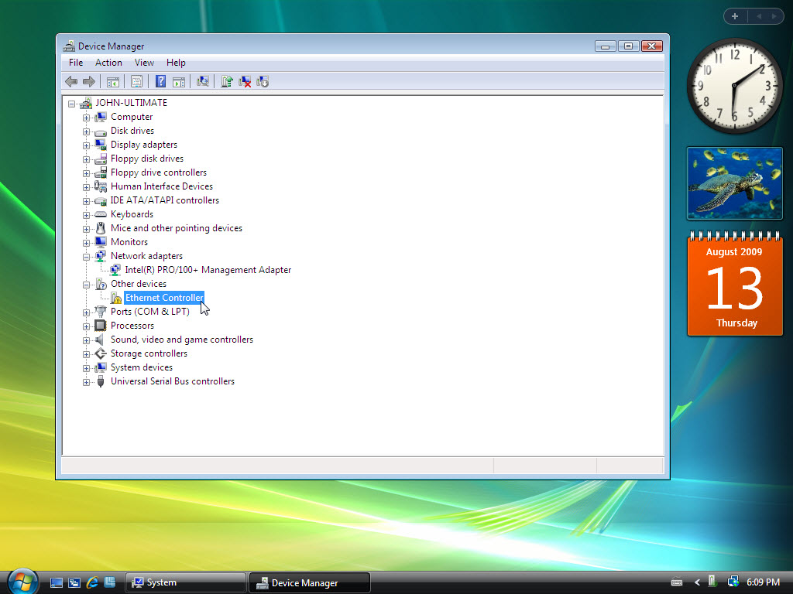

How many Network adapters are present (enabled and disabled) in the list?

- Right-click the new NIC icon or Ethernet controller, and then choose Properties.

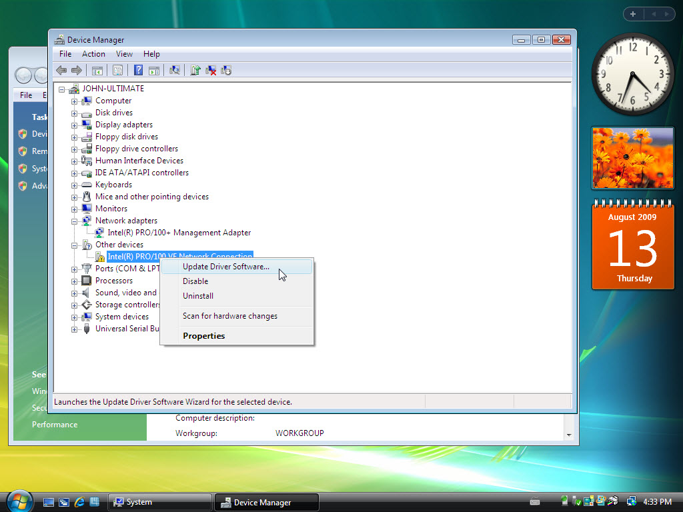

- Choose the Driver tab. Click the Update Driver button.

The “Hardware Update Wizard” appears.

- If you are prompted to connect to Windows Update, click the No, not this time radio button, and then click Next.
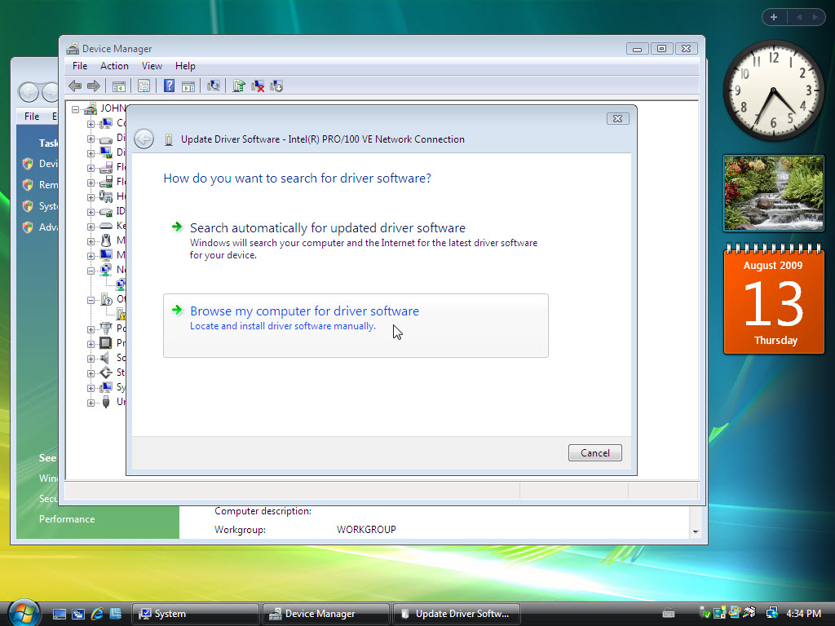

- Choose the Install from a list or specific location (Advanced) radio button, and then click Next.

- Insert the CD or floppy disk with the new NIC drivers, and then click Next.

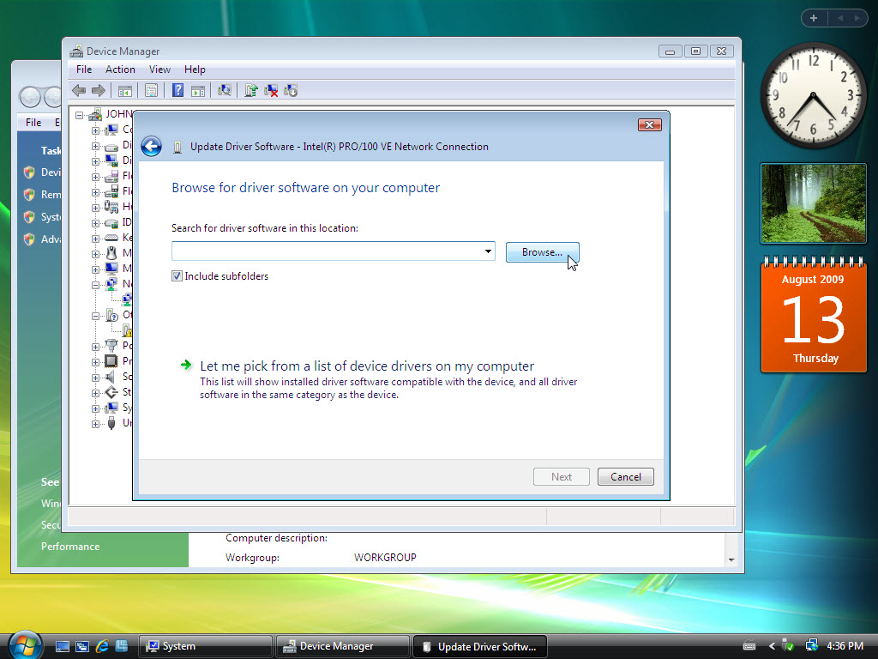

The “Please wait while the wizard searches…” window appears.

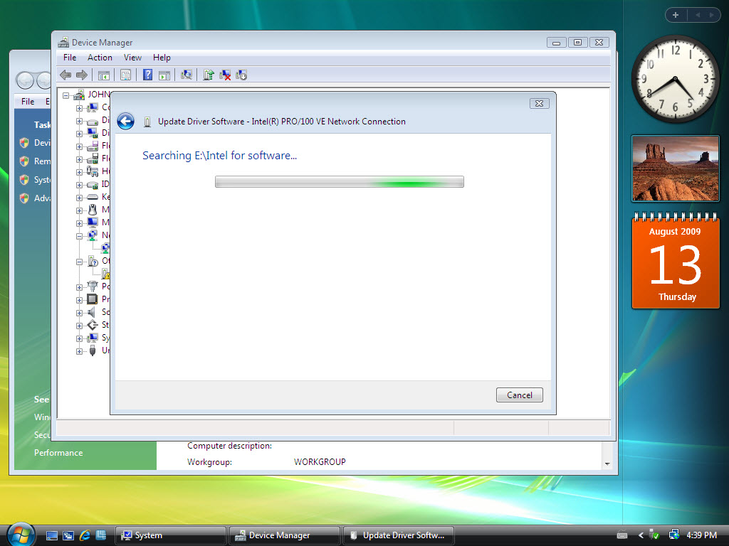
g. Click Finish after Windows installs the new driver.

The Hardware Update Wizard window closes.

h. Click Close.

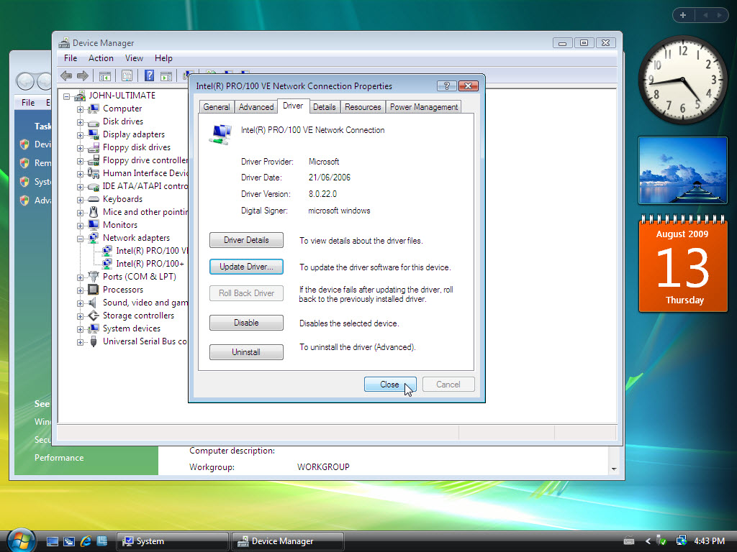

The “NIC Properties” window closes.

- Close the Device Manager.

Step 7: View the NIC settings
- Choose Start > Start Search.

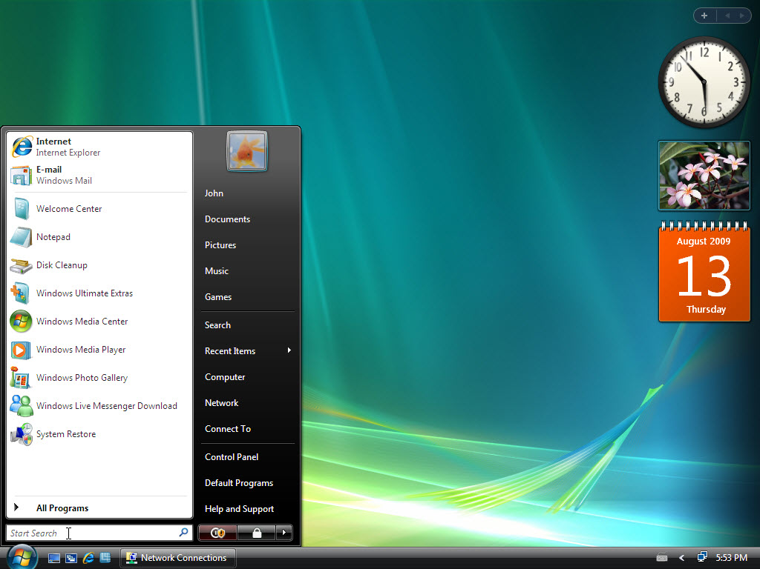
- Type cmd and press Enter.

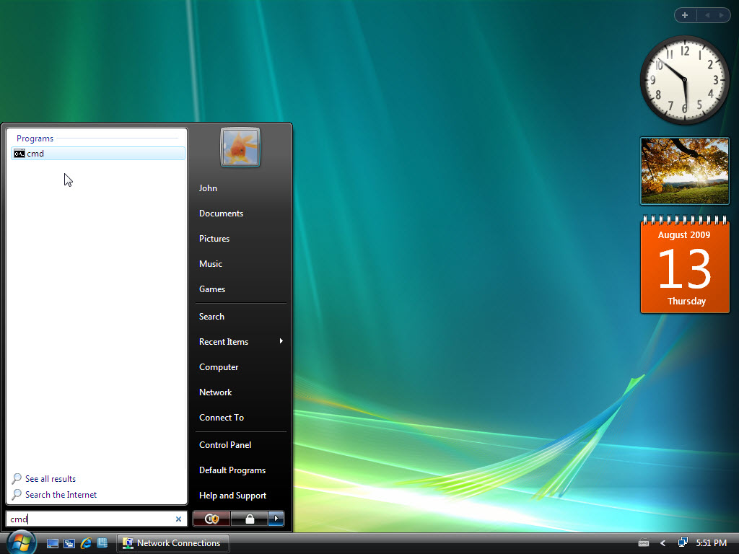

The “C:\WINDOWS\System32\cmd.exe” window appears.

- Type ipconfig and press Enter.

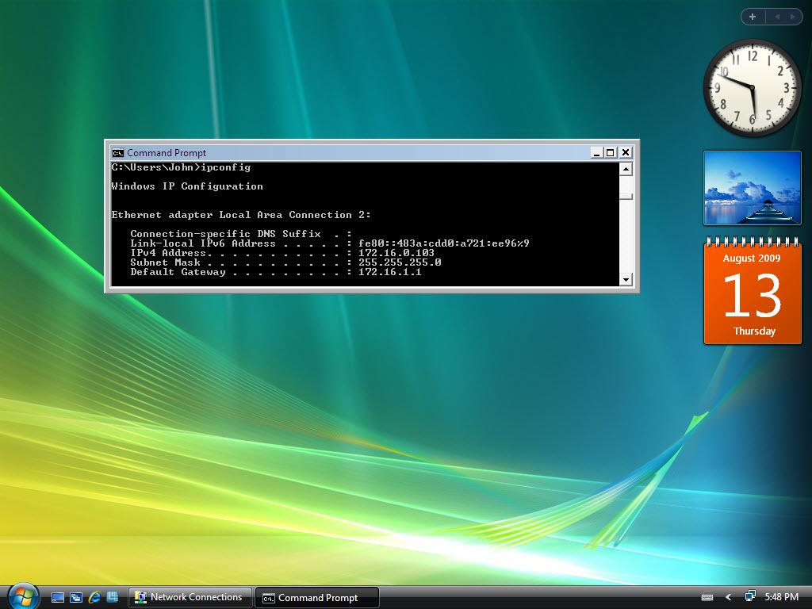
The settings of the new NIC are displayed.

What is the IP address?

What is the subnet mask?

What is the default gateway?

Step 8: Open the Network Connections window
- Choose Start > Network.

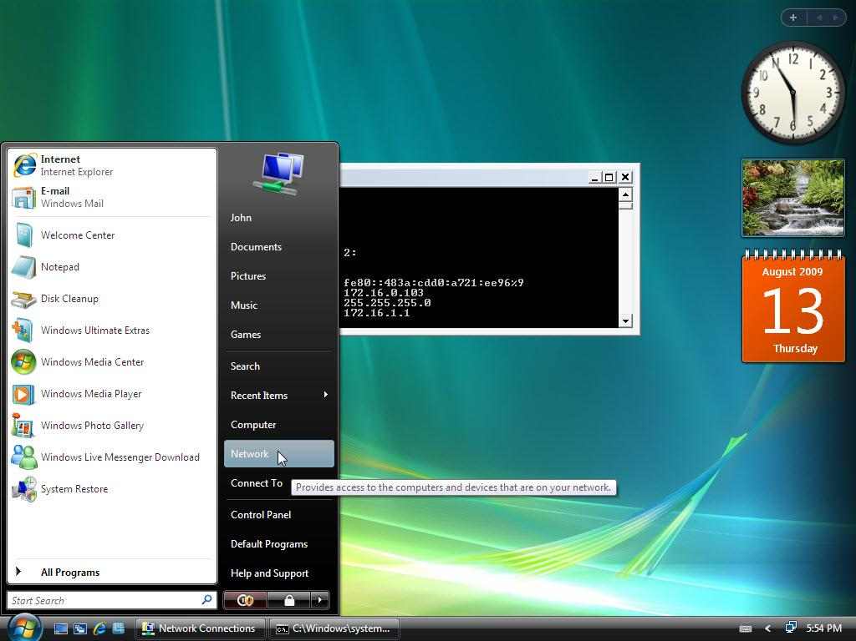

- Click Network and Sharing Center.

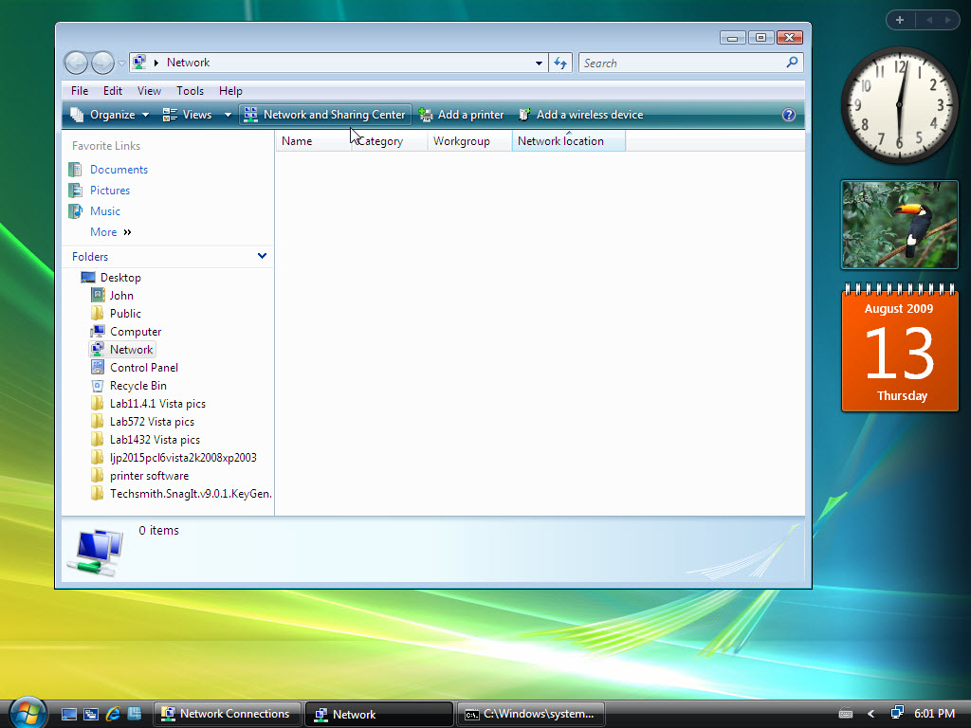

The “Network and Sharing Center” window appears.

- Click Manage network connections.

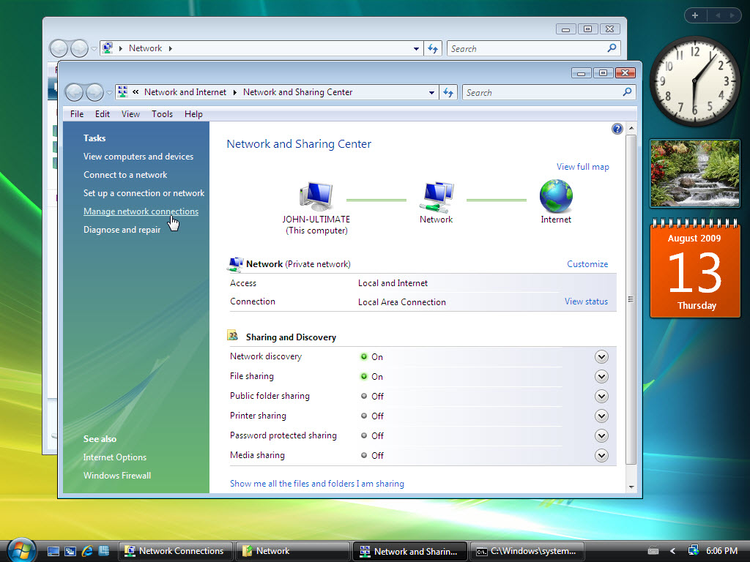

The “Network Connections” window appears.

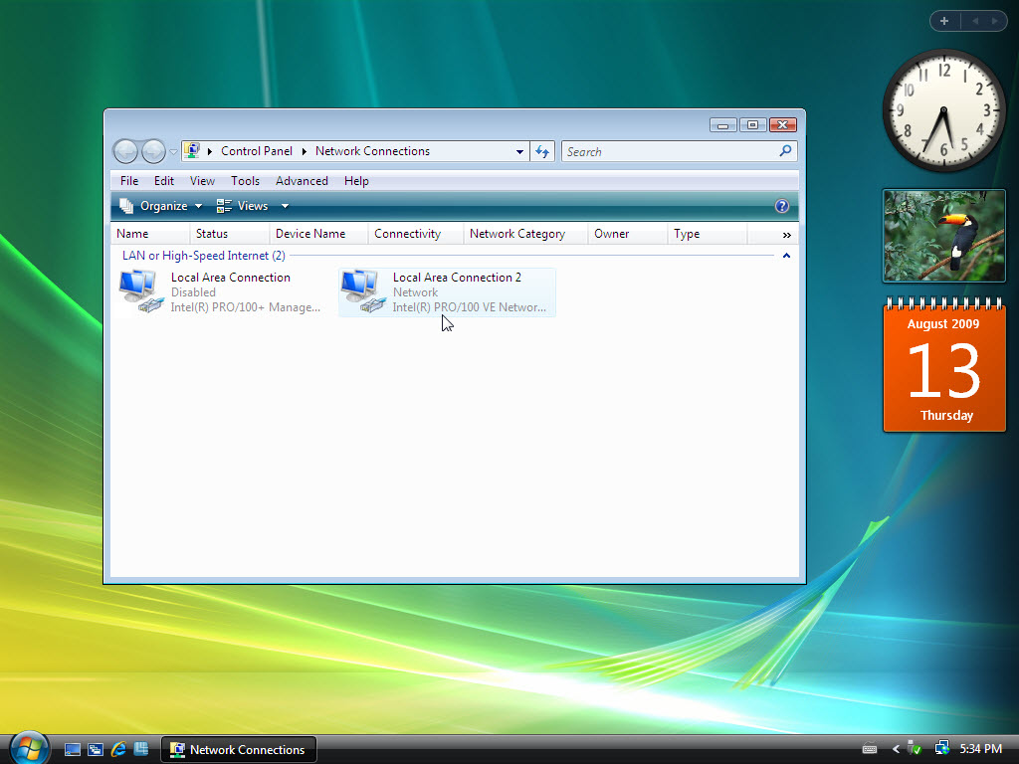

Step 9: Set a static IP address
- Right-click the connected “Local Area Connection 2” and choose Properties.

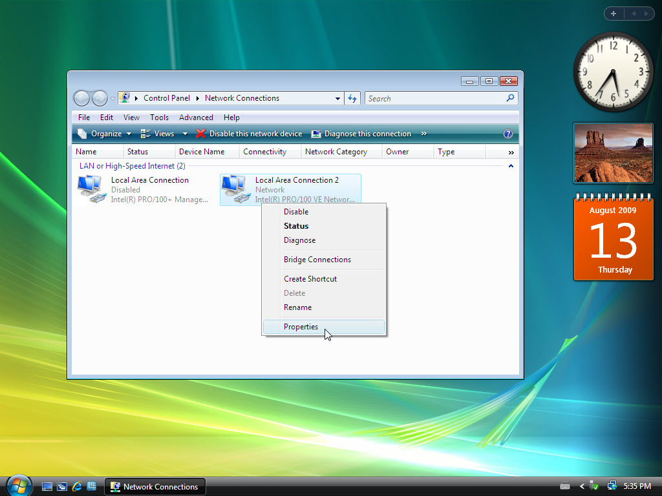
The “Local Area Connection 2 Properties” window appears.

- Choose Internet Protocol Version 4 (TCP/IPv4) and click Properties.

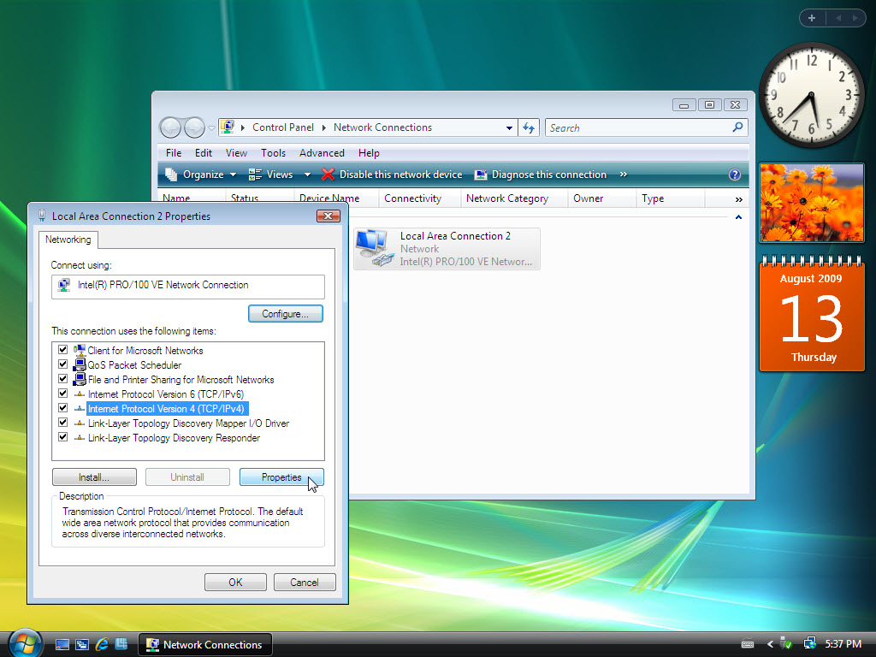

- Click the Use the Following IP address: radio button.

Note: Use the IP address, subnet mask, and default gateway you wrote down earlier in the lab to fill in the following three fields:

- Type the IP address assigned to your computer in the “IP address” field.

- Type the subnet mask assigned to your network in the “Subnet mask:” field.

- Type the default gateway assigned to your network in the “Default gateway:” field.
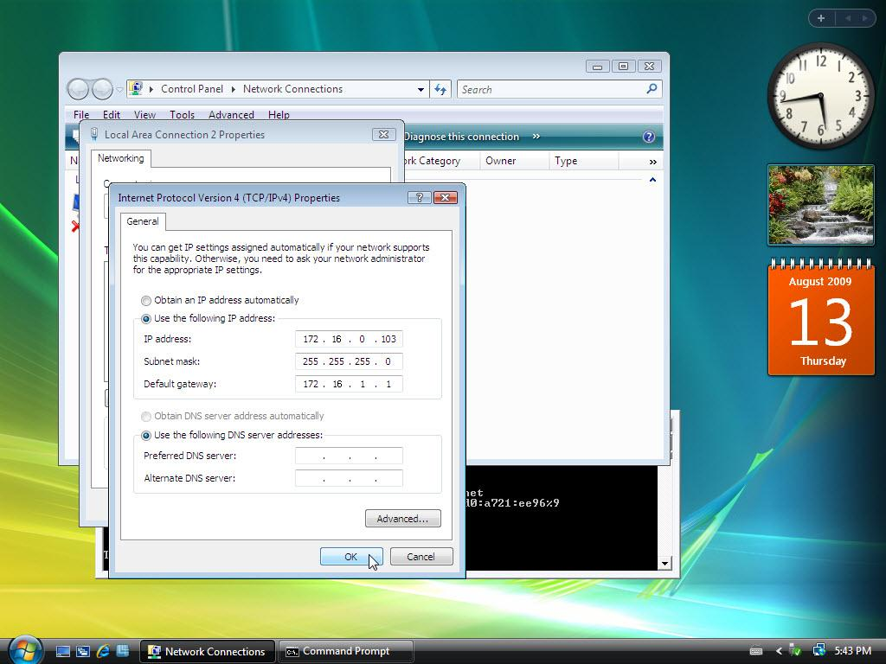

- Click OK.

The “Internet Protocol (TCP/IP) Properties” window closes.

- Click OK.

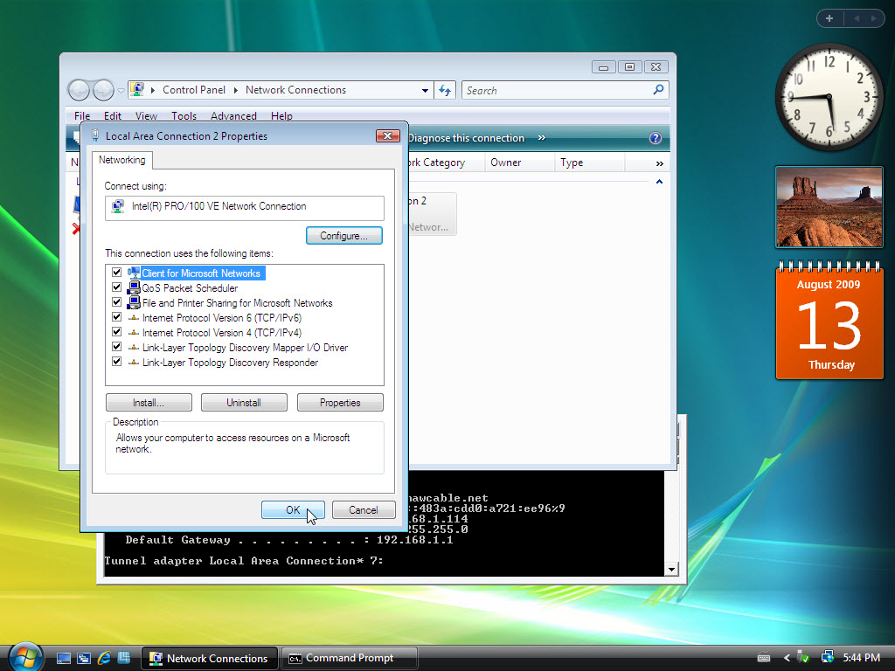
The “Local Area Connection Properties” window closes.

Step 10: Ping your computer
The “C:\WINDOWS\System32\cmd.exe” window is revealed.

- Type ipconfig /all, and then press Enter.

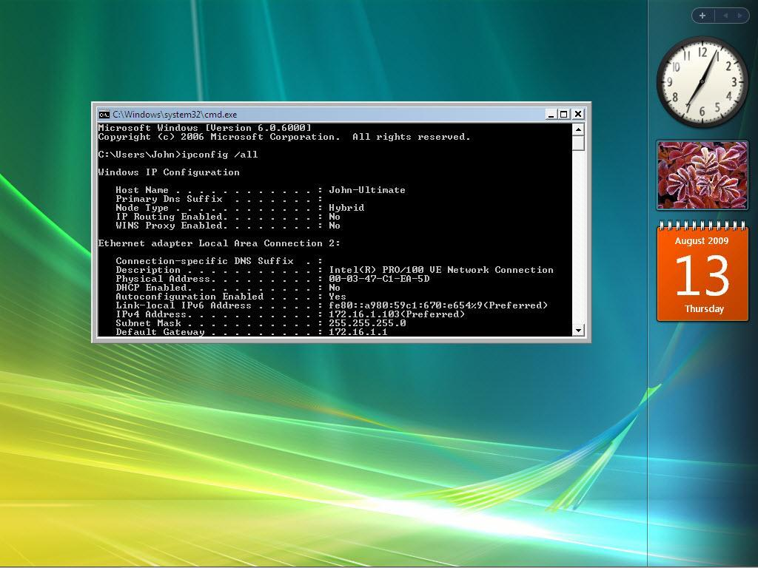

Does the NIC have DHCP enabled?

- Type ping and your IP address. For example, ping 172.16.1.103.

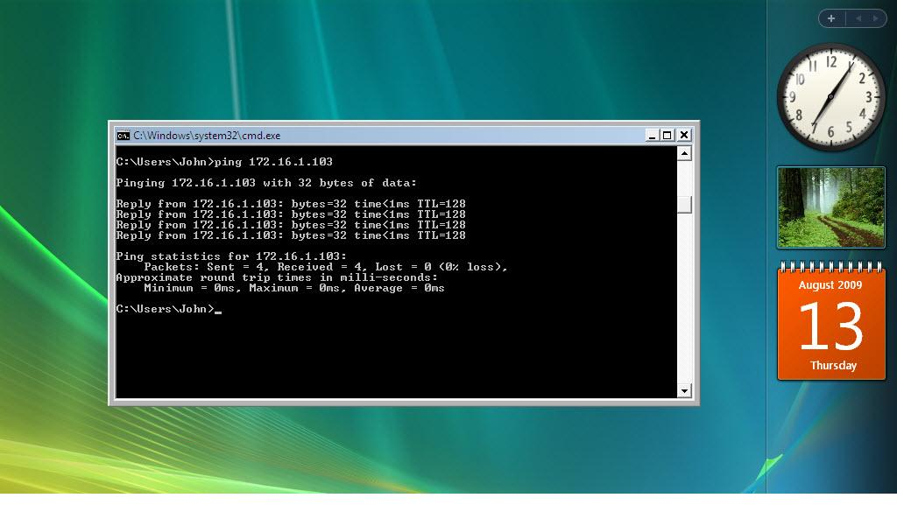
Write one of the replies of your ping command.

- Type exit, and then press Enter.

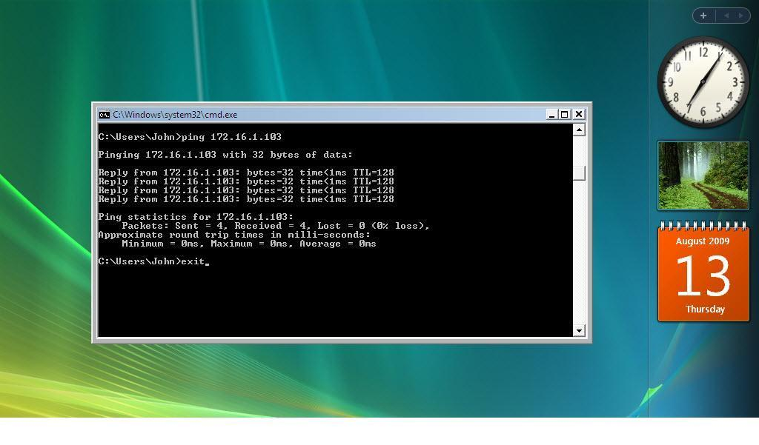

Step 11: Set the NIC to use DHCP
- Choose Start > Network.

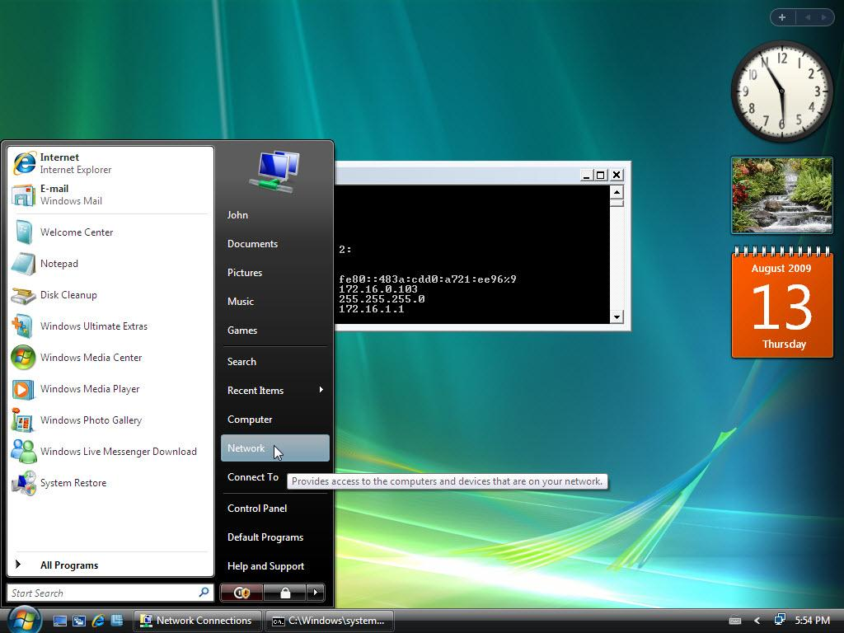

- Click Network and Sharing Center.

The “Network and Sharing Center” window appears.

- Click Manage network connections link.

The “Network Connections” window appears.

- Right-click the connected “Local Area Connection 2” and choose Properties.

The “Local Area Connection 2 Properties” window appears.

- Choose Internet Protocol Version 4 (TCP/IPv4) and click Properties.

- Click the Obtain an IP address Automatically radio button.

- Click OK.

The “Internet Protocol (TCP/IP) Properties” window closes.

- Click OK.

The “Local Area Connection Properties” window closes.

