8.9.2 Lab: Configure an Ethernet NIC to use DHCP in Windows XP

Introduction

Print and complete this lab.

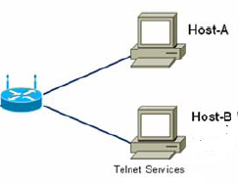

In this lab, you will configure an Ethernet NIC to use DHCP to obtain an IP address, test connectivity and establish a telnet connection between 2 computers.
Note: The instructor will have a Telnet server configured on Host B.

Recommended Equipment
- Linksys 300N router
- Two Computers running Window XP Professional
- Ethernet patch cable

Step 1
For Host A, plug one end of the Ethernet patch cable into “Port 1” on the back of the router.

For Host A, plug the other end of the Ethernet patch cable into the network port on the NIC in your computer.

For Host B, plug one end of the Ethernet patch cable into “Port 2” on the back of the router.

For Host B, plug the other end of the Ethernet patch cable into the network port on the NIC in your computer.

Plug in the power cable of the router if it is not already plugged in.

Turn on both computers and log on to Windows in Host A as an administrator.

Click Start.

Right-click My Network Places, and then choose Properties.

The “Network Connections” window appears.

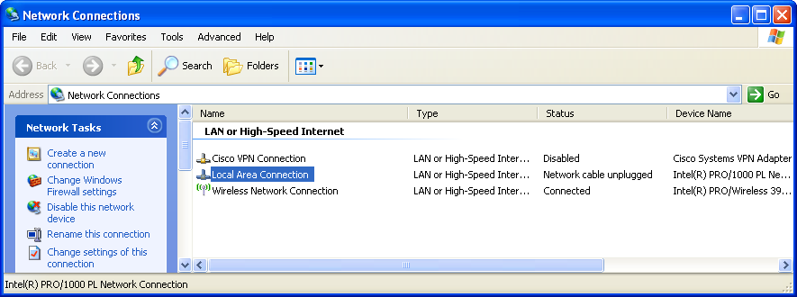

Step 2
Right-click Local Area Connection, and then choose Properties.

The “Local Area Connection Properties” window appears.

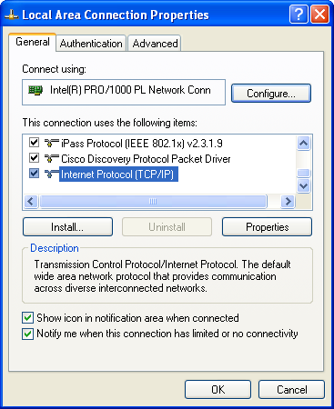

What is the name and model number of the NIC in the “Connect using:” field?

What are the items listed in the “This connection uses the following items:” field?

Step 3
Choose Internet Protocol (TCP/IP).

Click Properties.

The “Internet Protocol (TCP/IP) Properties” window appears.
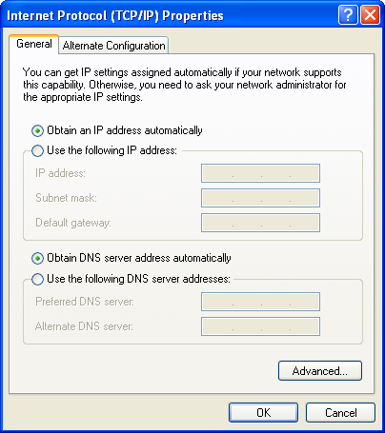

What is the IP address, Subnet mask, and Default gateway listed in the fields of the “Use the following IP address:” area?

Click the Obtain an IP address automatically radio button.

Click OK.

The “Internet Protocol (TCP/IP) Properties” window closes.

Click OK.

Restart your computer.

Step 4
Log onto Windows as an administrator.

Check the lights on the back of the NIC. These lights will blink when there is network activity.

Choose Start > Run....

Type cmd and click OK.

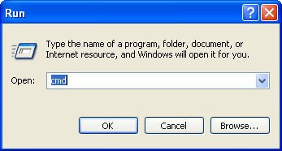
Type ipconfig/all, and then press the Enter key.
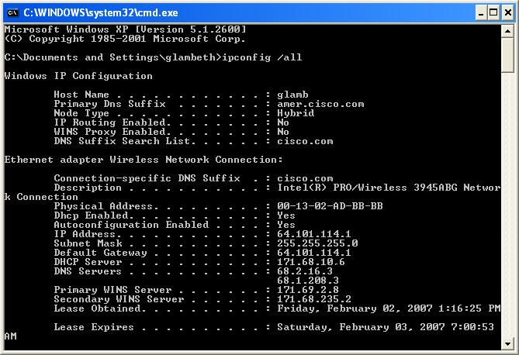
What is the IP address and subnet mask of the “Ethernet Adapter Local Area Network Connection”?

What is the IP address of the DHCP server?

On what date was the Lease Obtained?

On what date does the Lease Expire?

Step 5
Type ping and your IP address. For example, ping 192.168.1.103.

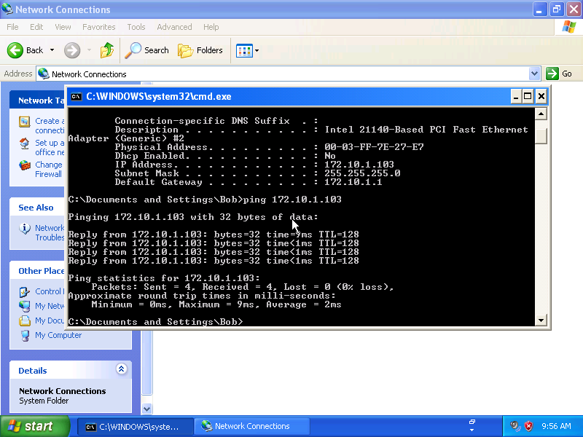

Write one of the replies of your ping command.

Ask the instructor for the IP address for Host B or login to Host B and obtain the IP address by typing ipconfig in the command window.

What is the IP address for Host B?

Type ping and the IP address for Host B.

If the ping was not successful, troubleshoot.

Type exit, and then press Enter.

Step 6
Log in to Host A as an administrator, if not already done.

Choose Start > Run....

Type telnet and click OK.

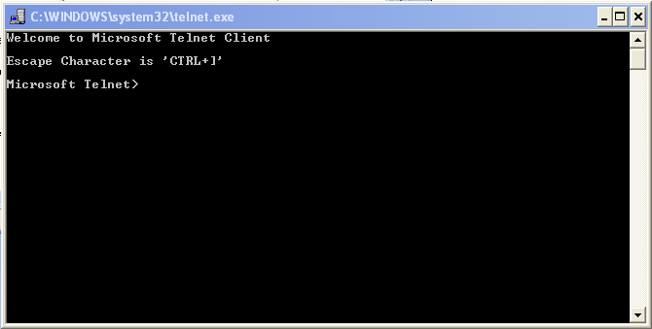

Type help.

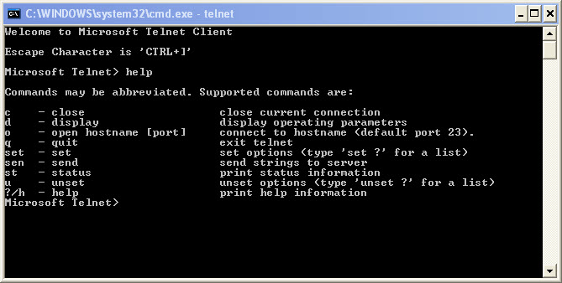

List each of Windows telnet supported commands and descriptions.

At the Microsoft Telnet> prompt type: o hostname (IP address of Host B).

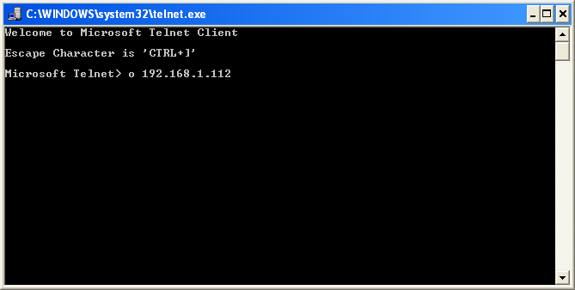

Log in to the telnet server (Host B).
Ask instructor for account username and password.

Username:

Password:

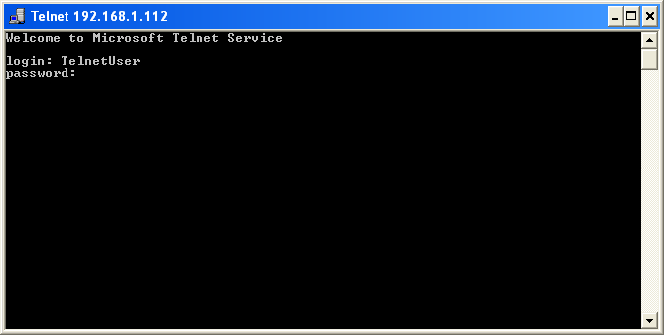

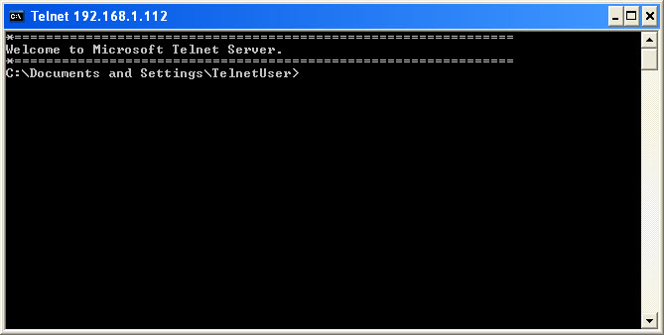

What message is displayed on the telnet server to indicate you are connected?

What directory are you connected to?

Type exit to disconnect from the telnet server.

Press any key to continue.

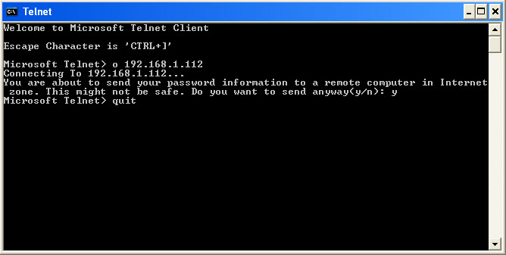

Type the proper command to exit the telnet session.

Close all windows and properly log off both computers.

