8.9.2 Optional Lab: Configure an Ethernet NIC to use DHCP in Windows Vista

Introduction

If Vista is not available in your classroom, you may complete this lab by viewing the figures in this document.

Print and complete this lab.

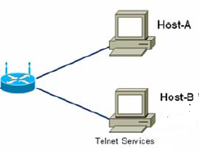

In this lab, you will configure an Ethernet NIC to use DHCP to obtain an IP address, test connectivity and establish a telnet connection between 2 computers.
Note: The instructor will have a Telnet server configured on Host B.

Recommended Equipment
- Linksys 300N router
- Two Computers running Window Vista
- Ethernet patch cable

Step 1
For Host A, plug one end of the Ethernet patch cable into “Port 1” on the back of the router.

For Host A, plug the other end of the Ethernet patch cable into the network port on the NIC in your computer.

For Host B, plug one end of the Ethernet patch cable into “Port 2” on the back of the router.

For Host B, plug the other end of the Ethernet patch cable into the network port on the NIC in your computer.

Plug in the power cable of the router if it is not already plugged in.

Turn on both computers and log on to Windows in Host A as an administrator.

Click Start.

Right-click Network, and then choose Properties.

The “Network and Sharing Center” window appears.

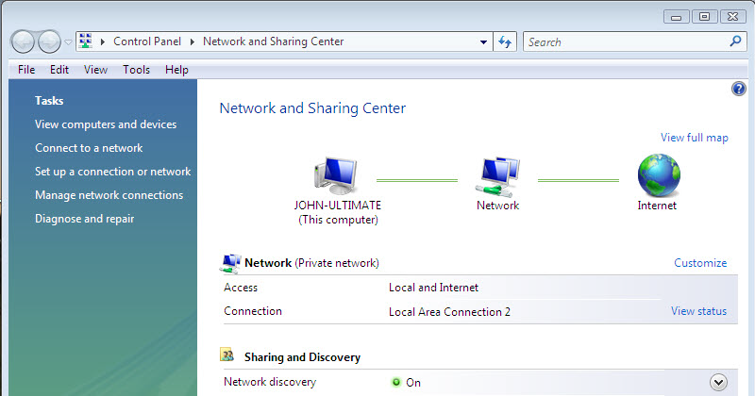

Step 2
Click View Status, and then choose Properties > Continue if asked.

The “Local Area Connection Status” window appears.

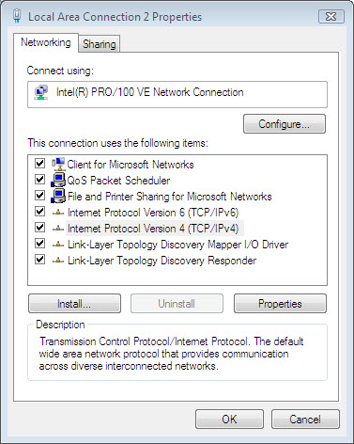

What is the name and model number of the NIC in the “Connect using:” field?

What are the items listed in the “This connection uses the following items:” field?

Step 3
Choose Internet Protocol Version 4 (TCP/IP).

Click Properties.

The “Internet Protocol (TCP/IP) Properties” window appears.

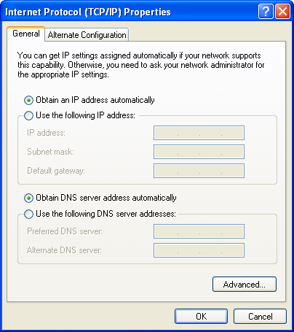

What is the IP address, Subnet mask, and Default gateway listed in the fields of the “Use the following IP address:” area?

Click the Obtain an IP address automatically radio button.

Click OK for the next two windows.

The “Internet Protocol (TCP/IP) Properties” window closes.

Click Close.

Restart your computer.

Step 4
Log onto Windows as an administrator.

Check the lights on the back of the NIC. These lights will blink when there is network activity.

Choose Start.

Type cmd in Start Search and press Enter.

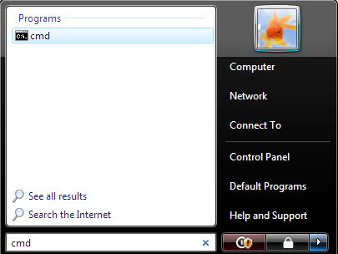

Type ipconfig /all, and then press the Enter key.
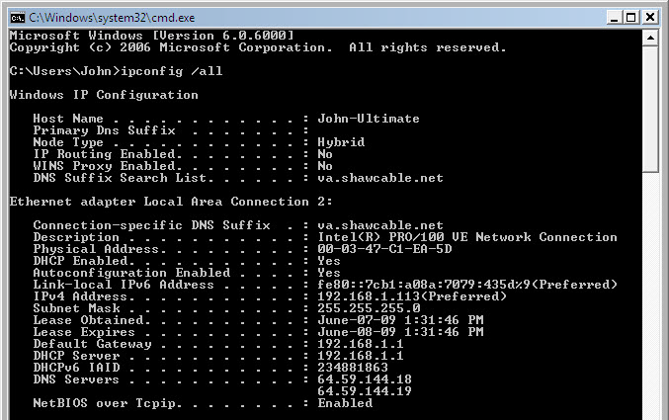
What is the IP address and subnet mask of the “Ethernet Adapter Local Area Network Connection”?

What is the IP address of the DHCP server?

On what date was the Lease Obtained?

On what date does the Lease Expire?

Step 5
Type ping and your IP address. For example, ping 192.168.1.113

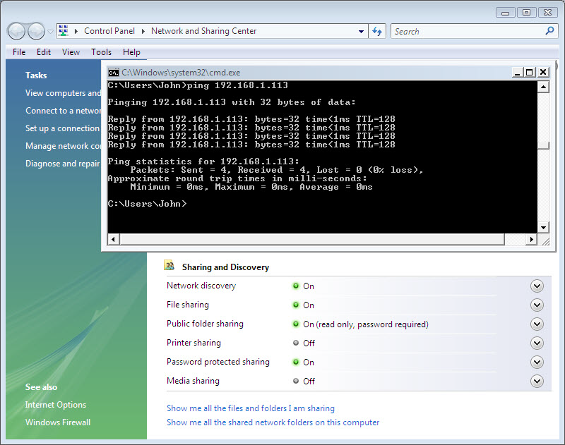

Write one of the replies of your ping command.

Step 6
To install Telnet Client, log in to Host A as an administrator, if not already done.

Click Start > Control Panel > Programs and Features.
Click Turn Windows features on or off > if asked click Continue.

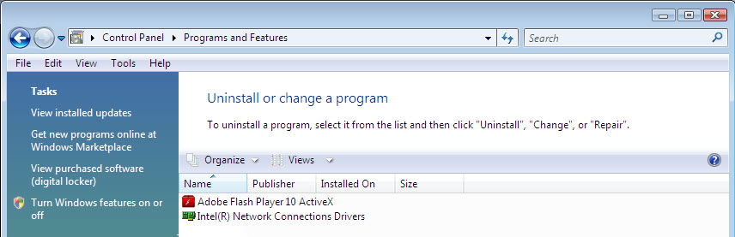

In the Windows Features list, select Telnet Client, and then click OK.

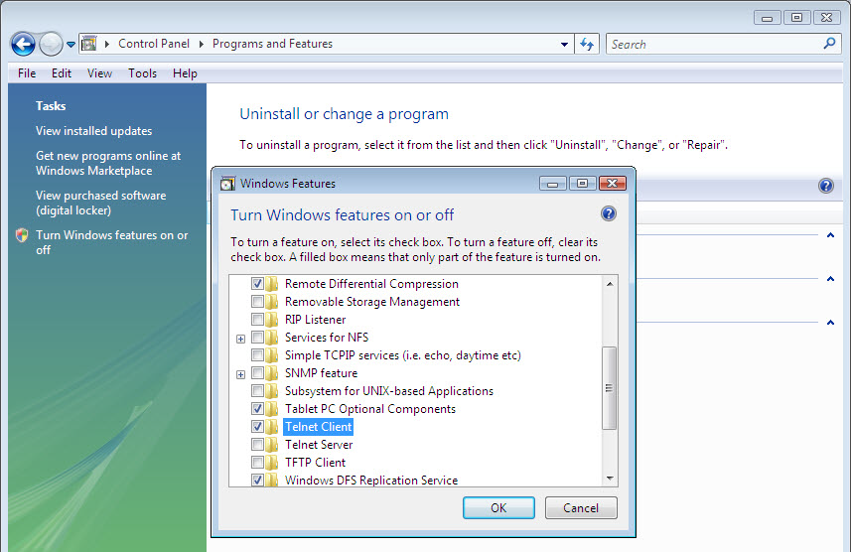

Close all Windows.

Choose Start > Command Prompt.

Type telnet and press Enter.

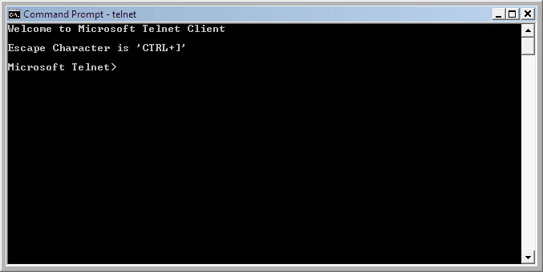

Type help.

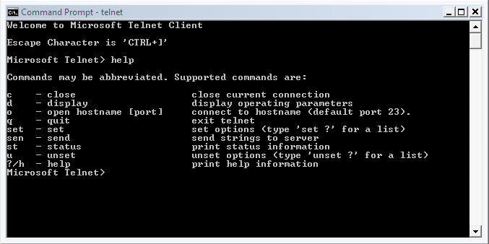

List each of the Windows telnet supported commands and descriptions.

At the Microsoft Telnet> prompt type: o hostname (IP address of Host B).

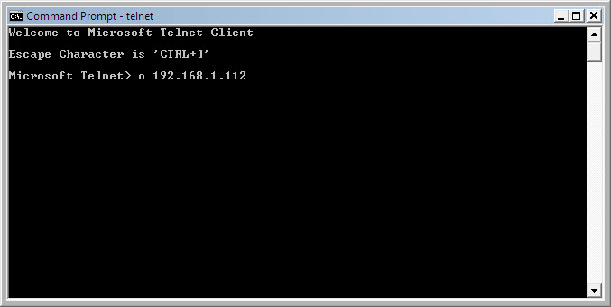

Log in to the telnet server (Host B).
Ask instructor for account username and password.

Username:

Password:

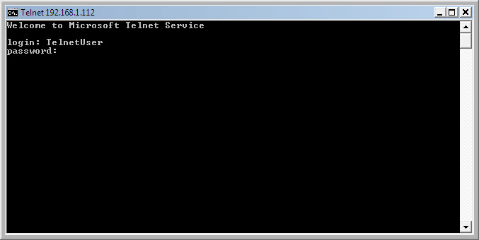

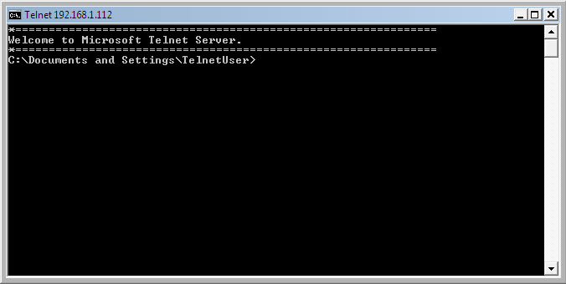

What message is displayed on the telnet server to indicate you are connected?

What directory are you connected to?

Type exit to disconnect from the telnet server.

Press any key to continue.

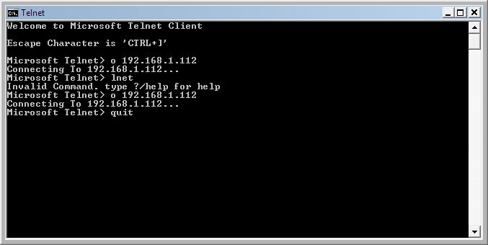

Type the proper command to exit the telnet session.

Close all windows and properly log off both computers.

