7.4.2 Lab: Install All-in-One Device and Software

Introduction

Print and complete this lab.

In this lab, you will install an all-in-one device. You will find, download, and update the driver and the software for the all-in-one device.

Recommended Equipment
- A Computer running Window XP Professional
- Internet connection
- All-in-one device

Step 1
If you are installing an all-in-one device that connects to a parallel port, shut down the computer and connect the cable to the all-in-one device and computer using a parallel cable. Plug the all-in-one device power cord into an AC outlet and unlock the all-in-one device if necessary. Restart your computer.

If you are installing a USB all-in-one device, plug the all-in-one device into the computer using a USB cable. Plug the all-in-one device power cord into an AC outlet if necessary. Unlock the all-in-one device if it is locked.

Step 2
Windows detects the new hardware.

The “Found New Hardware Wizard” window appears.

Click the Yes, this time only radio button, and then click Next.

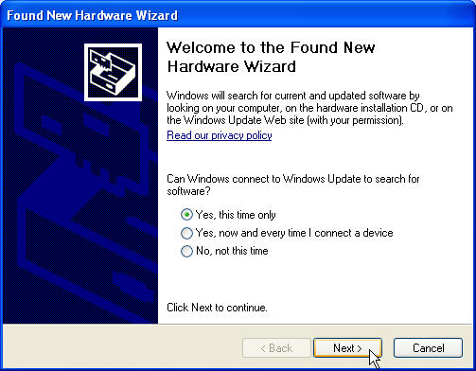
The second screen of the Found New Hardware Wizard appears.

The default is “Install the software automatically (Recommended)”.

Click Next.

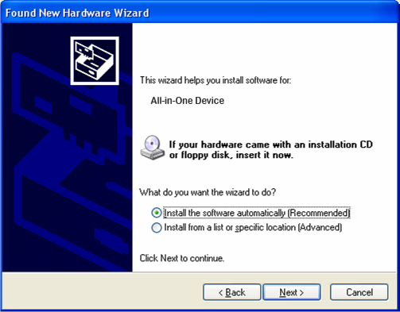

The “Please wait while the wizard searches…” window appears.

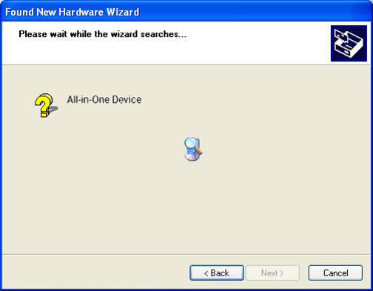

The “Cannot Install this Hardware” window may appear.

If this happens, click Finish.

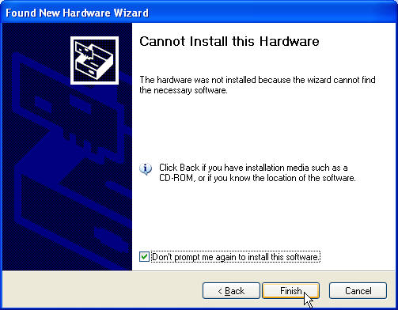

Step 3
If the computer does not detect the all-in-one device, right-click My Computer, then choose Manage > Device Manager.

Under “Other Devices”, double-click the all-in-one device you are trying to install.

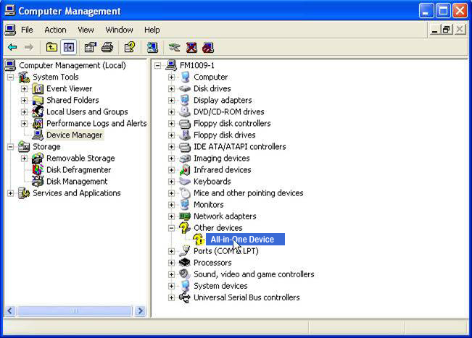

Step 4
The “Properties” window for the all-in-one device appears.

The “Device Status” area shows that “The drivers for this device are not installed. (Code 28)”.

Do not click “Reinstall Driver…” at this time.

Click Cancel.

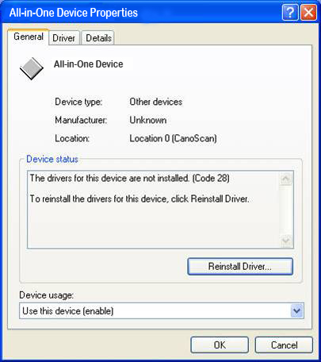

Step 5
Find the manufacturer and the model number of the all-in-one device.

Visit the manufacturer’s web site and navigate to the product downloads or support page. Download the most recent driver and software for the model of all-in-one device that you have installed. The software and driver must be compatible with your operating system.

Download the driver to a temporary folder on your desktop.
Double-click the installation file that you downloaded.

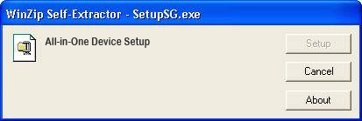

Step 6
Unplug the all-in-one device, and plug it back in.

The Windows XP operating system detects the new device and installs the new drivers.

To verify, right-click My Computer, and then choose Manage > Device Manager. You should now see the all-in-one device installed under “Imaging devices” on the right side of the window.

