5.7.2 Optional Lab: Managing Device Drivers with Device Manager in Windows Vista

Introduction

Print and complete this lab.

In this lab, you will use Windows Device Manager to gather information about different drivers and learn how Device Manager manages drivers.

Recommended Equipment
The following equipment is required for this exercise:
• A computer running Windows Vista Business

Step 1
Log on to the computer as an administrator.

Navigate to the “Control Panel” by clicking Start > Control Panel. Double-click the System icon.

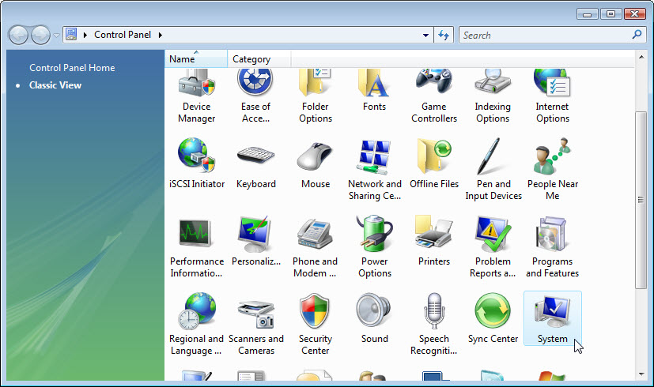

Step 2
The “System” window appears. At the left pane click Advanced system settings.
If User Account Control appears, click Continue.

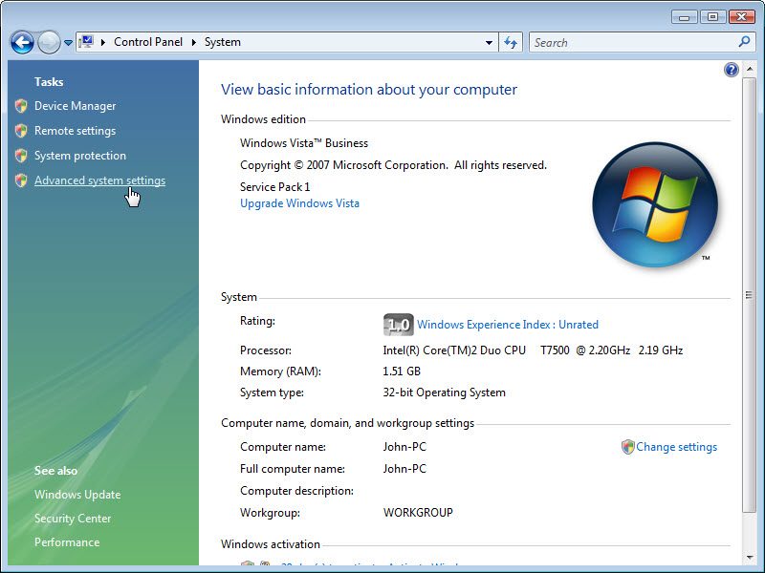

The “System Properties” window appears. Open “Windows Update Driver Settings” by clicking Hardware tab > Windows Update Driver Settings button.

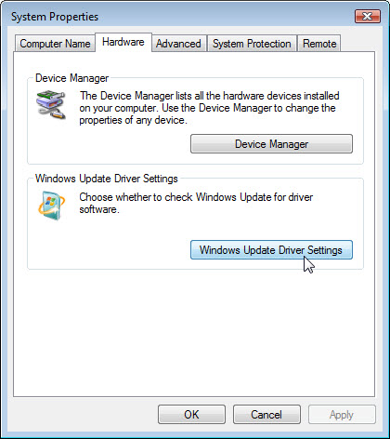

Accept the default setting and click OK.

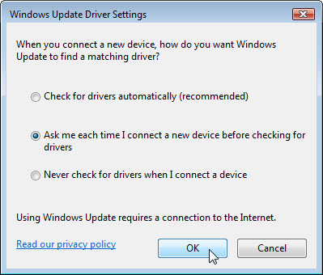

Step 3
Click the Device Manager button.

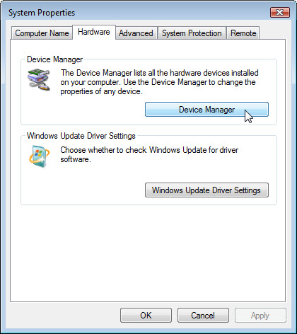

Step 4
Click the plus sign next to Display adapters. Right click the adapter name and select Properties.

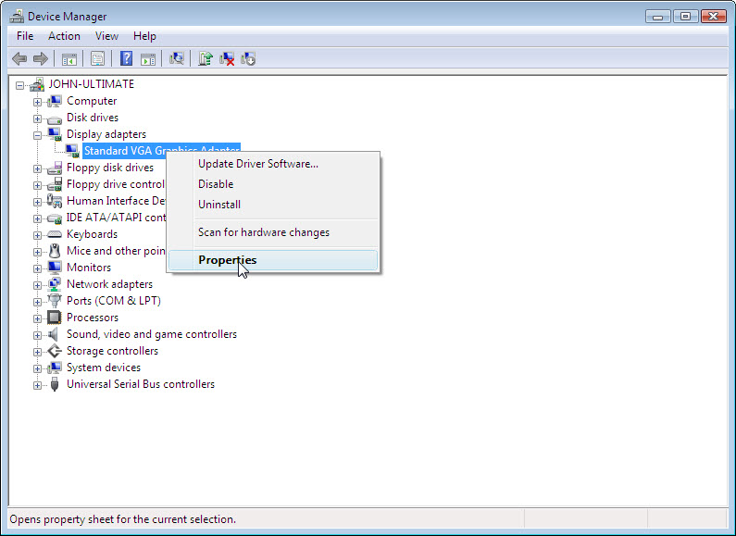

Step 5
The “Display adapters Properties” window appears.

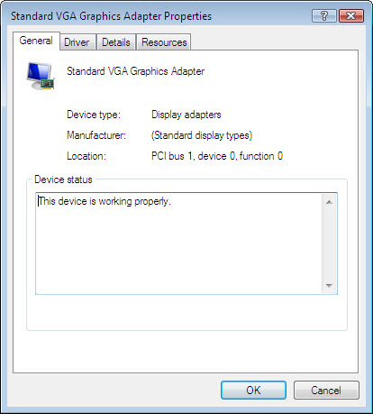

What information is displayed under the General tab?

Step 6
Click the Driver tab.

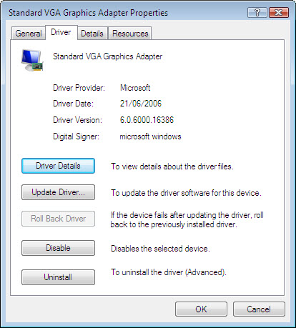

What functions can you accomplish from this page?

Step 7
Click the Detail tab. This tab provides more details about the hardware.

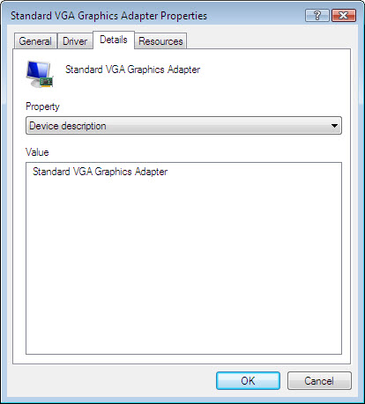

Step 8
Click the Resource tab.

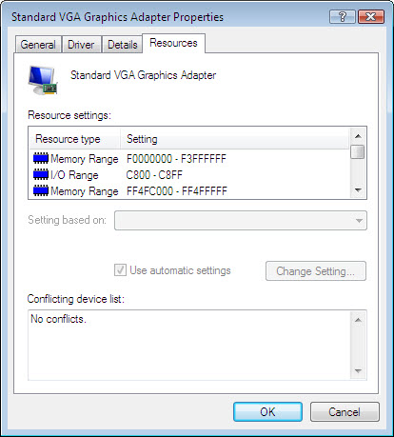

What information is displayed under the Resource tab? Answers may vary.

Close the “Display adapters Properties” windows, click Cancel.

Step 9
Navigate to the “Network adapter Properties” window” by clicking the plus sign next to Network adapters > right click the adapter name > select Properties.

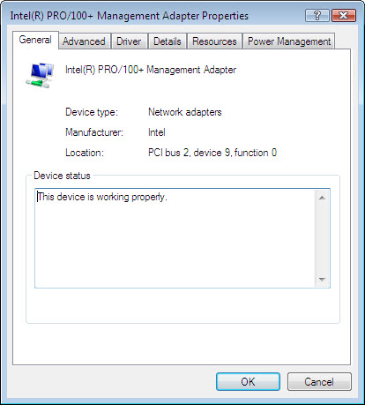

Which tabs are available?

Are there any extra tabs?

What is the purpose of the extra tabs?

Close the “Network adapters Properties” windows, click Cancel.
Close all windows and log off.

