5.7.2 Optional Lab: Managing Device Drivers with Device Manager in Windows 7

Introduction

Print and complete this lab.

In this lab, you will use Windows Device Manager to gather information about different drivers and learn how Device Manager manages drivers.

Recommended Equipment
The following equipment is required for this exercise:
• A computer running Windows 7

Step 1
Log on to the computer as an administrator.

Navigate to the “Control Panel” by clicking Start > Control Panel > System and Security. Click the System link.

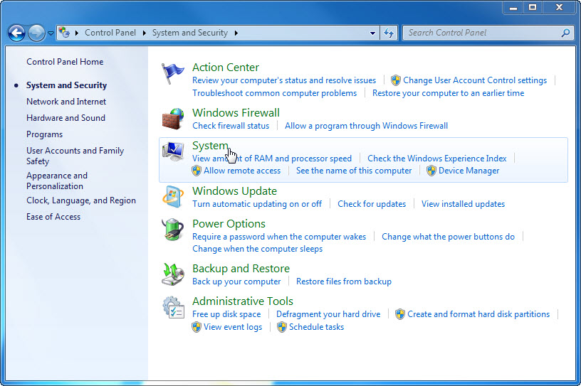

Step 2
The “System” window appears. In the left pane, click Advanced system settings.

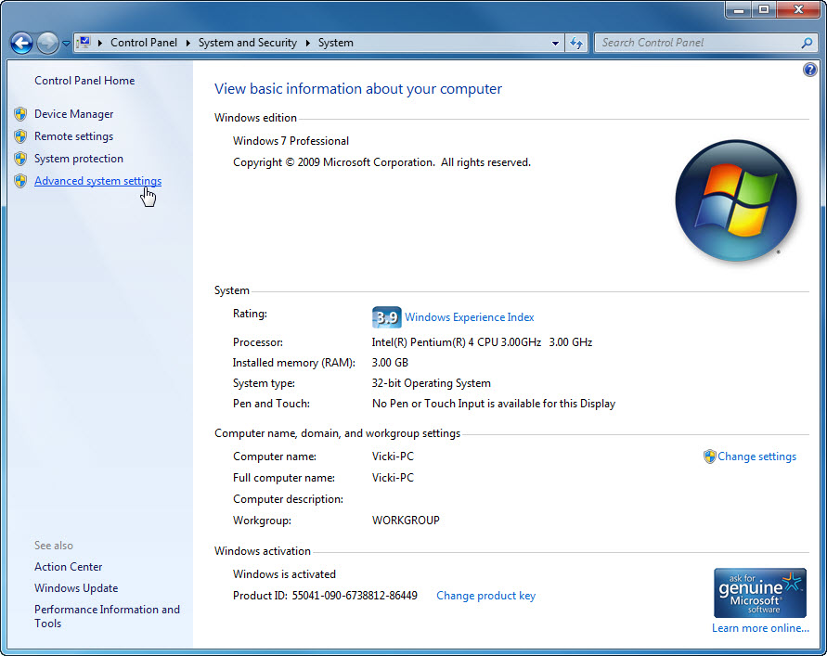

The “System Properties” window appears. Open “Device Installation Settings” by clicking the Hardware tab > Device Installation Settings button.

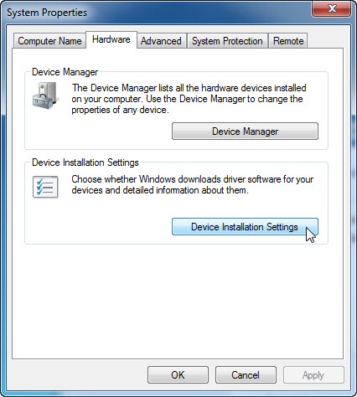

Accept the default setting and click Cancel.

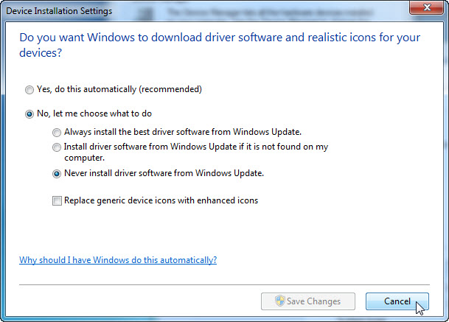

Step 3
Click the Device Manager button.

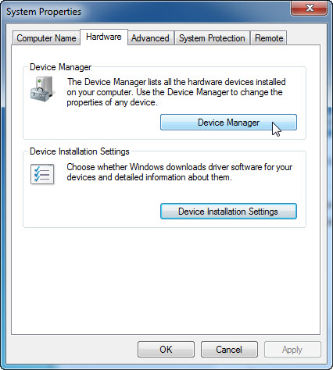

Step 4
Click the arrow next to Display adapters. Right-click the adapter name and select Properties.

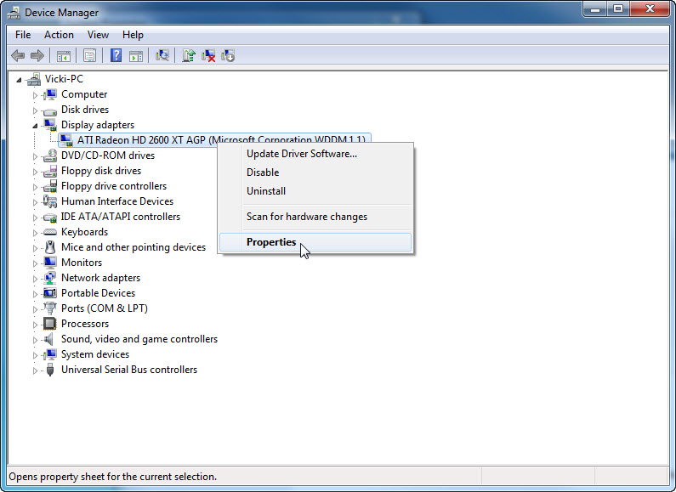

Step 5
The “Display adapters Properties” window appears.

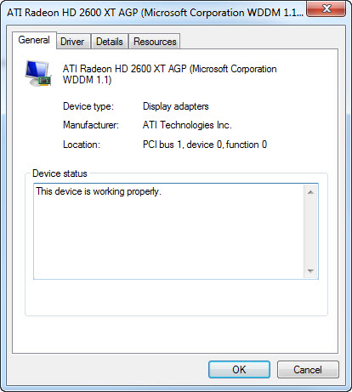

What information is displayed under the General tab?

Step 6
Click the Driver tab.

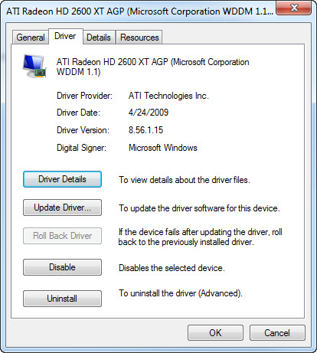

What functions can you accomplish from this page?

Step 7
Click the Detail tab. This tab provides more details about the hardware.

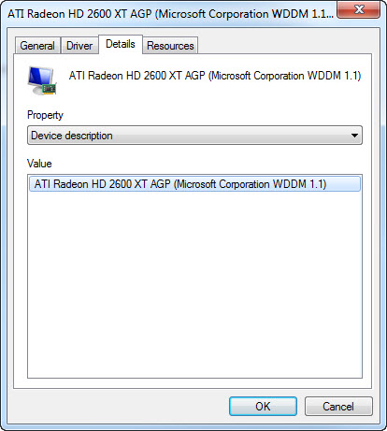

Step 8
Click the Resource tab.

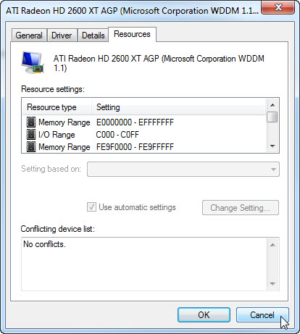

What information is displayed under the Resource tab? Answers may vary.

Close the “Display adapters Properties” windows, click Cancel.

Step 9
Navigate to the “Network adapter Properties” window by clicking the arrow next to Network adapters > right-click the adapter name > select Properties.

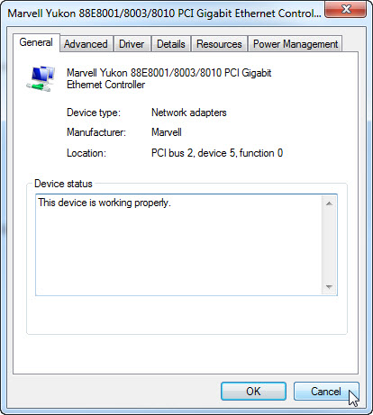

Which tabs are available?

Are there any extra tabs?

What is the purpose of the extra tabs?

Close the “Network adapters Properties” windows, click Cancel.
Close all windows and log off.

