5.6.2 Optional Lab: Restore Points in Windows Vista

Introduction

Print and complete this lab.

In this lab, you will create a restore point and return your computer back to that point in time.

Recommended Equipment
The following equipment is required for this exercise:
- A computer system running Windows Vista Business

Step 1
Click Start > All Programs > Accessories > System Tools > System Restore.
Click Continue if asked for permission.

The “System Restore” window appears.

To create a restore point, click open System Protection.

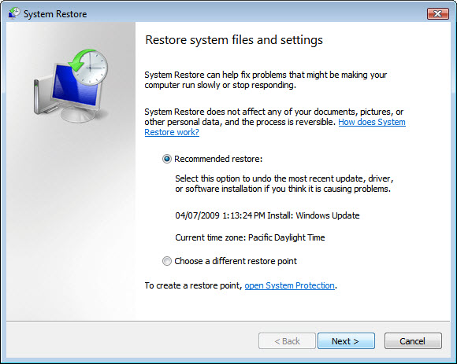

Step 2
The “System Properties” window appears.

In the “System Protection” tab, click Create.

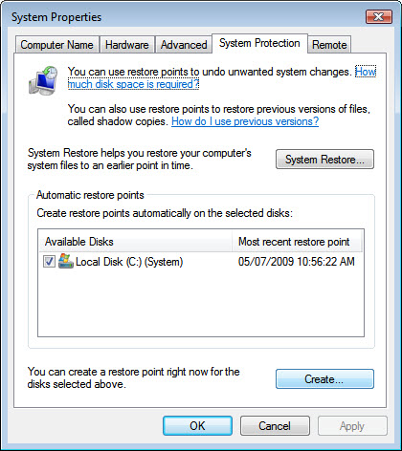

Step 3
In the “Create a restore point” description field, type Application Installed.

Click Create.

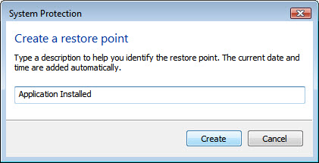

Step 4
After a period of time, a “The restore point was created successfully” message appears.

Click OK.

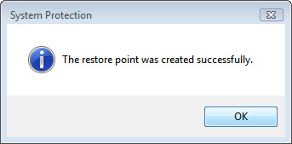

Step 5
The “System Properties” window with the “System Protection” tab selected appears. Notice in “Available Disks” area the new date below “Most recent restore point”.

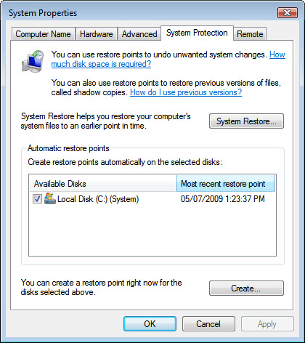

Click OK.

Close all open windows.

Step 6
Click Start > Control Panel > Programs and Features.

Click the Turn Windows features on or off link.

Click Continue if asked for permission.

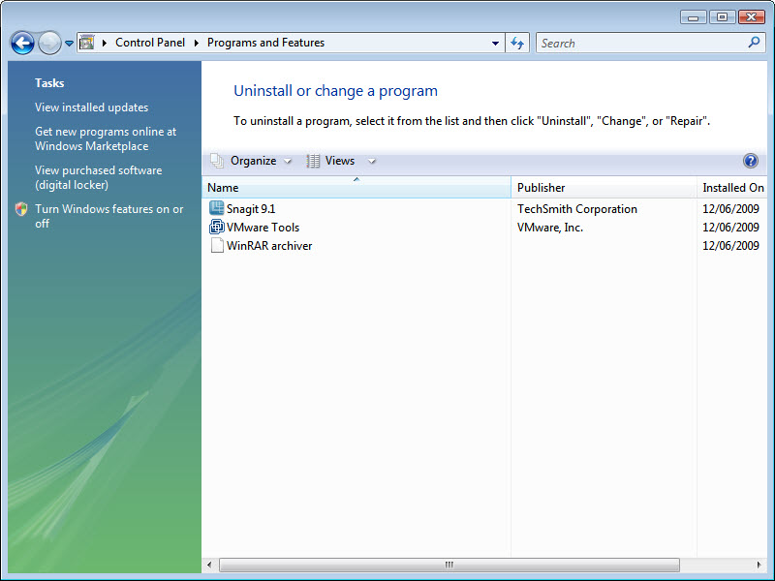

Step 7
The “Windows Features” window appears.

Click the Internet Information Services checkbox.

Click OK.

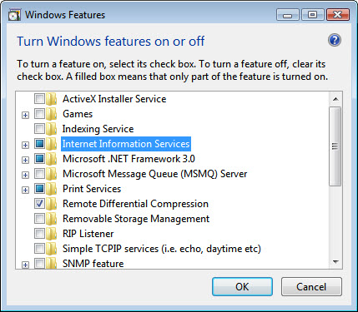

Step 8
The configuring features progress window appears.

The progress windows will close on its own when the configuration is completed.

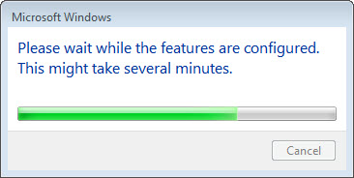

Step 9
When you navigate in a browser to localhost, you will see the new IIS default page.

Click Start > in Start Search type http://localhost.

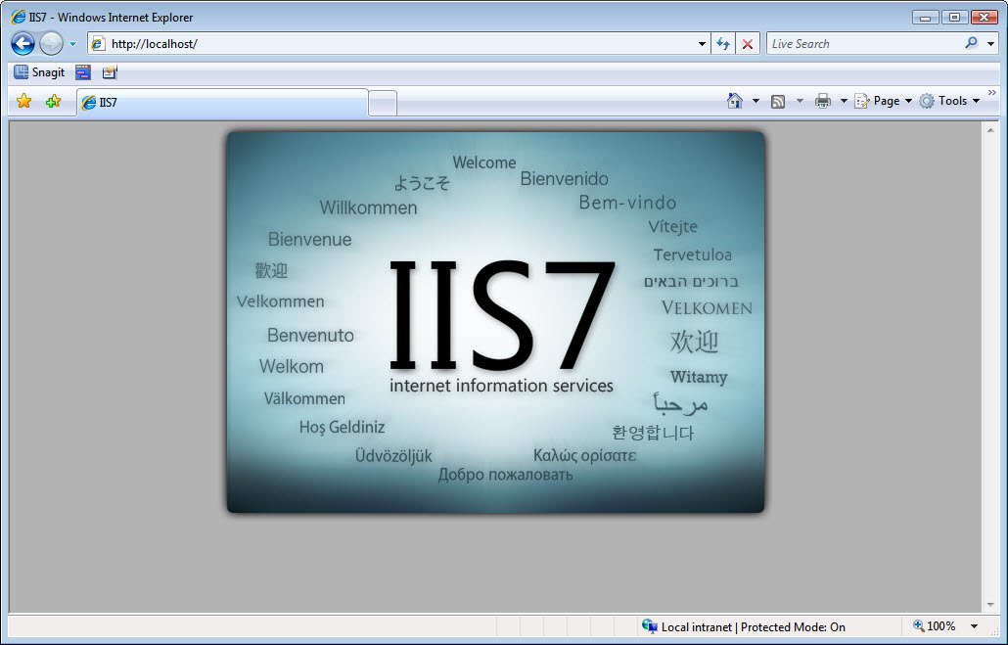

Close the browser.

Step 10
Open the Notepad application by clicking Start > All Programs > Accessories > Notepad.

Type This is a test of the Restore Points in the Notepad application.

Click File > Save As….

Click Documents.

Type Restore Point Test file in the “File Name:” field.

Click Save.

Click File > Exit.

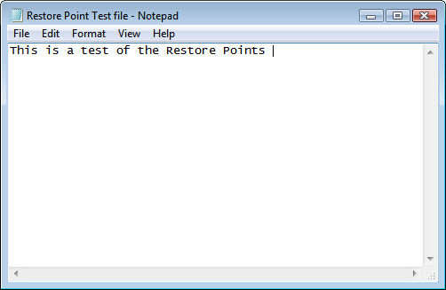

Step 11
Open IIS to confirm that you have successfully installed this service.

Click Start > All Programs > Administrative Tools > IIS Manager.

Click Continue if asked for permission.

Click File > Exit.

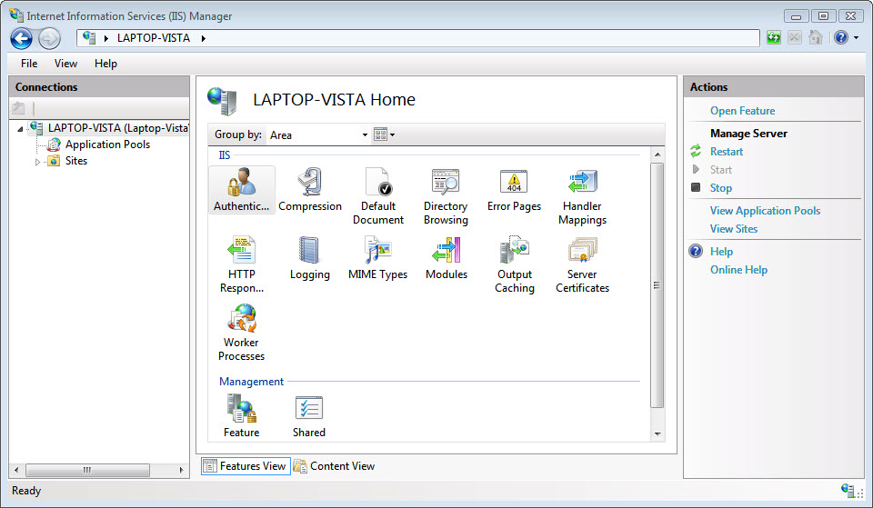

Step 12
Click Start > All Programs > Accessories > System Tools > System Restore.
Click Continue if asked for permission.

Select the Recommended Restore radio button.

Click Next.

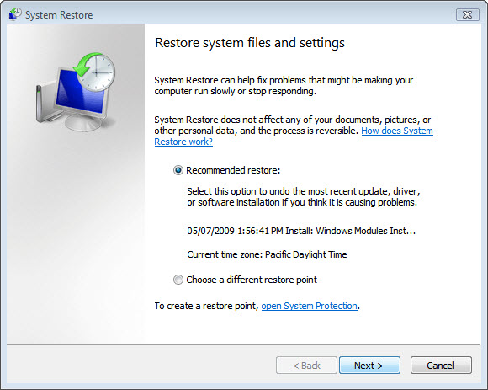

Step 13
The “Confirm your restore point” window appears.

NOTE: When you click Finish, Windows will restart the computer. Close all applications before you click Finish.

Click Finish.

Click Yes to confirm “System Restore”.

The operating system restores to the point before the IIS application was installed. This can take several minutes to complete.

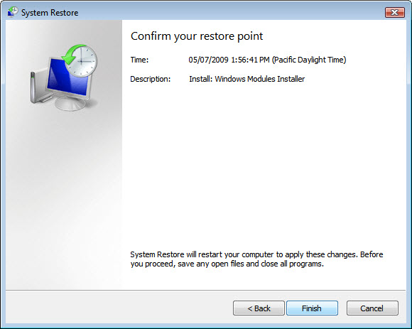

Step 14
The “Restoration Complete” window appears. Click Close.

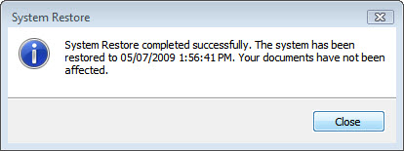

Step 15
Click Start > Control Panel > Administrative Tools.

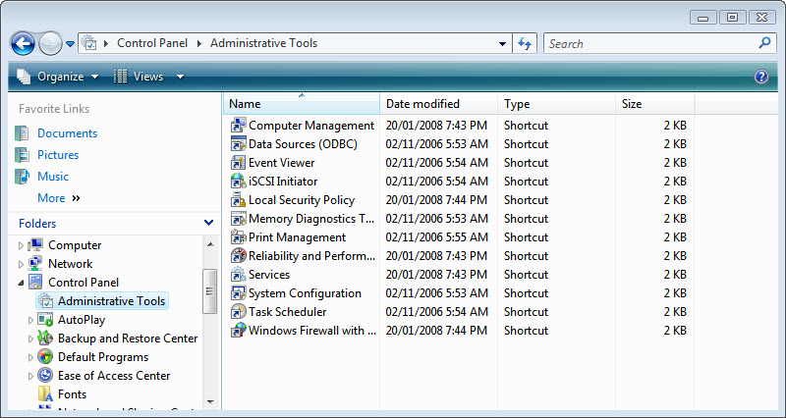

Is the IIS Manager application listed?

Step 16
Navigate to the “Documents” folder.

Open the “Restore Point Test file.txt” file.

Are the contents the same?

