5.6.2 Optional Lab: Restore Points in Windows 7

Introduction

Print and complete this lab.

In this lab, you will create a restore point and return your computer back to that point in time.

Recommended Equipment
The following equipment is required for this exercise:
- A computer system running Windows 7

Step 1
Click Start > Control Panel > System and Security > System > System protection.
To create a restore point, click System protection.

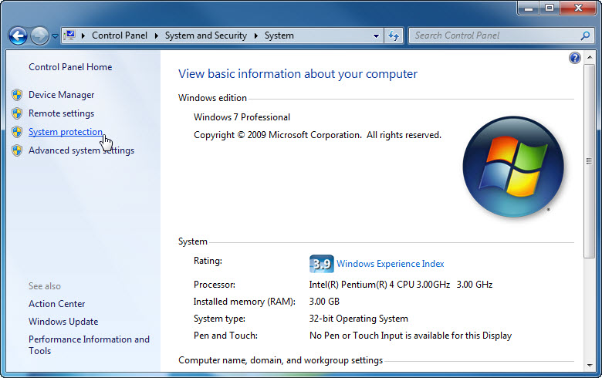

Step 2
The “System Properties” window appears.

In the “System Protection” tab, click Create.

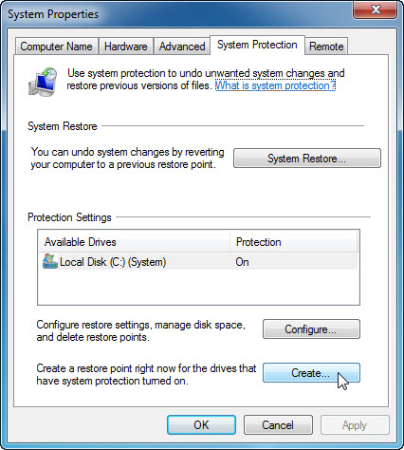

Step 3
In the “Create a restore point” description field, type Application Installed.

Click Create.

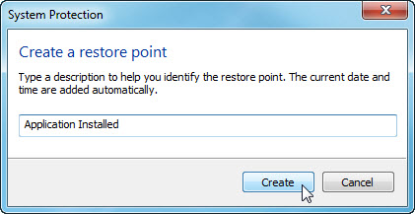

Step 4
The “The restore point was created successfully” message appears.

Click Close.

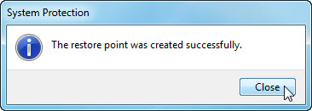

Step 5
The “System Properties” window with the “System Protection” tab selected appears.

Click System Restore.

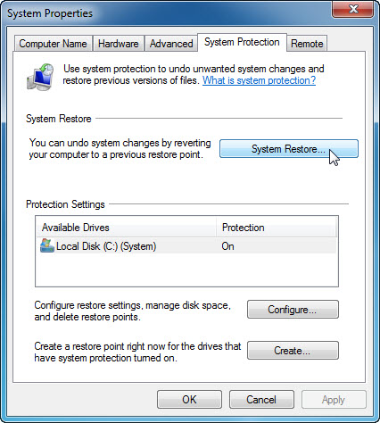

Select the Choose a different restore point radio button and click Next.

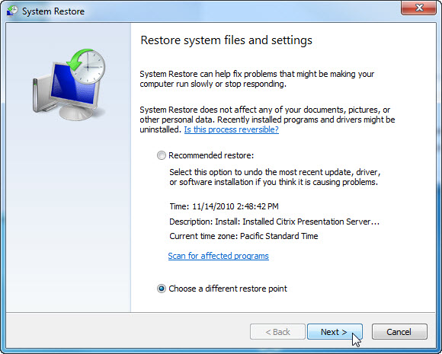

The “Restore your computer to the state it was in before the selected event” screen appears.

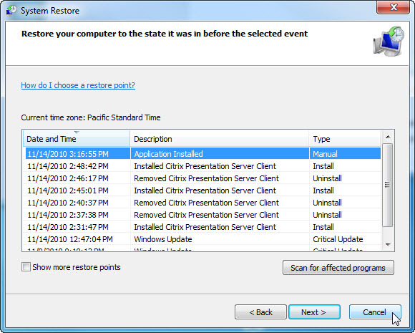

What is the date and time, and type of the most recent restore point?

Click Cancel.

Close all open windows.

Step 6
Click Start > Control Panel > Programs > Turn Windows features on or off link.

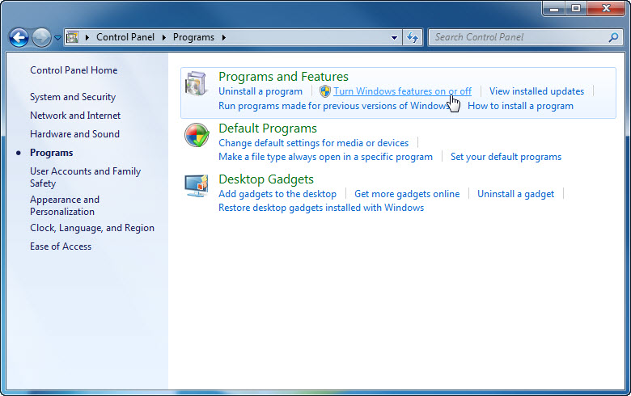

Step 7
The “Windows Features” window appears.

Click the Internet Information Services checkbox.

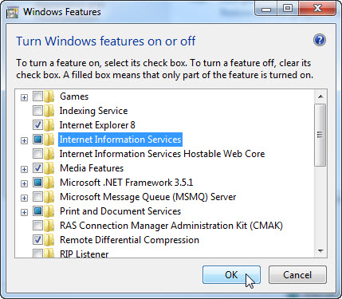

Click OK.

Step 8
The configuring features progress window appears.

The progress window will close on its own when the configuration is completed.



The “You must restart your computer to apply these changes” screen appears, click Restart Now.

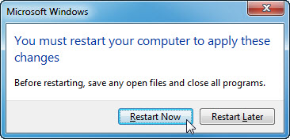

Step 9
Login to the computer once the Windows Features are configured.

When you navigate in a browser to localhost, you will see the new IIS default page.

Click Start > in Search programs and files type http://localhost.

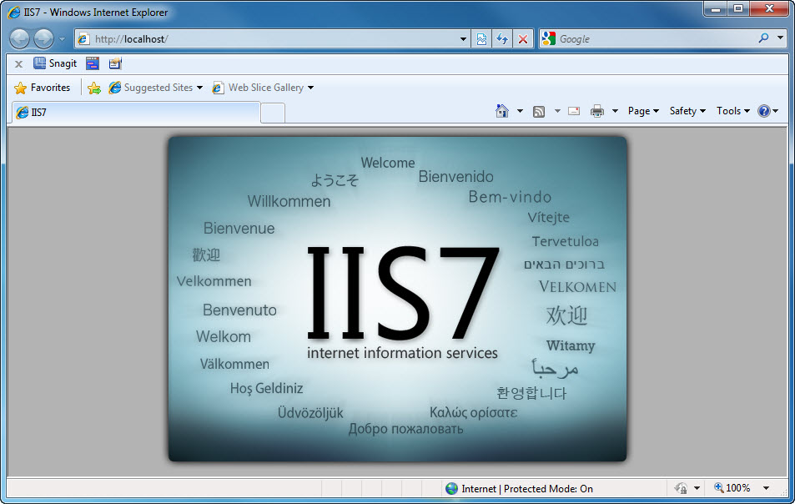

Close the browser.

Step 10
Open the Notepad application by clicking Start > All Programs > Accessories > Notepad.

Type This is a test of the Restore Points in the Notepad application.

Click File > Save As….

Click Documents.

Type Restore Point Test file in the “File Name:” field.

Click Save.

Click File > Exit.

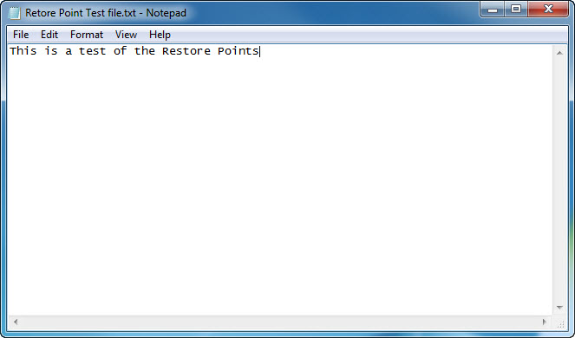

Step 11
Open IIS to confirm that you have successfully installed this service.

Click Start > Control Panel > System and Security > Administrative Tools > Internet Information Services (IIS) Manager.

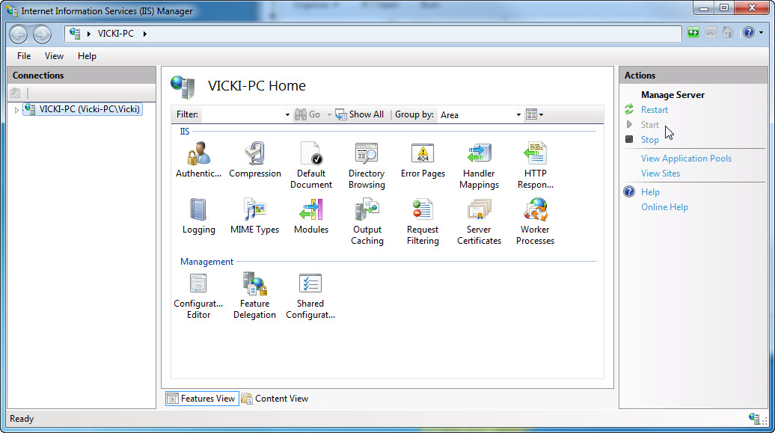

Click File > Exit.

Step 12
Click Start > All Programs > Accessories > System Tools > System Restore.
Select the Choose a different restore point radio button.

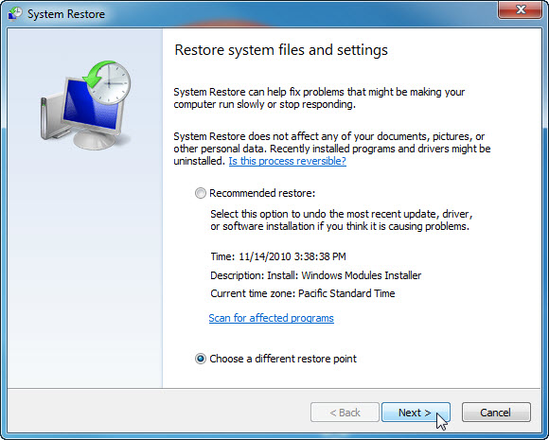

Click Next.

Step 13
The “Restore your computer to the state it was in before the selected event” screen appears.

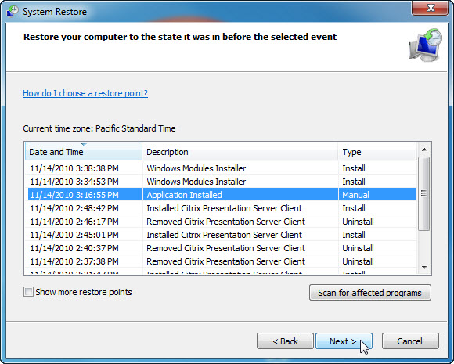

Select the restore date and time that you recorded earlier in this lab. Example: 11/14/2010 3:16:55. Click Next.

Note: When you click Finish, Windows will restart the computer. Close all applications before you click Finish.

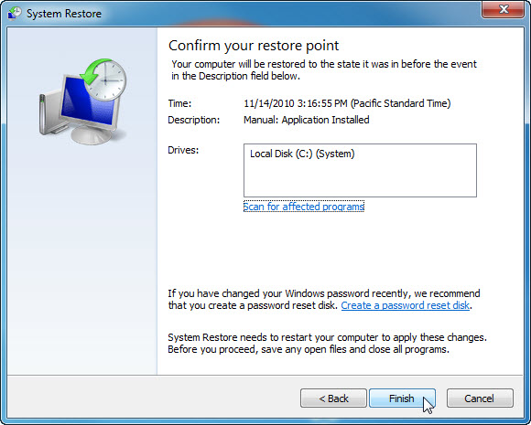

Click Finish.

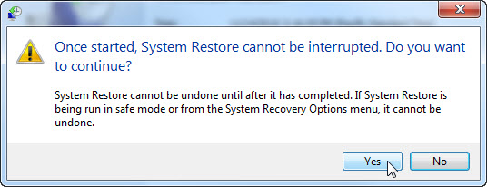

Click Yes to confirm “System Restore”.

The operating system restores to the point before the IIS application was installed. This can take several minutes to complete.

Step 14
The “System Restore completed successfully” window appears. Click Close.

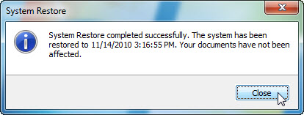

Step 15
Click Start > Control Panel > System and Security > Administrative Tools.

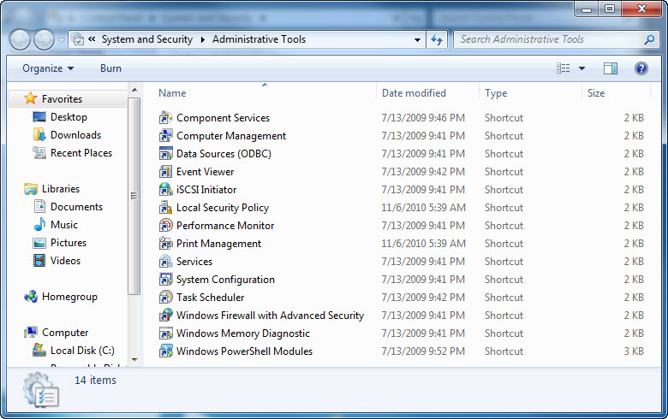

Is the Internet Information Services (IIS) Manager application listed?

Step 16
Navigate to the “Documents” folder.

Open the “Restore Point Test file.txt” file.

Are the contents the same?



