5.5.4 Optional Lab: Install Third-Party Software in Windows Vista

Introduction

Print and complete this lab.

In this lab, you will install and remove a third party software application supplied by your instructor. The student will install the CITRIX ICA 32-bit Windows Web Client application.

Recommended Equipment

The following equipment is required for this exercise:
- A computer system that is using Windows Vista
- A flash drive or CD with CITRIX ICA 32-bit Windows install package

Step 1
Log on to the computer with the Administrator account.

Use Windows Explorer to navigate to the CITRIX folder.
If installing from a CD, place the CD into the CD drive.
Navigate to D: \CITRIX.

If installing from a flash drive, place the flash drive into a USB port.
Navigate to E: \CITRIX.

Locate the Ica32pkg.msi application in the CD or flash drive. Click the Ica32pkg icon to start the installation process of the Citrix application. You may need to double-click the icon to start the installation.

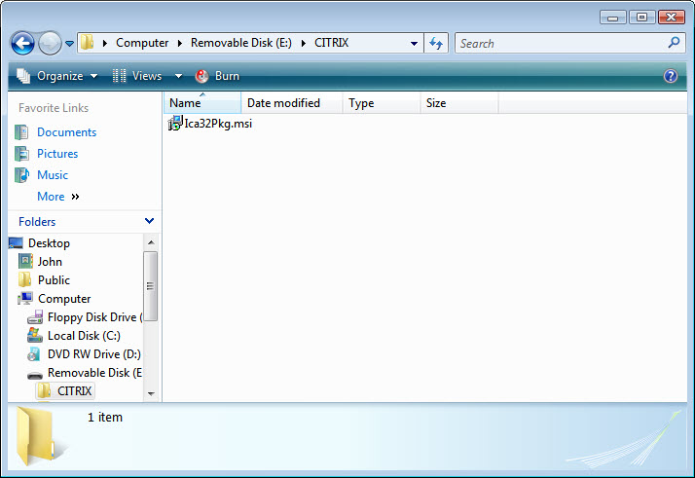

Step 2
When the Select Language window opens, select a language and click OK.

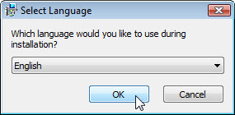

Click Next when the Citrix Presentation Server Client Setup program window opens.

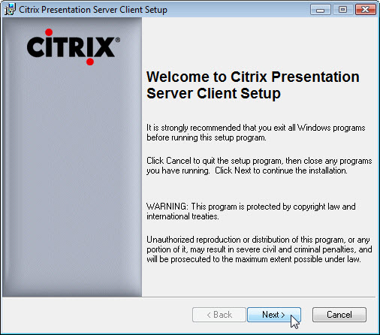

Select “I accept the license agreement”. Click Next.

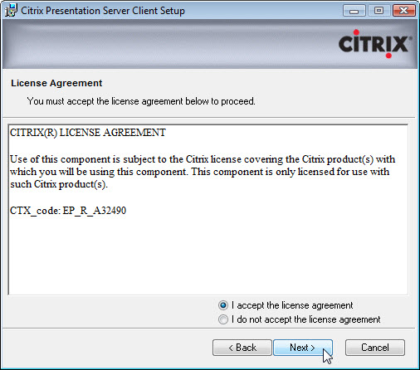

The “Select Client” page appears. Only the Web Client will be installed in this lab.
To stop the other clients from being installed click the hard drive icon next to “Program Neighborhood Agent” and “Program Neighborhood”. Select Entire feature will be unavailable, for both of these.

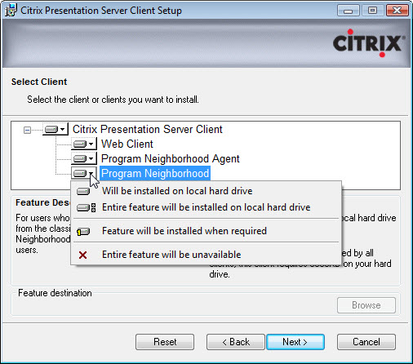

How can you tell if a program will not be installed?

Click Next.

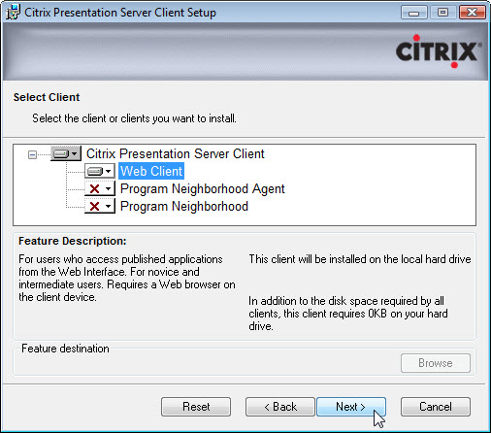

The “Client Name” page appears. Leave the default choice and click Next.

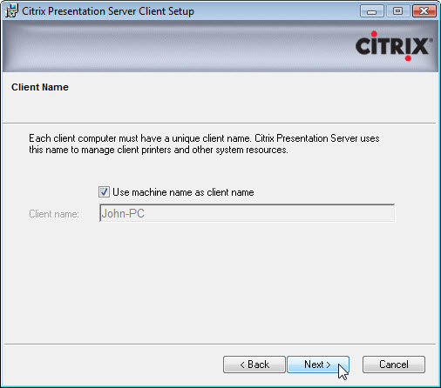

In the “Use Locale Name and Password” page, leave the default choice of No.
Click Next.

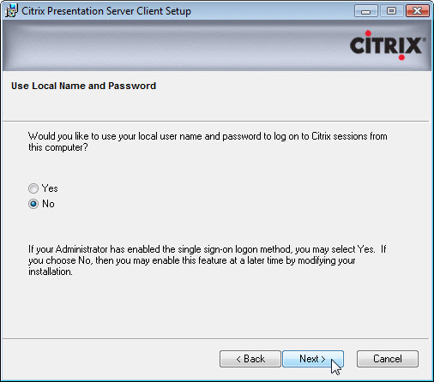

On the “Ready to install” page, click Next to install the application.

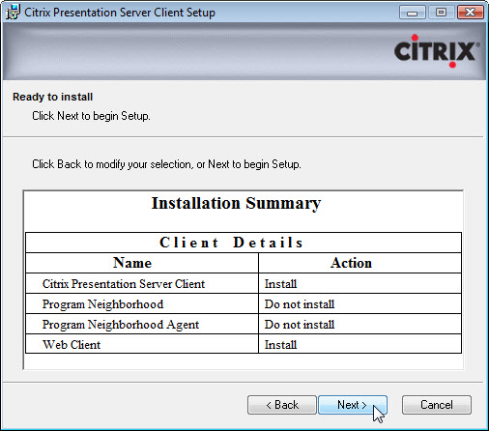

Click Continue if asked for permission.

A window opens displaying the file installation progress.

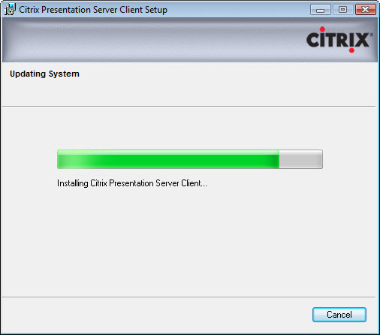

When the “Citrix Presentation Sever Client has been successfully installed” page appears, click Finish.

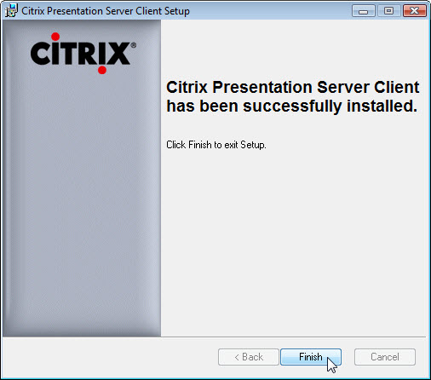

Step 3
To uninstall a program, choose Start > Control Panel > Programs and Features. Click the Citrix Presentation Server Client in the list.

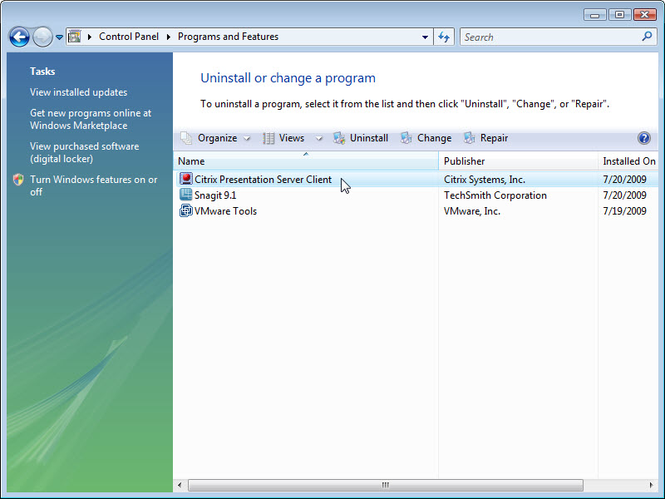

Click Uninstall.

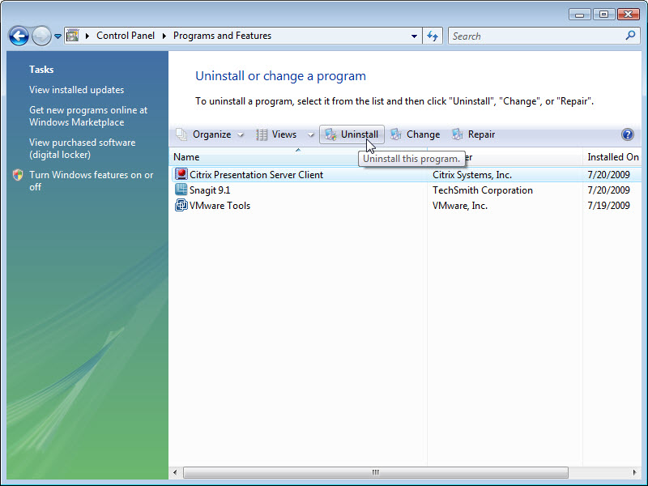
Click Yes to confirm the removal.

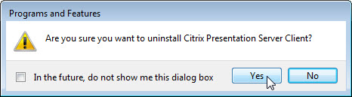

The following screen will appear displaying the removal progress:

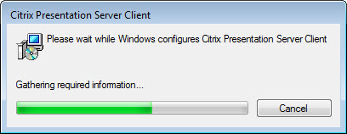

If the “An unidentified program wants access to your computer” appears, click Allow.

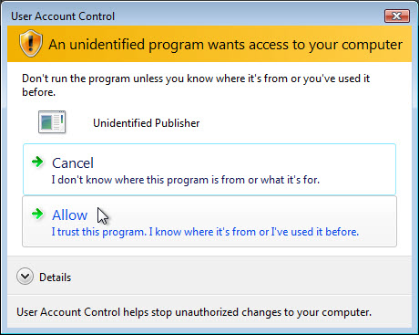
After the application removal process, the Uninstall or change a program window no longer shows the Citrix Presentation Server Client in the list.

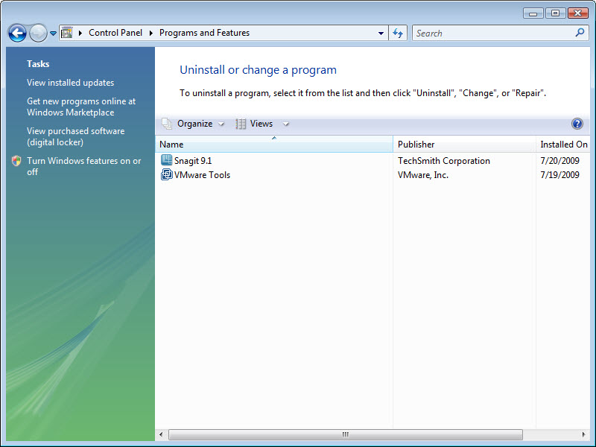

- Why does Microsoft recommend using Uninstall or change a program to remove an installed application?

