5.5.4 Lab: Install Third-Party Software in Windows XP

Introduction

Print and complete this lab.

In this lab, you will install and remove a third party software application by using the Microsoft Windows XP Professional Installation CD. The student will install the CITRIX ICA 32-bit Windows Client application.

Recommended Equipment

The following equipment is required for this exercise:
- A computer system that is using Windows XP
- A Microsoft Windows XP installation CD

Step 1
Log on to the computer with the Administrator account.
Place the Windows XP Professional installation CD into the CD drive. Use Windows Explorer to navigate to the following folder:
D:\VALUEADD\3RDPARTY\MGMT\CITRIX

Locate the ICA32.exe application in the folder. Click the ICA32 icon to start the installation process of the Citrix application. You may need to double-click the icon to start the installation.

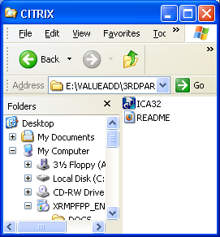

Step 2
Click Next when the InstallShield Wizard window opens.

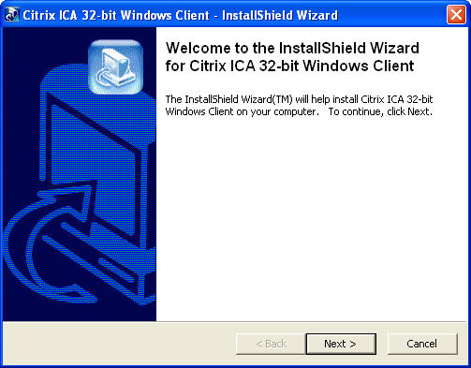

A window opens displaying the file extraction progress.

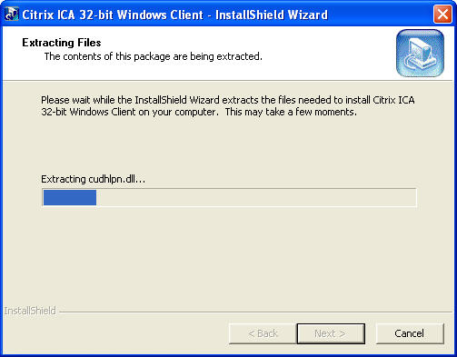

After the files have been extracted, the ICA Client Setup program begins. Click Next to begin the installation.

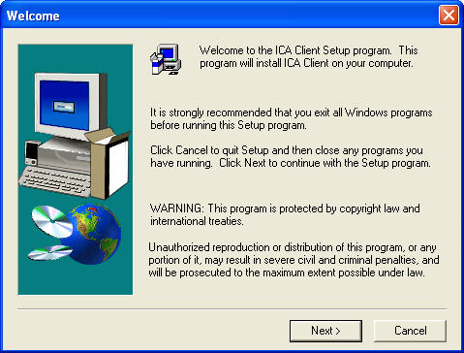

Click Yes on the License agreement.

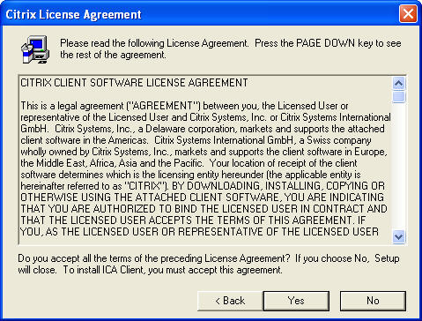
Use the default location. Click Next.

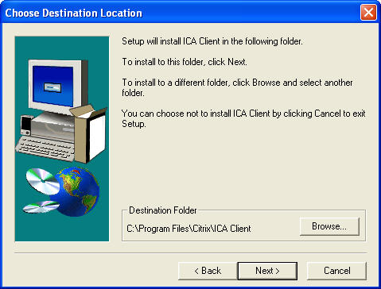

Use the default location. Click Next.

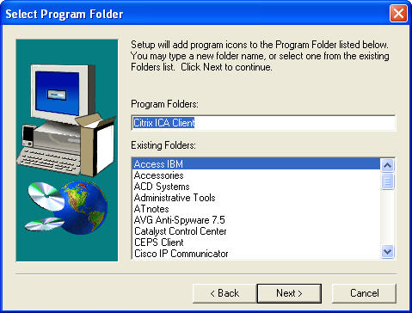
Enter “student” as the ClientName. Click Next.

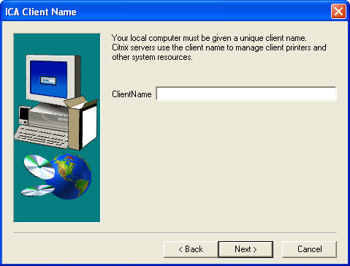

In the Select Desired Features window, leave the default choice of No. Click Next.

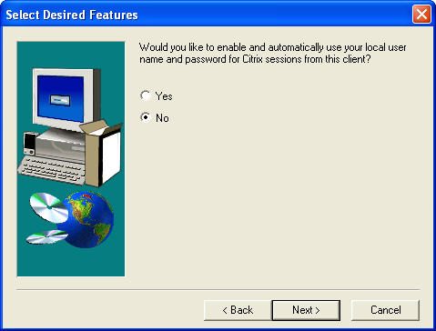
You have successfully installed the Citrix program.

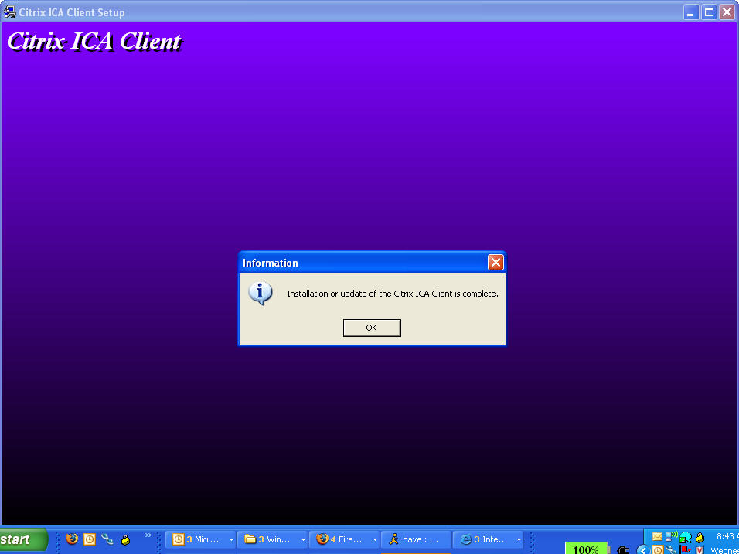

Step 3
To uninstall a program, choose Start > Control Panel > Add or Remove Programs. Click the Citrix ICA Client in the list. Click Change/Remove.

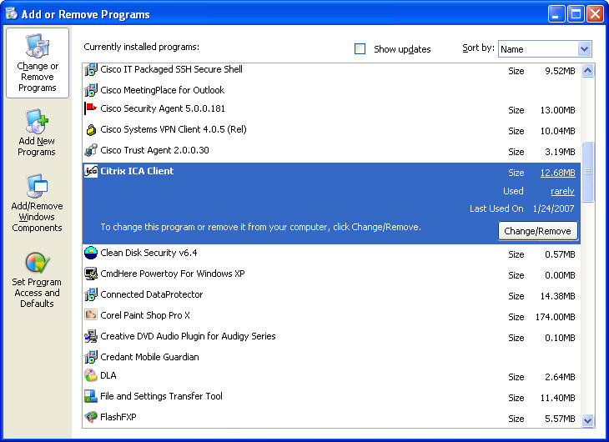
Click Yes to confirm the removal.

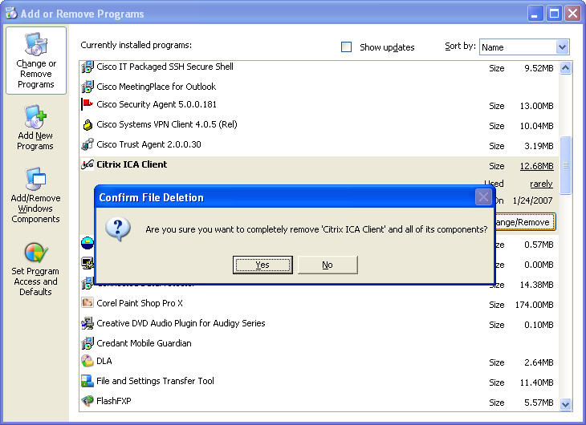

The following screen will appear displaying the removal progress:

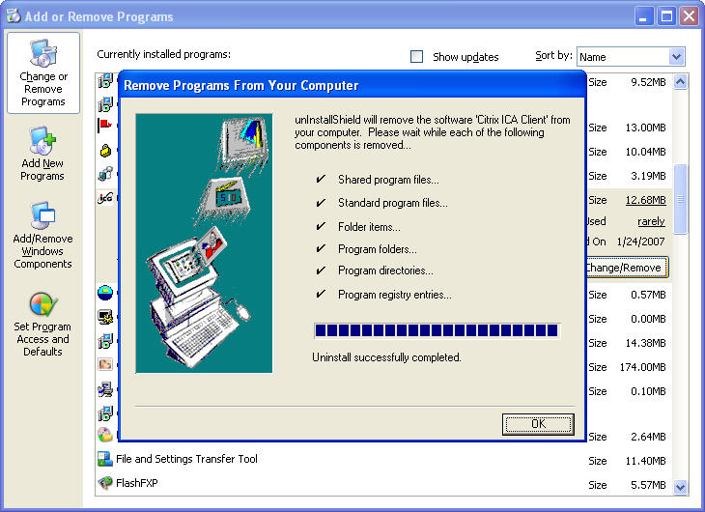
After the application removal process, the Add or Remove Programs window no longer shows the Citrix ICA Client in the list.

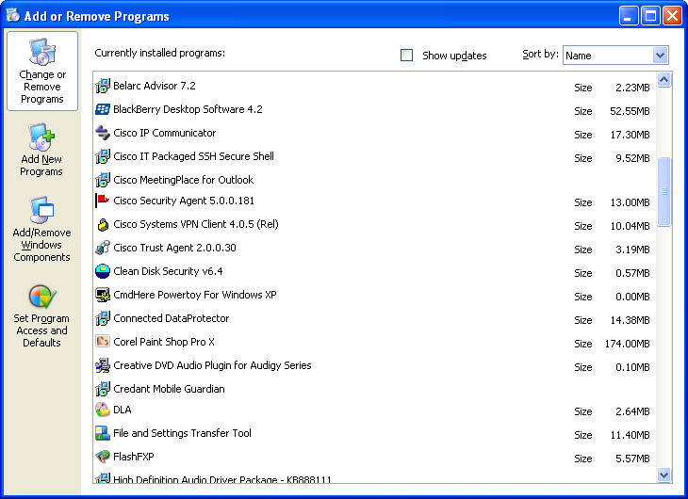

- Why does Microsoft recommend using Add/Remove Programs to remove an installed application?

