5.5.3 Lab: Managing Administrative Setting and Snap-ins in Windows XP

Introduction

Print and complete this lab.

In this lab, you will use administrative tools to monitor system resources. You will also build a custom console to manage storage devices.

Recommended Equipment
The following equipment is required for this exercise:
• A computer running Windows XP Professional
• Internet access

Step 1
Log on to the computer as an administrator.

Navigate to the “Control Panel” window by clicking Start > Control Panel. Double-click the Network Connections icon.

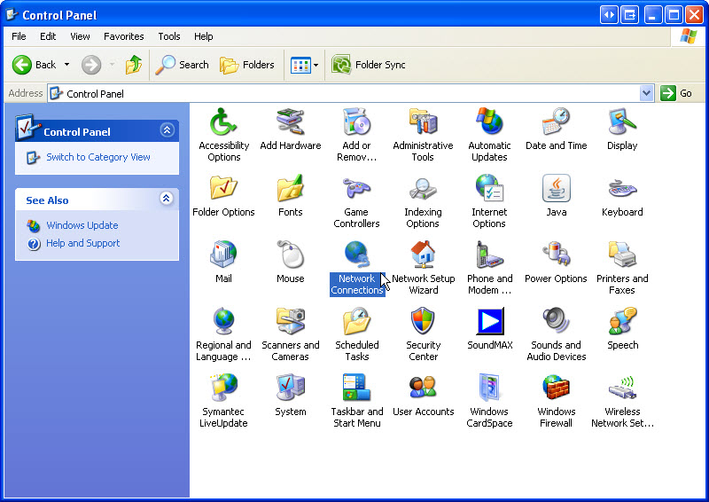

Reduce the size of the “Network Connections” window. Leave this window open.

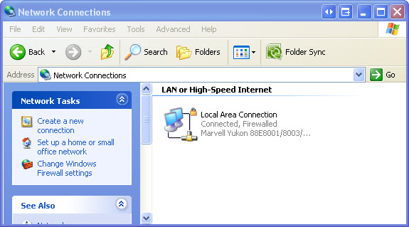

Step 2
Once again navigate to the “Control Panel” window by clicking Start > Control Panel. Double-click the Administrative Tools icon.

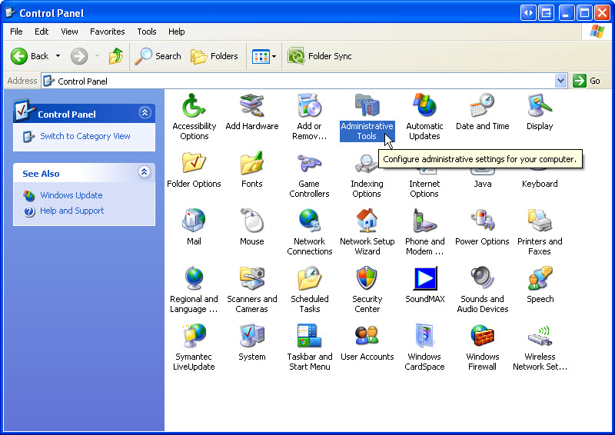

Double-click the Performance icon.

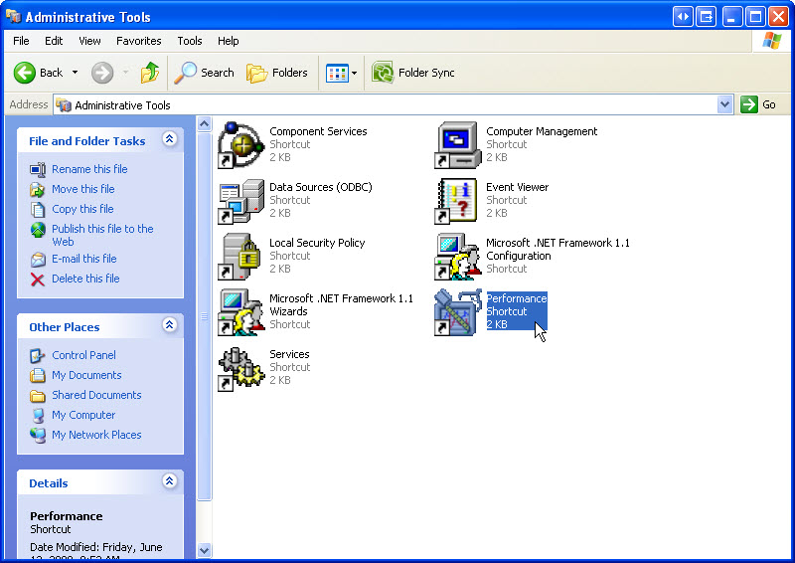

Step 3
The “Performance” window appears. Make sure the System Monitor in the left pane is highlighted. Click the Freeze Display icon to stop the recording.

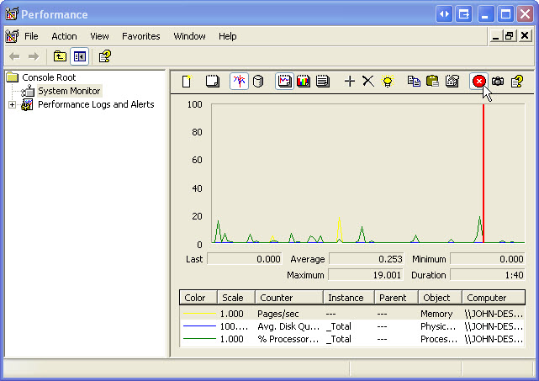

Click the Clear Display icon to clear the graph. Leave this window open.

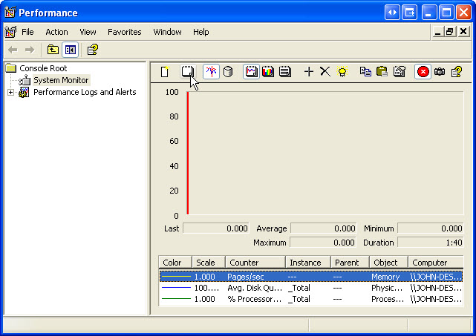

Step 4
Navigate to the “Administrative Tools” window by clicking Start > Control Panel > Administrative Tools. Double-click the Services icon.

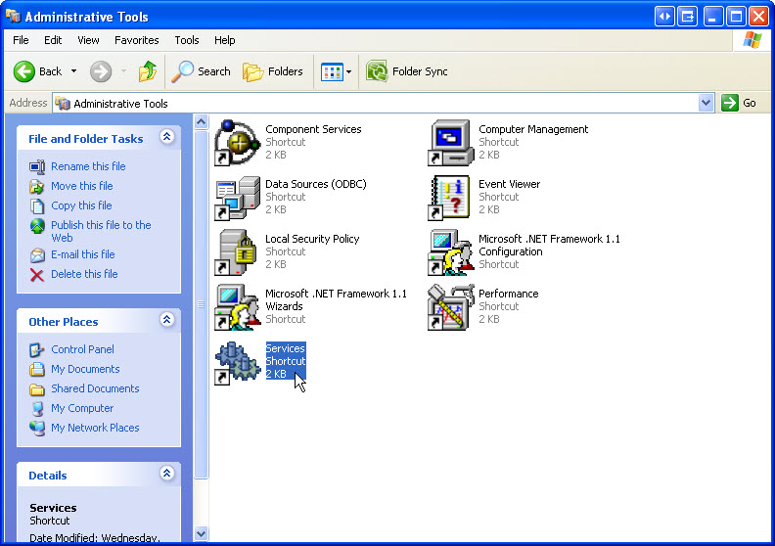

Step 5
Expand the width of the “Services” window so you have a clear view of the content. Scroll down in the right pane until you see the service Routing and Remote Access. Double click Routing and Remote Access.

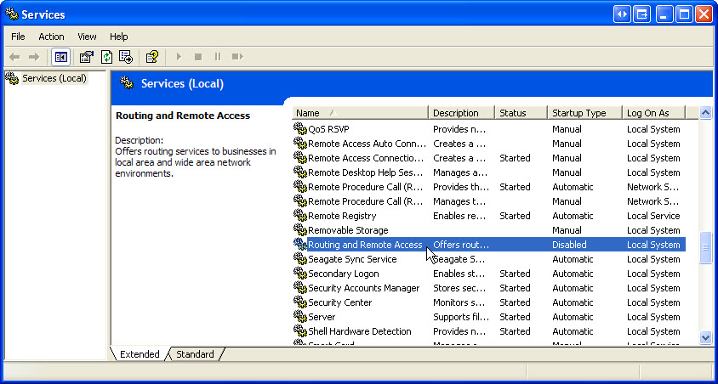

The “Routing and Remote Access Properties (Local Computer)” windows appears. In the Startup type select Manual. Click Apply.

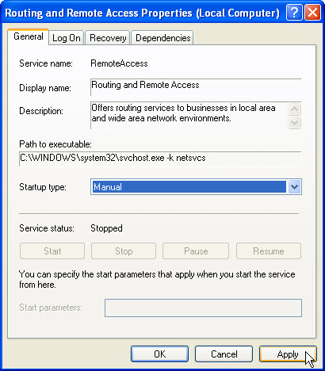

The Start button is now active; do not click the button yet. Leave this window open.

Step 6
Position the following three windows so you can clearly see them at the same time for steps 7 to 14: Network Connections, Routing and Remote Access Properties (Local Computer), and Performance.

Step 7
Click the “Performance” window so it is activated. Click the Freeze Display icon to start the recording.

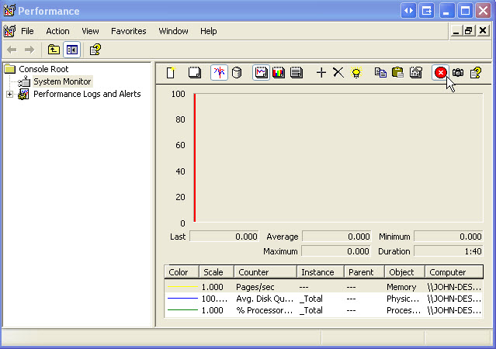

Step 8
Click the “Routing and Remote Access Properties (Local Computer)” window so it is activated. To start the Service click Start.

A window with a progress bar appears.

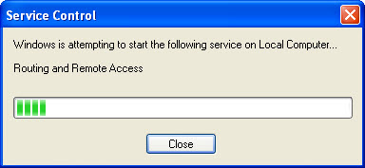

The “Routing and Remote Access Properties (Local Computer)” window now shows the Stop and Pause button active. Leave this window open.

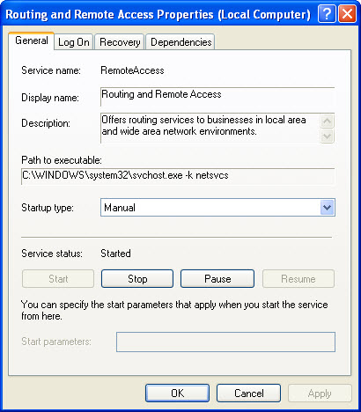

Step 9
Click the “Network Connections” window so it is activated.

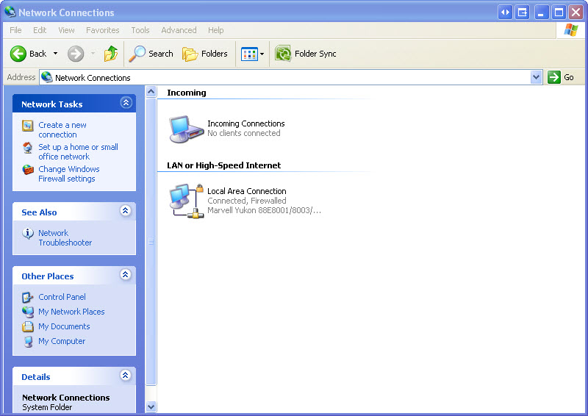

- What changes appear in the right pane, after starting the Routing and Remote Access service?

Step 10
Click the “Routing and Remote Access Properties (Local Computer)” window so it is activated. Click Stop.

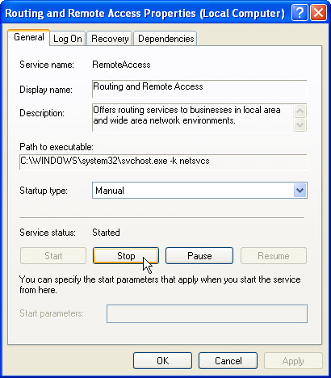

Step 11
Click the “Network Connections” window so it is activated.

- What changes appear in the right pane, after stopping the Routing and Remote Access service?

Step 12
Click the “Performance” window so it is activated. Click the Freeze Display icon to stop the recording.

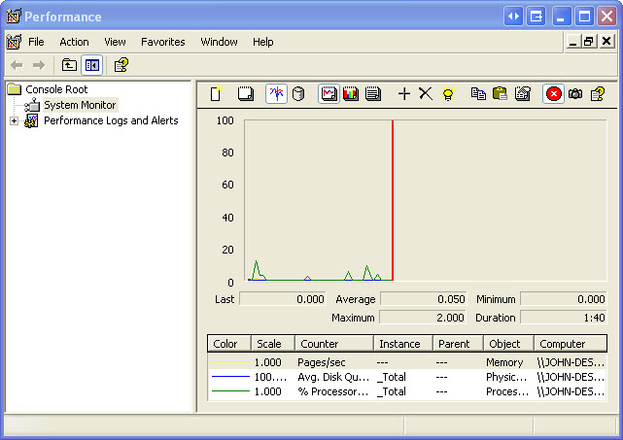

- Which Counter is being recorded the most in the graph (hint: look at the graph color and Counter color)?

Click the View Report icon.

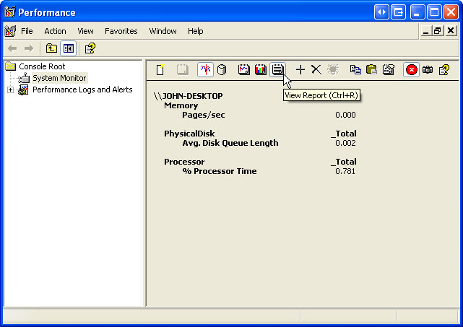

- List the values of the three counters.

Step 13
Click the “Routing and Remote Access Properties (Local Computer)” window so it is activated. In the Startup type select Disabled. Click OK.

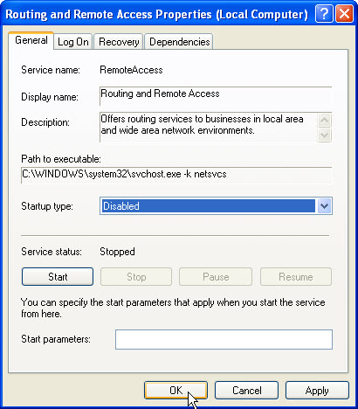

Click the “Service” window so it is activated.

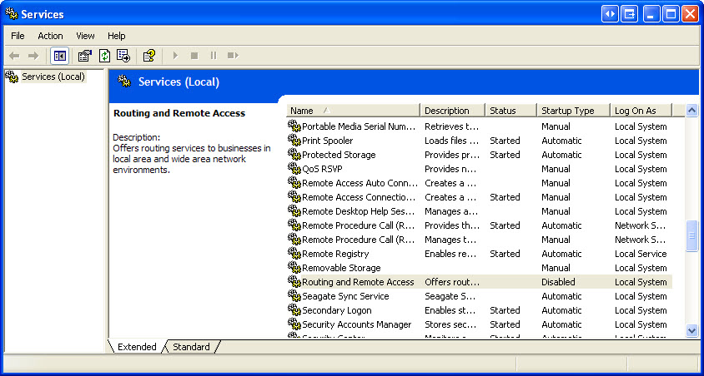

- What is the Status and Startup Type for Routing and Remote Access?

Step 14
Click the “Performance” window so it is activated. Click the Freeze Display icon to start the recording.

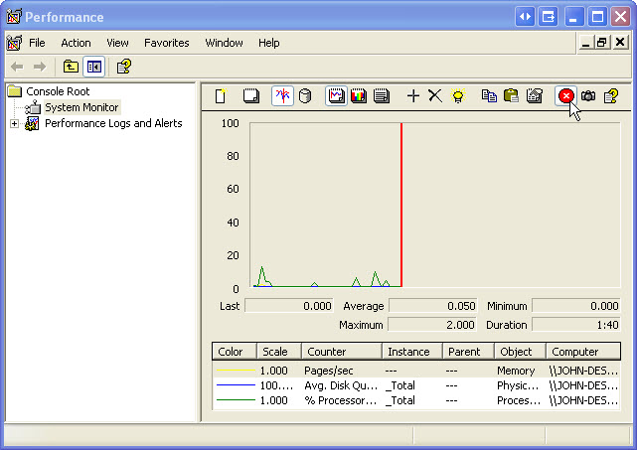

Step 15
Close all open windows.

Step 16
Navigate to the “Control Panel” window by clicking Start > Control Panel. Double-click the Computer Management icon.

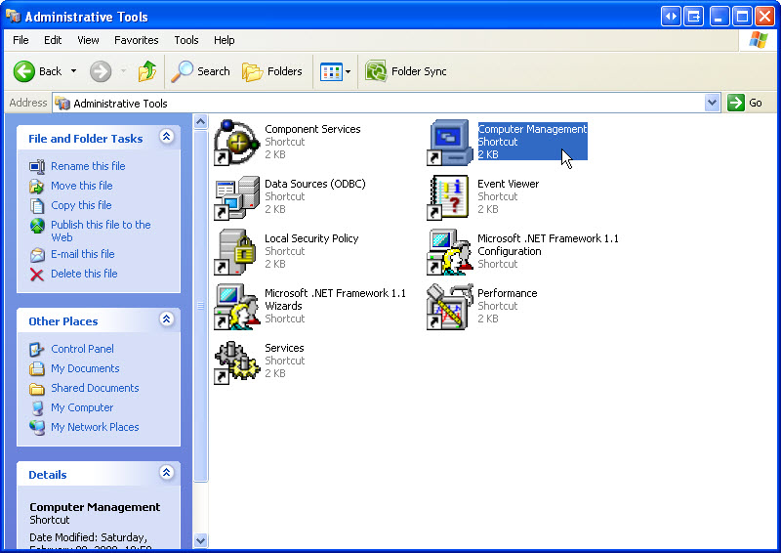

Step 17
The “Computer Management” window appears. Expand the three categories by clicking on the plus sign next to: System Tools, Storage and Services, and Applications.

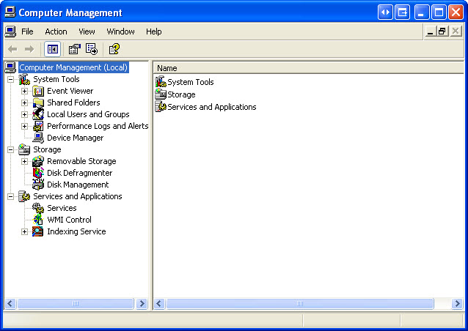

Step 18
Click the plus sign next to Event Viewer. Then click on System.

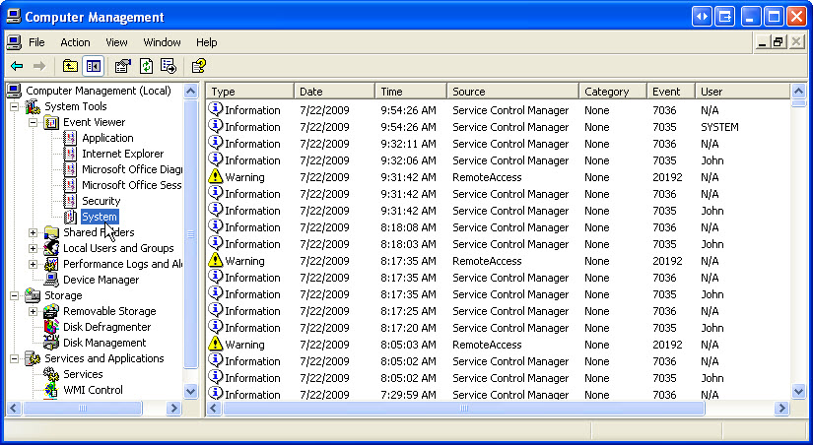

Double click the first event in the window.

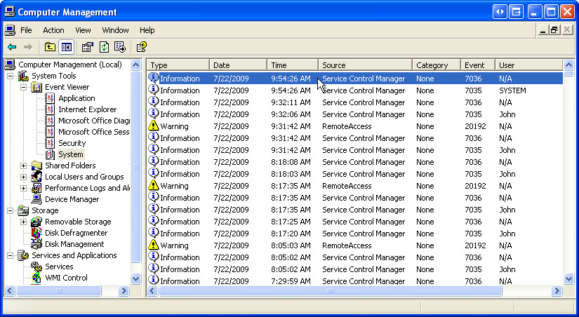

The “Event Properties” window appears for the event. Click the down arrow key to locate an event for Routing and Remote Access.

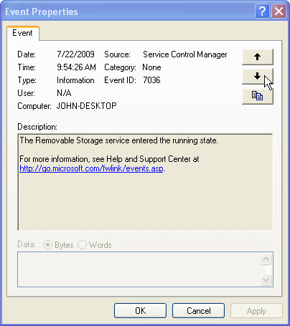

Step 19
You should find four events that describe the order for starting and stopping the Routing and Remote access service.
Write down the description for each of the four events. Do not include any URL information.

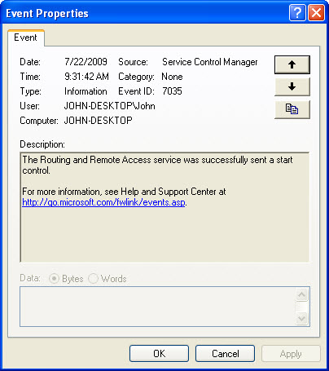

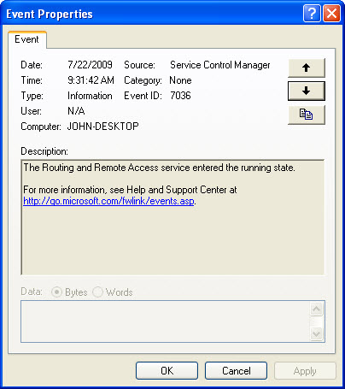

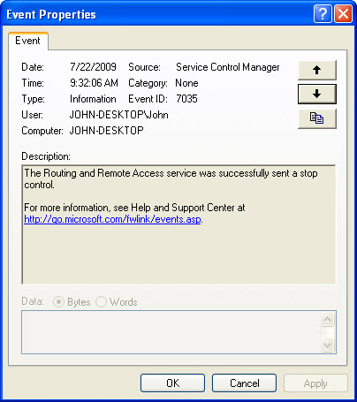

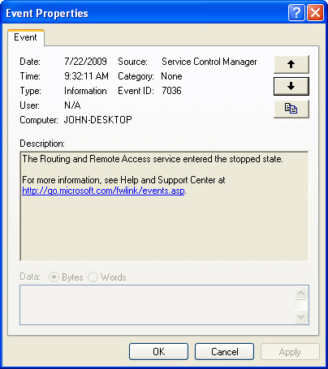

Step 20
Close all open windows.

Step 21
Navigate to the “Run” window by clicking Start > Run. Type MMC and click OK.

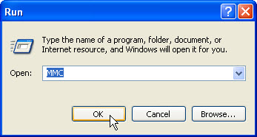

Step 22
The “Console1” (console number may vary) window and the Console Root window appear.

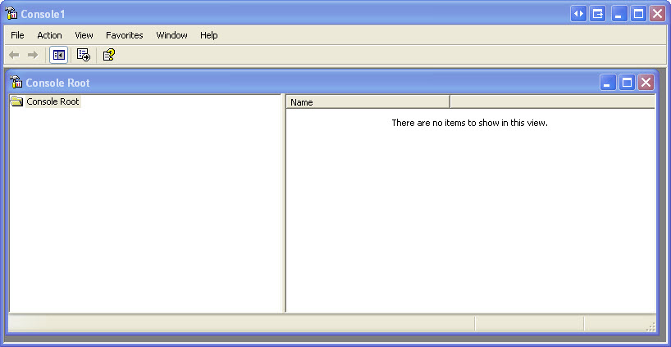

Step 23
To build your own custom console click File > Add/Remove Snap-in. The “Add/Remove Snap-in” window appears.

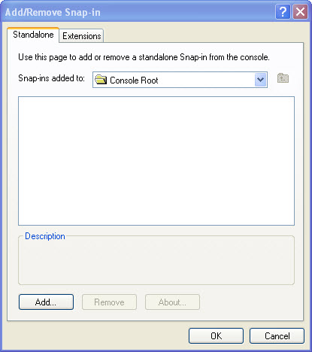

To add a snap-in click Add.

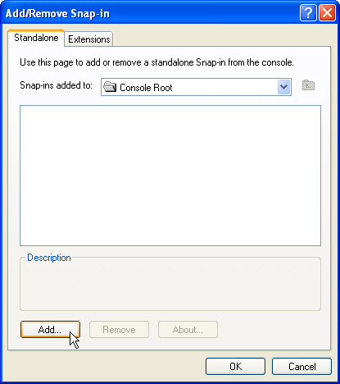

The “Add Standalone Snap-in” window appears. To add a folder snap-in so that you can organize all your snap-ins, scroll down until you see the Folder snap-in. Select Folder > click Add.

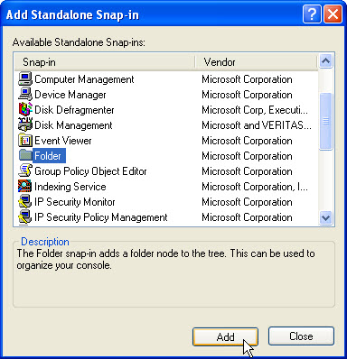

To add the “Link to Web Address” snap-in, scroll down until you see the snap-in. Select Link to Web Address > click Add. The “Link to Web Address” wizard opens. In the Target box type http://www.cisco.com/. Click Next.

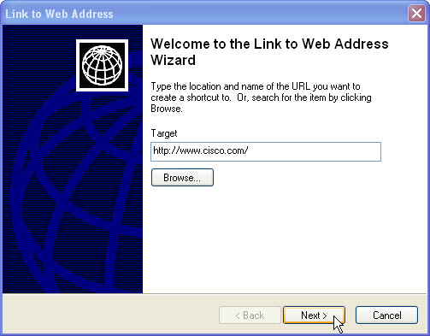

In the “Select a name for the URL reference” box type Cisco. Click Finish.

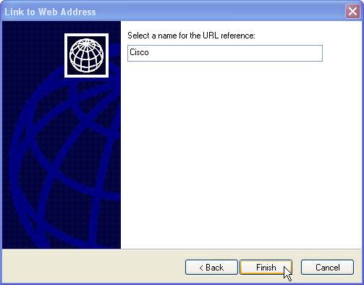

To close the “Add Standalone Snap-in” window, click Close.

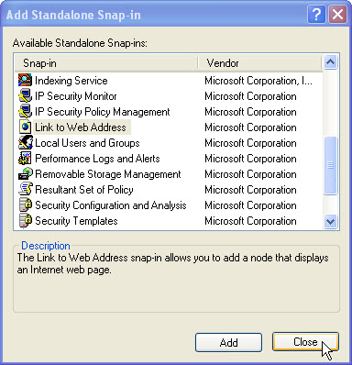

Step 24
Click the “Add/Remove Snap-in” window so it is activated. In the “Snap-ins added to” box select Folder. Click Add.

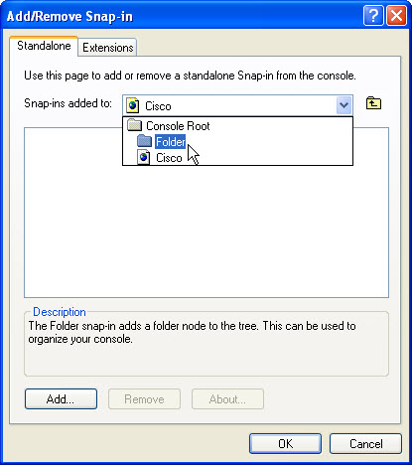

Add these snap-ins: Disk Defragmenter, Disk Management, and Removable Storage Management.

Note: When asked what computer the snap-in will manage; select the default by clicking Finish.

To close the “Add Standalone Snap-in” window, click Close.

Click the “Add/Remove Snap-in” window so it is activated. Click OK.

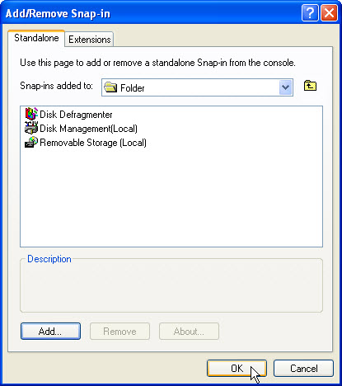

Step 25
The “Console1” window appears. Right click the Folder icon and select Rename. Change the name of the folder to Storage Tools.

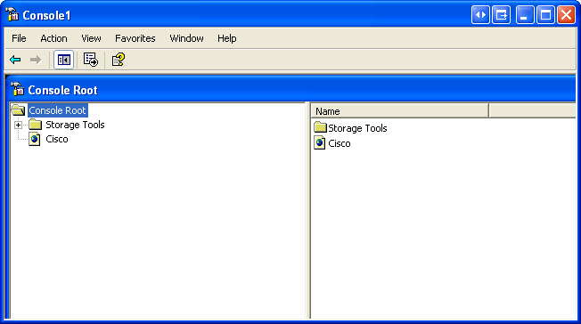

To save the custom console click File > Save As. Change the file name to your name. Example: John’s Console. Change the “Save in” box to Desktop. Click Save.

Step 26
Close all open windows.

On the desktop double click the Console icon to re-open the console with your snap-ins.

