5.5.1 Optional Lab: Run Commands in Windows Vista

Introduction

Print and complete this lab.

In this lab, you will open the same program by using the Windows Explorer and the “Run…” command.

Recommended Equipment
The following equipment is required for this exercise:
- A computer system running Windows Vista Business

Step 1
Boot the computer and log on as yourself.

Right-click the Start button and then click Explore.

Navigate to the Local Disk (C:) hard drive disk

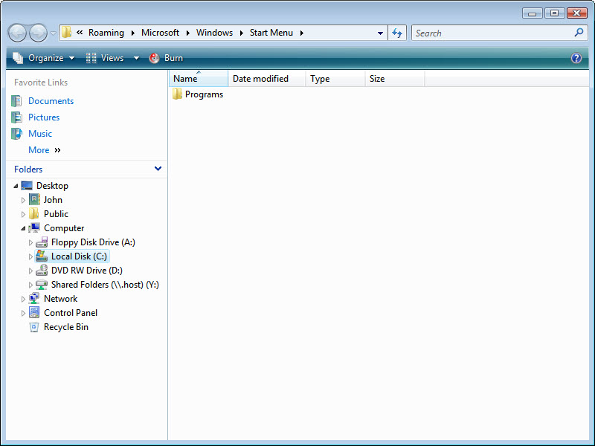

Step 2
Right-click the Local Disk(C:) hard disk drive.

Click Properties and then click the Disk Cleanup button.

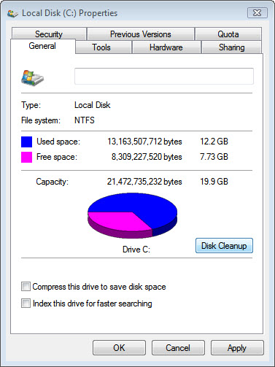

The Disk Cleanup Options window appears.

Click My files only.

Note: Clicking Files from all users on this computer will display the User Account Control window to ask for permission.

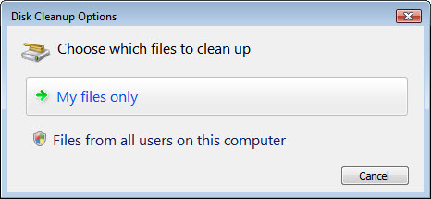

The Disk Cleanup for (C:) window appears.

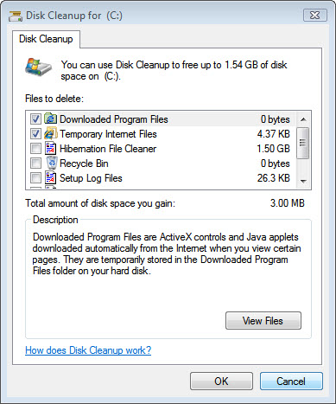

Windows calculates the amount of space used by unnecessary files.

Click Cancel.

Step 3
Open the Run dialog box by clicking Start > in the Start Search box, type Run….

Type cleanmgr in the “Open:” field.

Click OK.

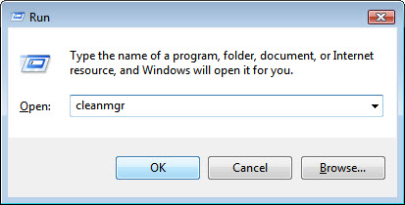

The Disk Cleanup Options window appears.

Click My files only.

Note: Clicking Files from all users on this computer will display the User Account Control window to ask for permission.

The “Disk Cleanup for (C:)” window opens.

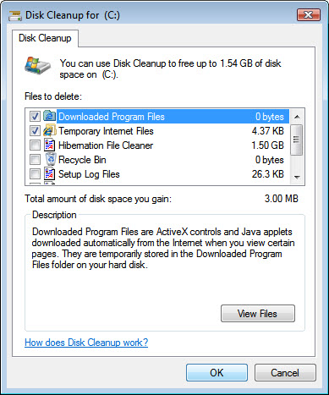

Step 4
Click the OK button.

- Why should disk cleanup be performed regularly?

