5.5.1 Optional Lab: Run Commands in Windows 7

Introduction

Print and complete this lab.

In this lab, you will open the same program by using the Windows Explorer and the “Run…” command.

Recommended Equipment
The following equipment is required for this exercise:
- A computer system running Windows 7

Step 1
Boot the computer and log on as yourself.

Right-click the Start button and then click Open Windows Explorer.

Navigate to the Local Disk (C:) hard drive.

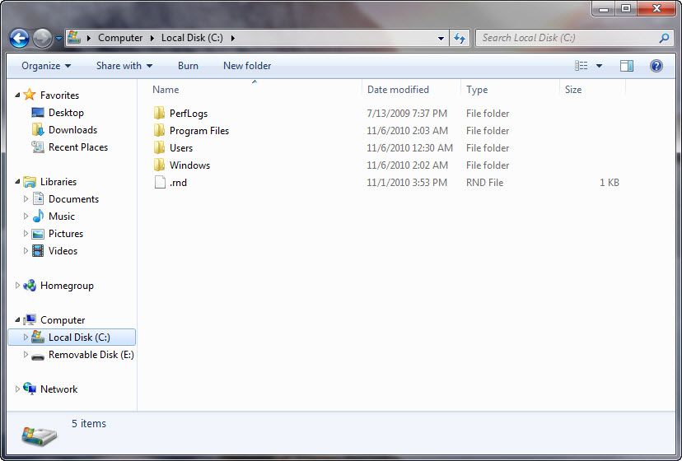

Step 2
Right-click the Local Disk(C:) hard drive.

Click Properties and then click the Disk Cleanup button.

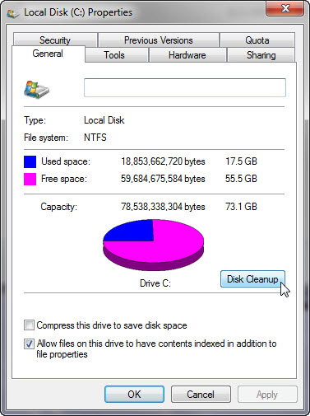

The Disk Cleanup window appears and calculates available free space.

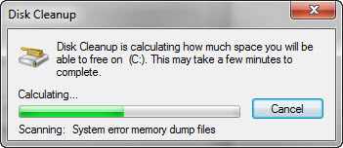

The Disk Cleanup for (C:) window appears.

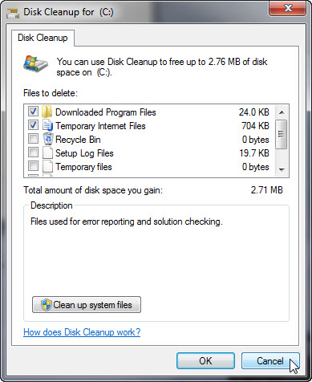

Windows calculates the amount of space used by unnecessary files.

Click Cancel.

Step 3
Open the Run dialog box by clicking Start, and in the Search programs and files box, type Run and press Enter.

Type cleanmgr in the “Open:” field.

Click OK.

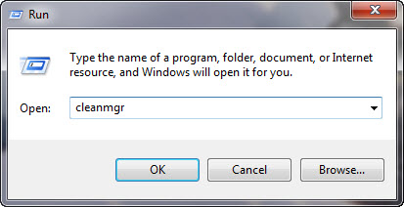

The Disk Cleanup window appears and calculates available free space.

The “Disk Cleanup for (C:)” window opens.

Step 4
Click the OK button.

- Why should disk cleanup be performed regularly?

