5.4.8 Lab: Managing System Files with Built-in Utilities in Windows XP

Introduction

Print and complete this lab.

In this lab, you will use Windows built-in utilities to gather information about the system and to troubleshoot system resources. You will also learn how to export and import registry setting.

Recommended Equipment
The following equipment is required for this exercise:
• A computer running Windows XP Professional

Step 1
Log on to the computer as an administrator.

Open the command prompt by clicking Start > Run > type cmd > click OK.

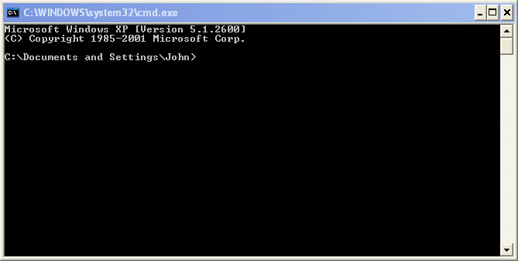

What is the drive path shown? Answers may vary.

Type help and press Enter.

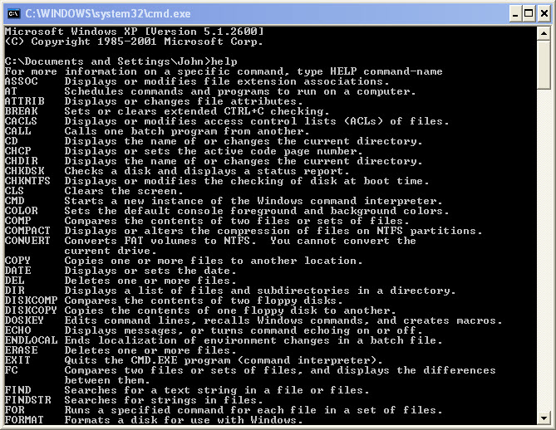

What is the command to change directory?

What is the command to display the contnets in a directory?

Type cd .. and press Enter.

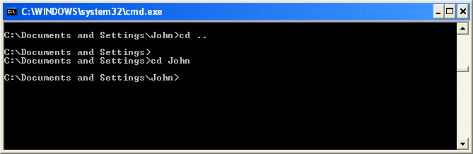

What is the drive path shown? Answers may vary.

Change back to original drive path.
Example: Type cd John and press Enter.

What is the drive path shown? Answers may vary.

Type dir /? and press Enter.
If asked, Press any key to continue.

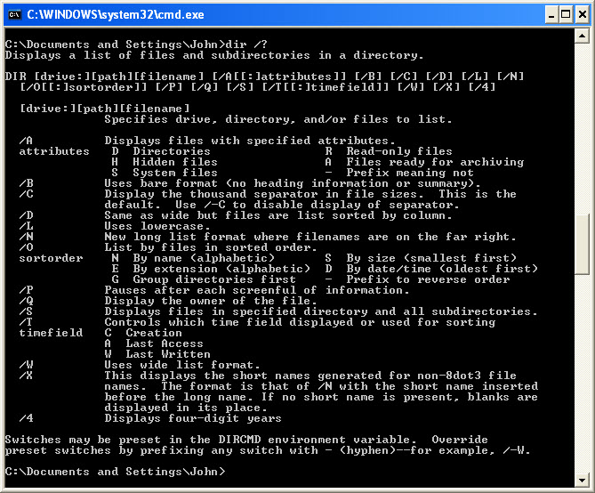

Which switch displays a wide list format?

Type dir and press Enter.
Type dir /w and press Enter.

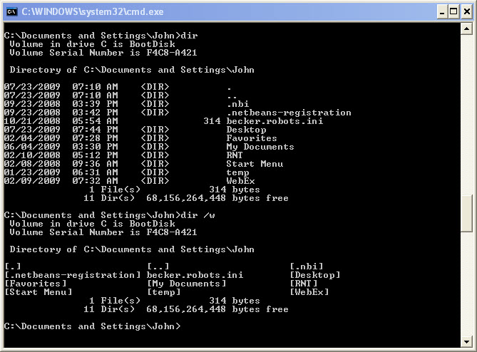

What is the difference between these two commands?

Type VOL.
What volume is drive C in? Answers may vary.

Close the Command prompt window.

Step 2
Open System Information by clicking Start > Run > type msinfo32 > click OK.

Click the plus sign next to Hardware Resources, Components, and Software Environment. Expand the window so you can see all the content.

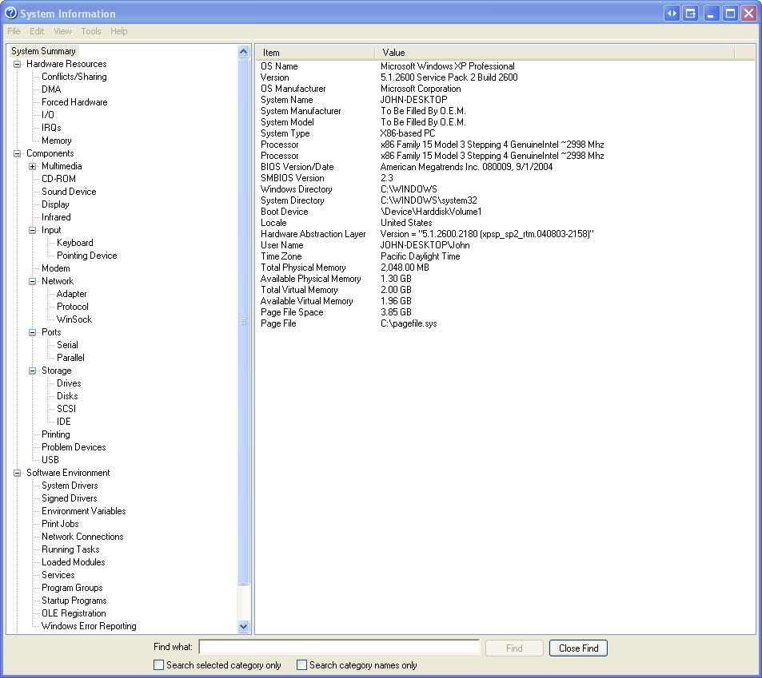

Under the System Summary heading locate and list the following:
Processor
BIOS Version/Date
Total Physical Memory

Under the Hardware Resources heading locate and list the following:

DMA channels and the device using the resources.

I/O address range for these devices.
Printer Port (LPT1)
Communications Port (COM1)
Communications Port (COM2)

IRQ address for these devices.
System timer
Communications Port (COM1)
Communications Port (COM2)

Under the Components heading and Software heading look around to see what information is provided in these areas.

Close the System Information window.

Step 3
Open System Configuration Utility by clicking Start > Run > type msconfig > click OK.
Note: It is very important that you do not make any changes in this utility without instructor permission.

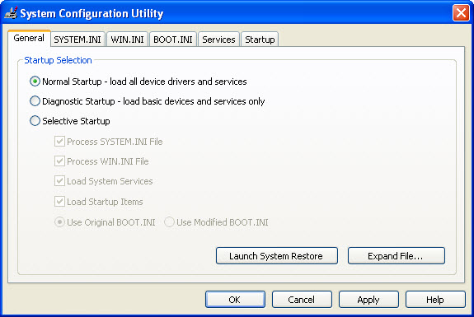

Click the General tab if not all ready active.
What are the startup options?

Click the SYSTEM.INI, WIN.INI and BOOT.INI tabs. These tab are for modifying these files.

Click the Service tab. This tab lists the computers services and there status.

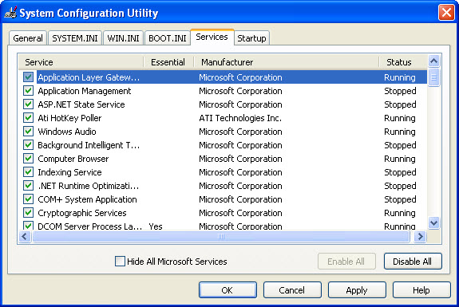

Can you enable and disable services at this tab?

Click the Startup tab. This tab lists the programs that are automatically loaded every time you turn on your computer.

Click Cancel to close the System Configuration Utility window.

Step 4
Open DirectX Diagnostic Tool by clicking Start > Run > type dxdiag > click OK.
If you are asked to have DirectX check driver signatures click No.

Note: When DirectX Diagnostic Tool first opens it may take a minute to load all information. Your DirectX Diagnostic Tool may not appear exactly as shown in this lab.

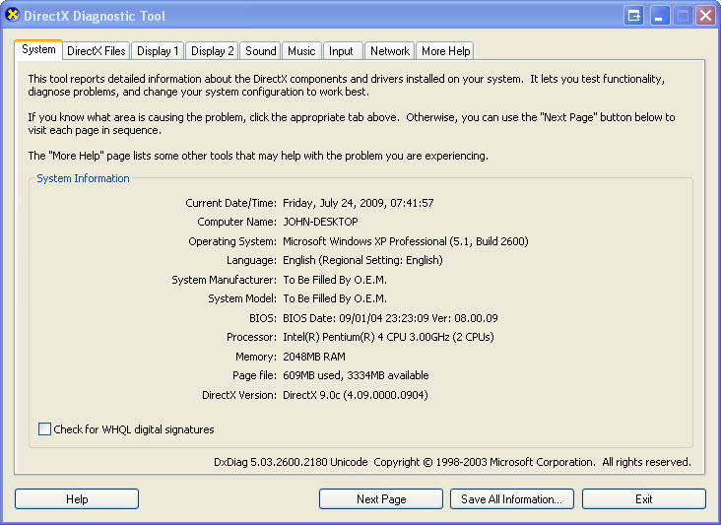

Make sure the System tab is active.
What does this tool report?

Click Next Page until you are at the DirectX Files tab.
A list of DirectX files is listed.

Click Next Page until you are at the Display tab.
Click Test DirectDraw.

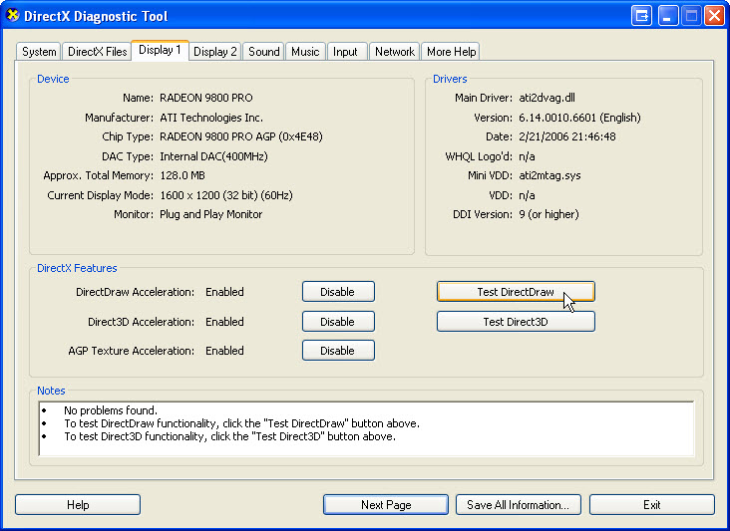

Follow the rest of the instruction as the test progresses.
Place a check mark next to ever test that your computer passes.
alternating black and white rectangles ____

bouncing white box in a black box ____

fullscreen bouncing white box ____

Click Test Direct3D.

Follow the rest of the instruction as the test progresses.
DirectX 7 interface test: what did you see? S

DirectX 8 interface test: what did you see?

DirectX 9 interface test: what did you see?

Click Next Page until you are at the Sound tab.
If you have a headphones click Test DirextSound. If you have no headphones move to the next instruction.

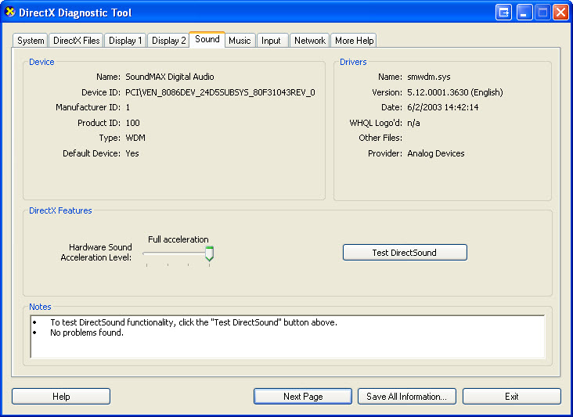

Did you hear the sound effects in the audio test?

Click Next Page until you are at the Music tab.
If you have a headphones click Test DirextMusic. If you have no headphones move to the next instruction.

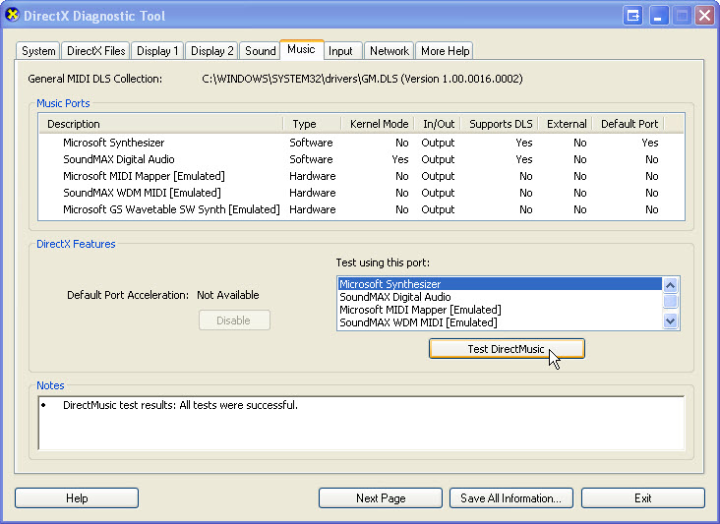

Did you hear music playing?

Click Next Page until you are on the Input tab.
What information is listed on this page?

Click Next Page until you are on the Network tab.
What information is listed on this page?

Click Next Page until you are on the More Help tab.

Click on the various buttons to see what is provided.
What tools are provided on this page?

Click Exit.

Step 5
Open the Desktop tab in Display Properties by right clicking the desktop > Properties > Desktop tab.

What is the Background picture?
Answers will vary

Set the background image to (None). If the Color dropdown button is not blue, click the Color dropdown button, select blue.
Click OK.

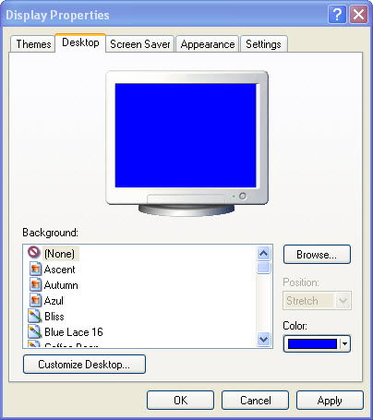

The computer screen should now have a blue background. If not ask the instructor for assistance.

Step 6
Open Registry Editor by clicking Start > Run > type regedit > click OK.
Note: Do make any changes in the Registry Editor without instructor permission.

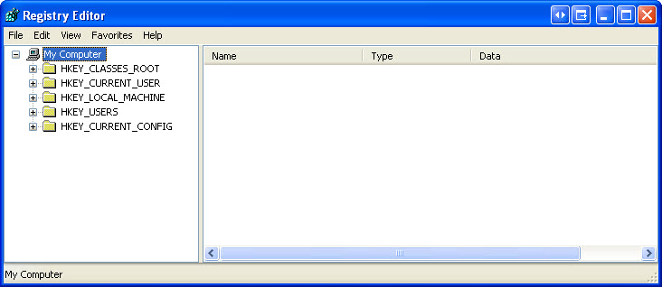

Click the HKEY_Current_User icon. To search for the desktop Background key click Edit > Find > type Background > click Find Next.

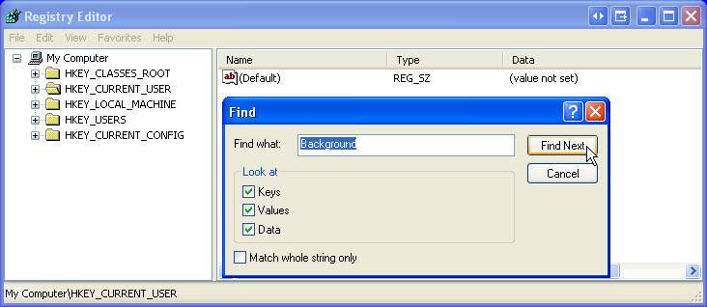

The Background value is located. Leave this window open.

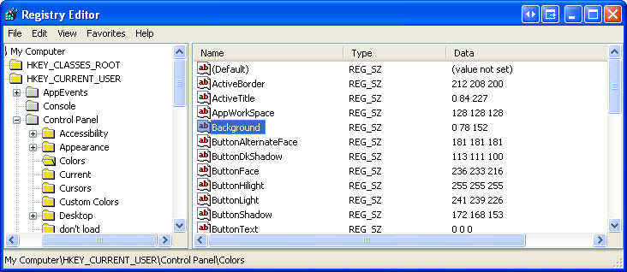

In which folder is the Background located?

What is the data value of the Background (hint – it has three number that corresponds to red, green blue)? Answers may vary based on the shade of red selected in Display Properties.

Step 7
We will now export HKEY_CURRENT_USER\Control Panel\Colors folder.
In the left pan click the Colors folder.

Click File > Export. Save the file to the Desktop. File name: BlueBKG

At the desktop right click the BlueBKG.reg icon > Edit.

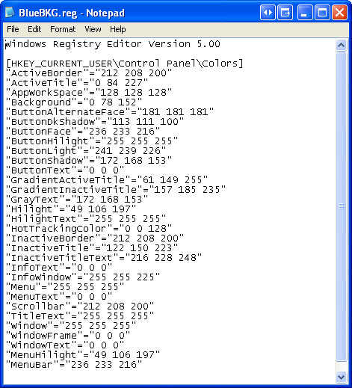

What is the data value of the Background? Answers may vary based on the shade of blue selected in Display Properties.

Close BlueBKG.reg – Notepad window.

Step 8
Open the Desktop tab in Display Properties by right clicking the desktop > Properties > Desktop tab.
Set the Color dropdown button is not red, click the Color dropdown button, select red.
Click OK.

In a few second the desktop will turn to red.

Click the Registry Editor window so it is activated.
On your keyboard press F5 to refresh the Registry Editor window.

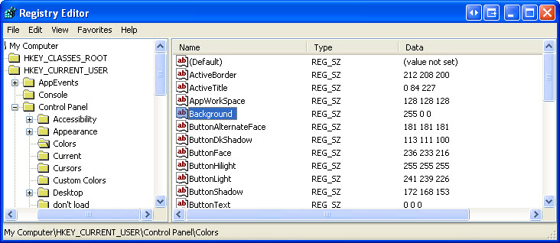

What is the data value of the Background? Answers may vary based on the shade of red selected in Display Properties.

Step 9
We will now import BlueBKG.reg file.
Click the Registry Editor window so it is activated.

Click File > Import. Locate and click the BlueBKG.reg icon then click Open. Click OK.

Click the Registry Editor window so it is activated.
What is the data value of the Background? Answers may vary based on the shade of blue selected in Display Properties.

What is the color of the desktop?

Restart the computer.
What is the color of the desktop?

Reset Display Properties Background to the original settings (hint – see step 5).

