5.4.8 Optional Lab: Managing System Files with Built-in Utilities in Windows Vista

Introduction

Print and complete this lab.

In this lab, you will use Windows built-in utilities to gather information about the system and to troubleshoot system resources. You will also learn how to export and import registry setting.

Recommended Equipment
The following equipment is required for this exercise:
• A computer running Windows Vista Business

Step 1
Log on to the computer as an administrator.

To add Run to the Start menu right click Start > Properties. Select Start Menu tab then click Customize ….

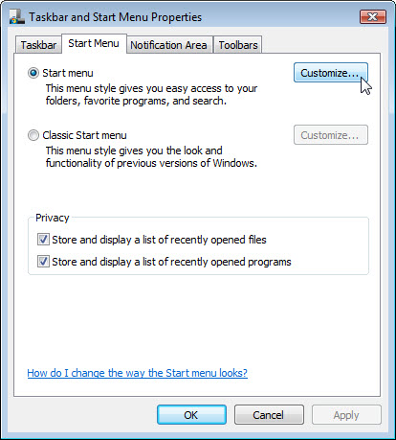

Scroll down until you see the Run command. Click in the box next to Run command. Click OK.

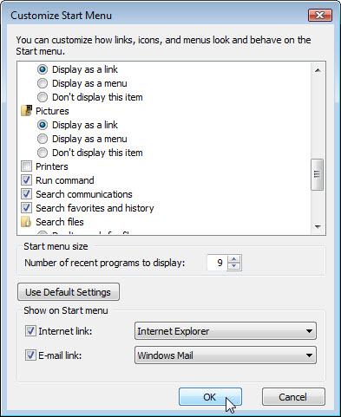

Click Apply > OK to close the “Taskbar and Start Menu Properties” window.

Open the command prompt by clicking Start > Run > type cmd > click OK.

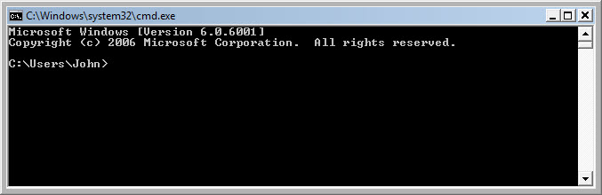

What is the drive path shown?
Answers may vary.

Type help and press Enter.

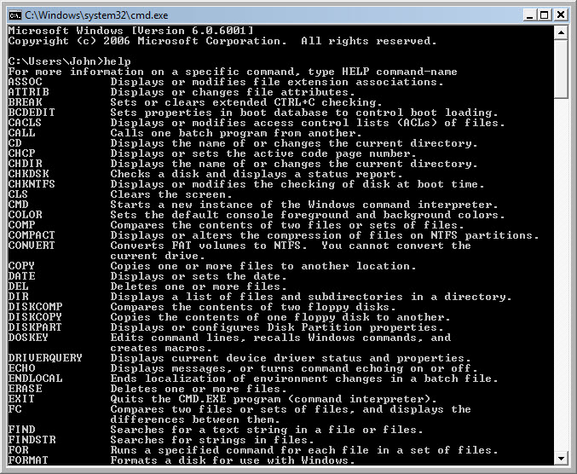

What is the command to change directory?

What is the command to display the contnets in a directory?

Type cd .. and press Enter.

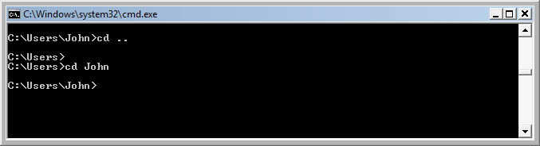

What is the drive path shown?
Answers may vary.

Change back to original drive path.
Example: Type cd John and press Enter.

What is the drive path shown?
Answers may vary.

Type dir /? and press Enter.
If asked, Press any key to continue.

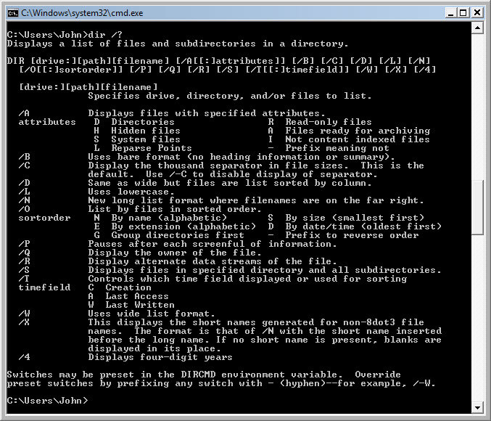

Which switch displays a wide list format?

Type dir and press Enter.

Type dir /w and press Enter.

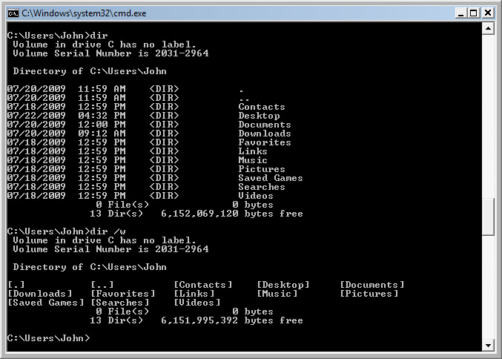

What is the difference between these two commands?

Type VOL.
What volume is drive C in? Answers may vary.

Close the Command prompt window.

Step 2
Open System Information by clicking Start > Run > type msinfo32 > click OK.

Click the plus sign next to Hardware Resources, Components, and Software Environment. Expand the window so you can see all the content.

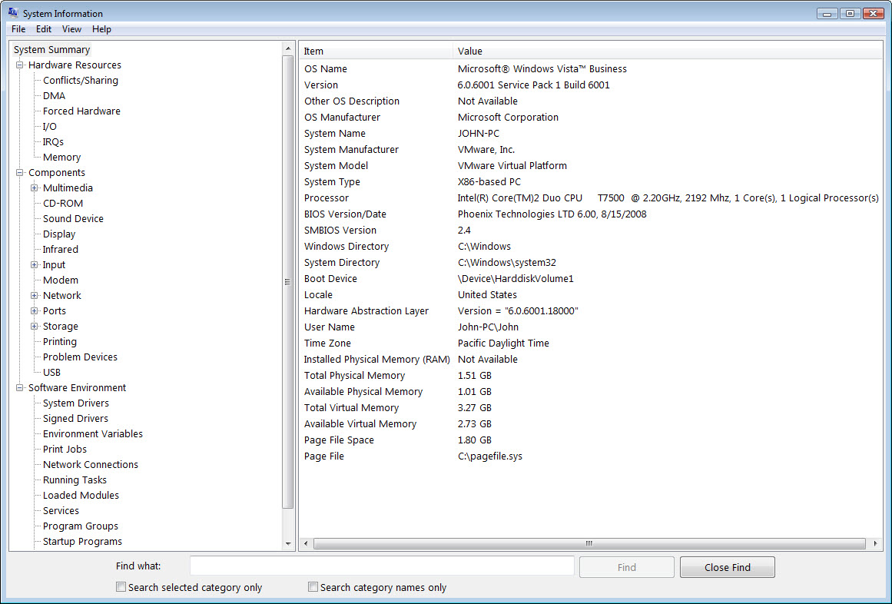

Under the System Summary heading locate and list the following:

Processor

BIOS Version/Date

Total Physical Memory

Under the Hardware Resources heading locate and list the following:

DMA channels and the device using the resources.

I/O address range for these devices.

Printer Port (LPT1)

Communications Port (COM1)

Communications Port (COM2)

IRQ address for these devices.

System timer

Communications Port (COM1)

Communications Port (COM2)

Under the Components heading and Software heading look around to see what information is provided in these areas.

Close the System Information window.

Step 3
Open System Configuration by clicking Start > Run > type msconfig > click OK.
If the “User Account Control” window appears click Continue.
Note: It is very important that you do not make any changes in this utility without instructor permission.

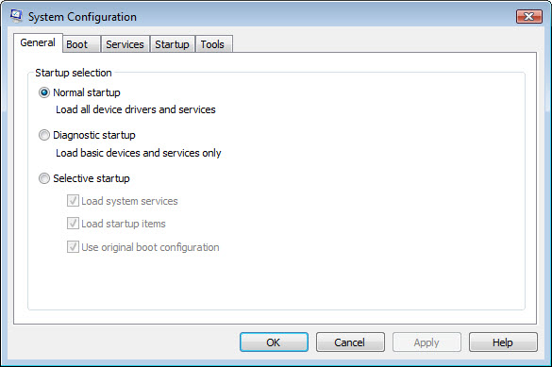

Click the General tab if not all ready active.
What are the startup options?

Click the BOOT tabs. This tab is for modifying boot options.

Click the Service tab. This tab lists the computers services and there status.

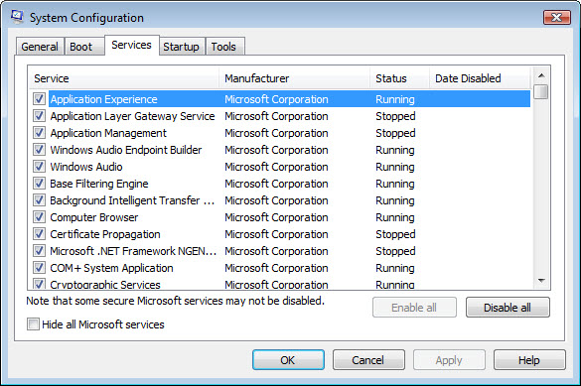

Can you enable and disable services at this tab?

Click the Startup tab. This tab lists the programs that are automatically loaded every time you turn on your computer.

Click the Tools tab.

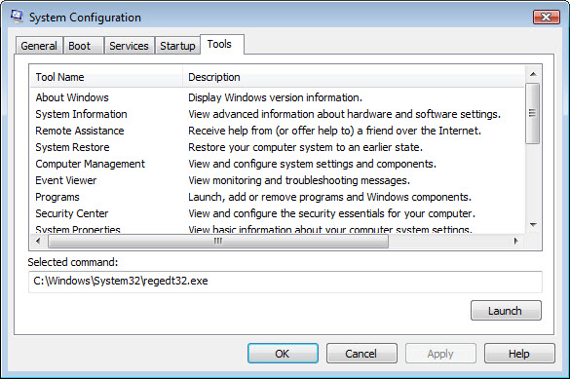

What can you do in this tab?

Click Cancel to close the “System Configuration” window.

Step 4
Open DirectX Diagnostic Tool by clicking Start > Run > type dxdiag > click OK.
If you are asked to have DirectX check driver signatures click No.

Note: When DirectX Diagnostic Tool first opens it may take a minute to load all information. Your DirectX Diagnostic Tool may not appear exactly as shown in this lab.

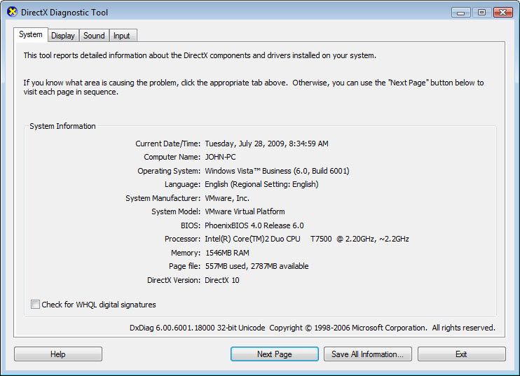

Make sure the System tab is active.
What does this tool report?

Click Next Page until you are at the Display tab.

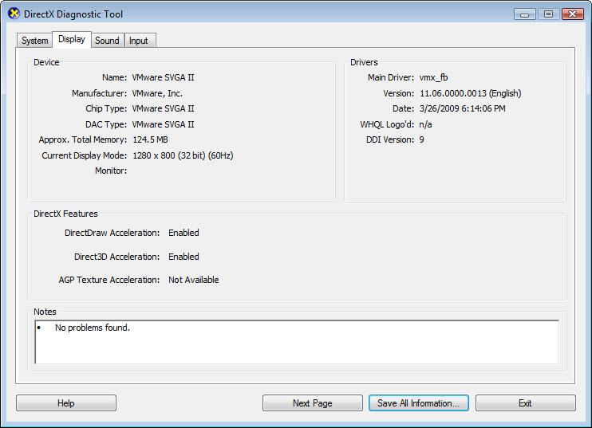

What information is listed on this page?

Click Next Page until you are at the Sound tab.

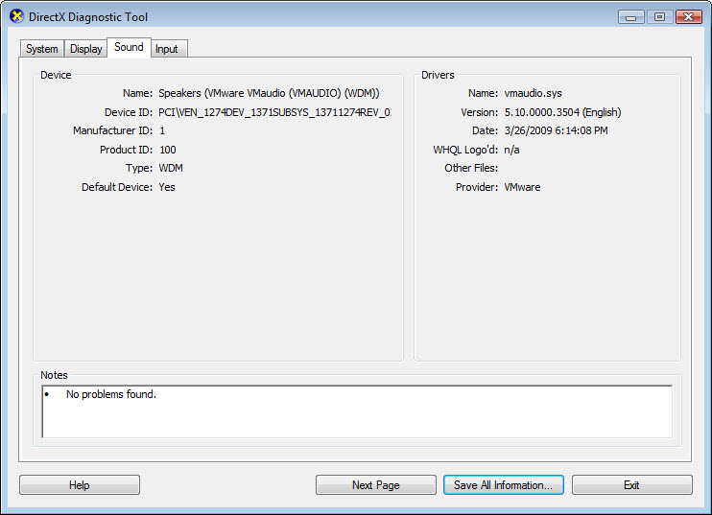

What information is listed on this page?

Click Next Page until you are on the Input tab.
What information is listed on this page?

Click Exit.

Step 5
Open the “Choose a desktop background” page in Personalize appearance and sounds by right clicking the desktop > Personalize > Desktop Background.

What is the Background picture?
Answers will vary

Click the Location dropdown button and select Solid Colors. Select a blue color.
Click OK.

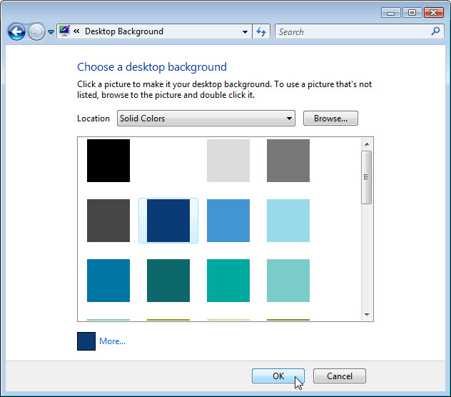

The computer screen should now have a blue background. If not ask the instructor for assistance.

Step 6
Open Registry Editor by clicking Start > Run > type regedit > click OK.
If the “User Account Control” window appears click Continue.
Note: Do make any changes in the Registry Editor without instructor permission.

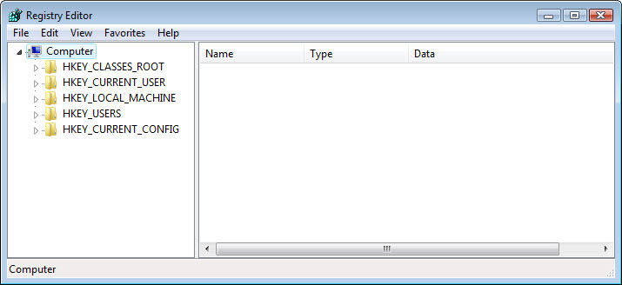

Click the HKEY_Current_User icon. To search for the desktop Background key click Edit > Find > type Background > click Find Next.

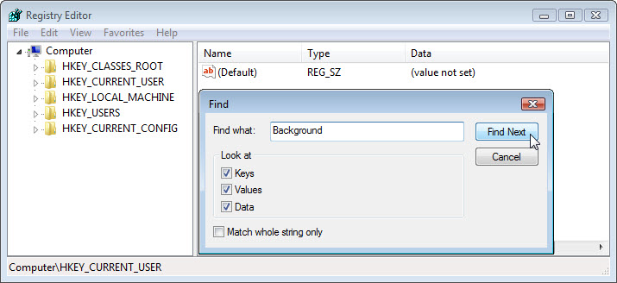

The Background value is located. Leave this window open.

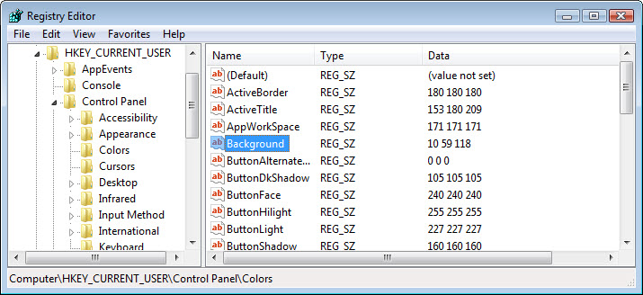

In which folder is the Background located?

What is the data value of the Background (hint – it has three number that corresponds to red, green blue)? Answers may vary based on the shade of red selected in Choose a desktop background.

Step 7
We will now export HKEY_CURRENT_USER\Control Panel\Colors folder.
In the left pan click the Colors folder.

Click File > Export. Save the file to the Desktop. File name: BlueBKG

At the desktop right click the BlueBKG.reg icon > Edit.

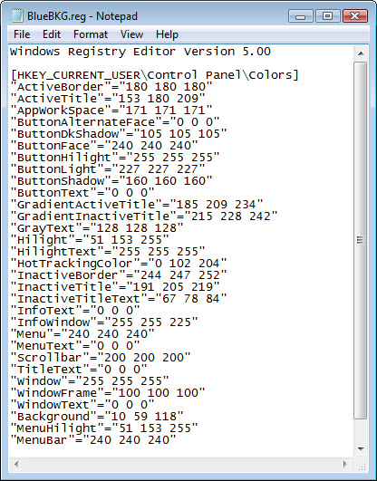

What is the data value of the Background? Answers may vary based on the shade of blue selected in Display Properties.

Close BlueBKG.reg – Notepad window.

Step 8
Open the “Choose a desktop background” page in Personalize appearance and sounds by right clicking the desktop > Personalize > Desktop Background.
Click the Location dropdown button and select Solid Colors. Select a red color.
Click OK.

In a few second the desktop will turn to red.

Click the Registry Editor window so it is activated.
On your keyboard press F5 to refresh the Registry Editor window.

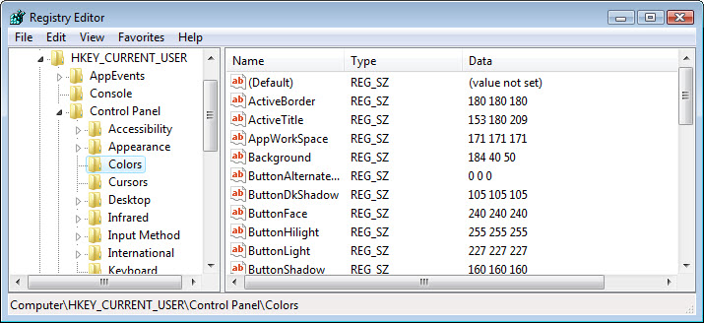

What is the data value of the Background? Answers may vary based on the shade of red selected in Display Properties.

Step 9
We will now import BlueBKG.reg file.
Click the Registry Editor window so it is activated.

Click File > Import. Locate and click the BlueBKG.reg icon then click Open.
Click OK.

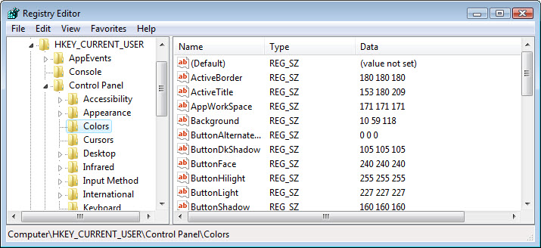

Click the Registry Editor window so it is activated.
What is the data value of the Background? Answers may vary based on the shade of blue selected in Display Properties.

What is the color of the desktop?

Restart the computer.
What is the color of the desktop?

Reset Display Properties Background to the original settings (hint – see step 5).

