5.4.5 Optional Lab: Create Accounts and Check For Updates in Windows Vista

Introduction

Print and complete this lab.

In this lab, you will create user accounts and configure the operating system for automatic updates after the Windows Vista Business installation process.

Recommended Equipment
The following equipment is required for this exercise:
• A computer with a new installation of Windows Vista Business

Step 1
Boot the computer. Navigate to the “Control Panel” window by clicking Start > Control Panel.

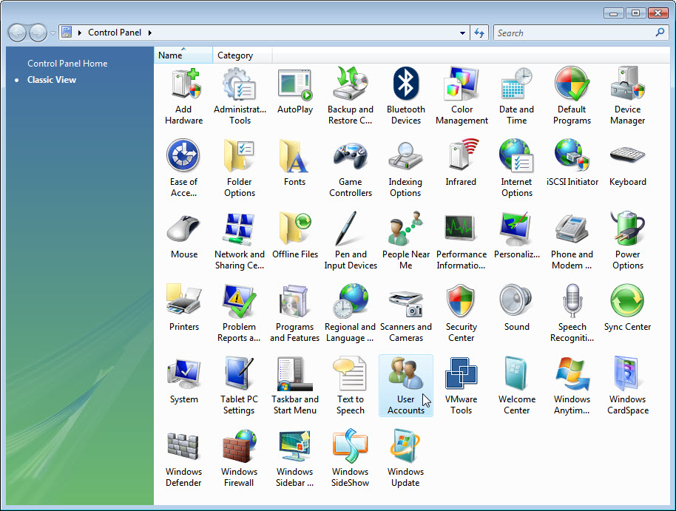

Step 2
Double-click the User Accounts icon.

The “User Accounts” window appears. Click Manage another account.

Click Continue if asked for permission.

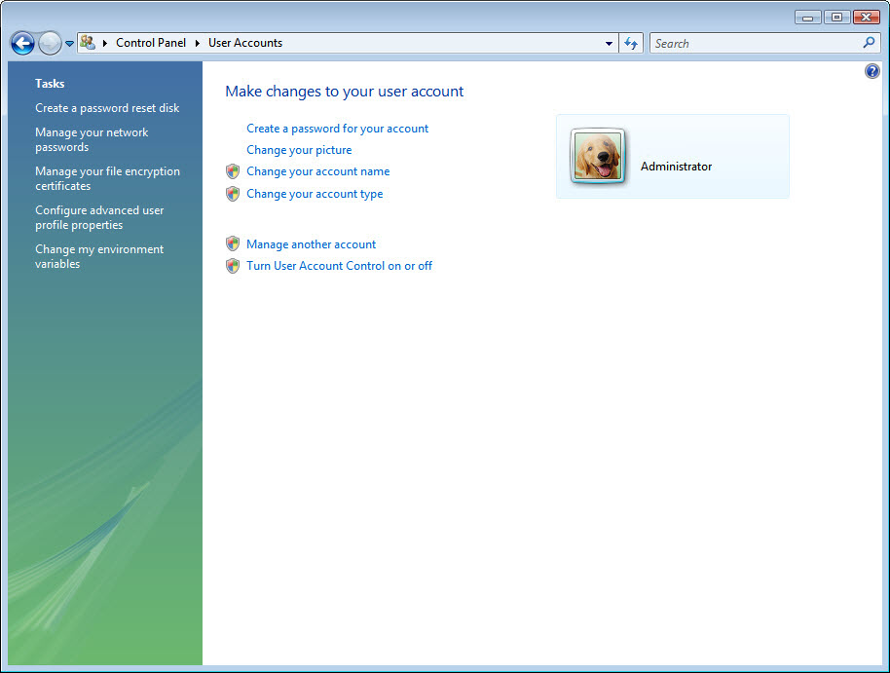

The “Manage Accounts” window appears. Click Create a new account.

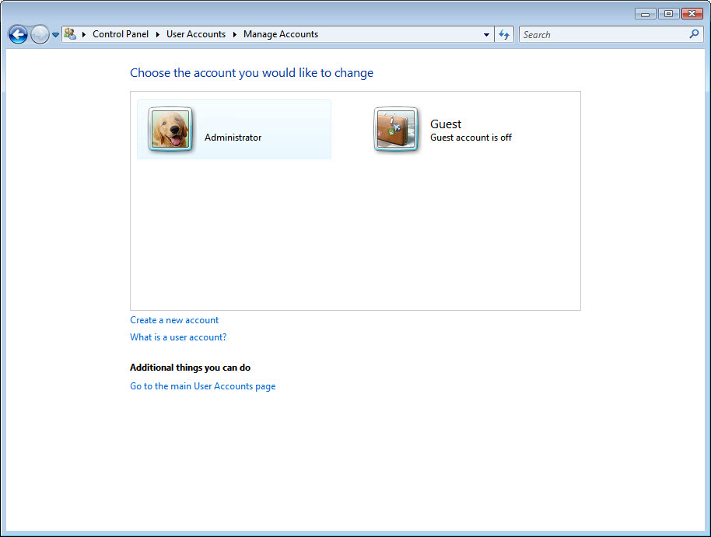

Step 3
At “Name the account and choose an account type”, type your name in the field, select Administrator as the account type and then click Create Account.

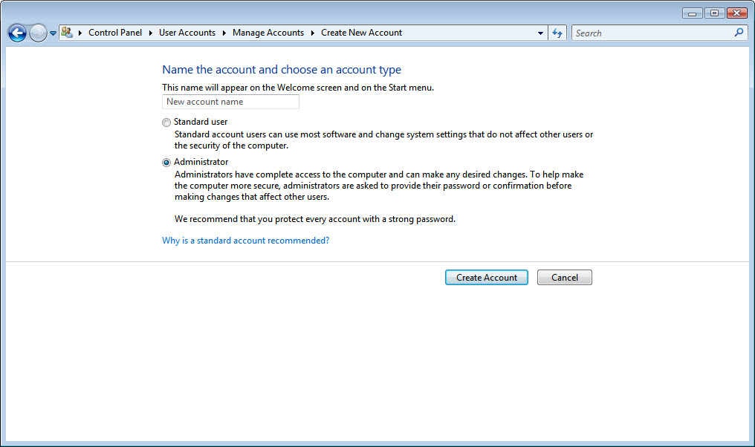

You have now finished creating a new account. Log off the computer and log back in as yourself. Leave the password field blank.

Step 4
Return to the “User Accounts” window of the control panel.

Click Create a password for your account.

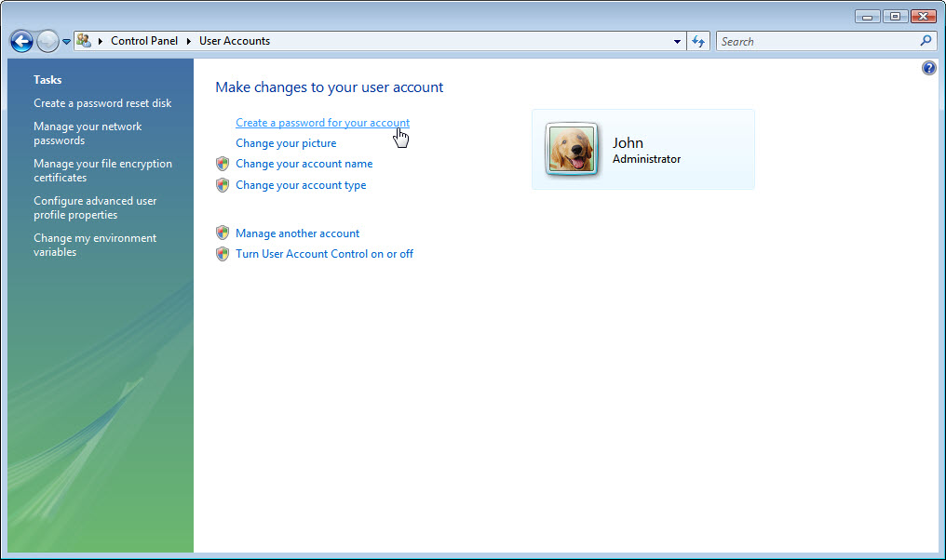

Step 5
On the “Create a password for your account” page, type your first initial and your last name in the “Type a new password:” field. Example: jsmith

Type the same password in the “Type the new password again to confirm:” field.

Type fi last name in the “Type a word or phrase to use as a password hint:” field.

Click Create Password.

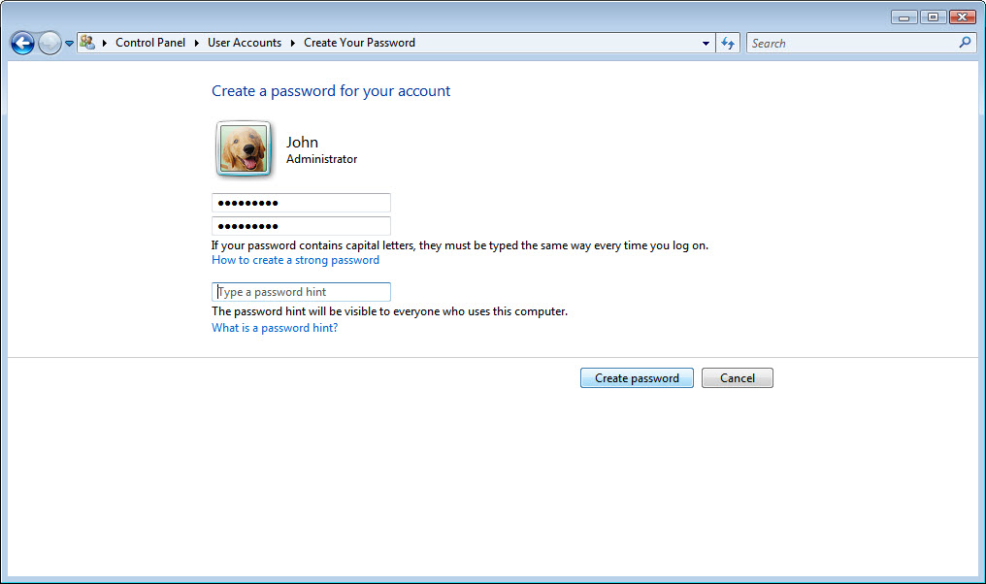

Step 6
Click the X in the Close box in the upper-right corner of the “User Accounts” window to close the window.

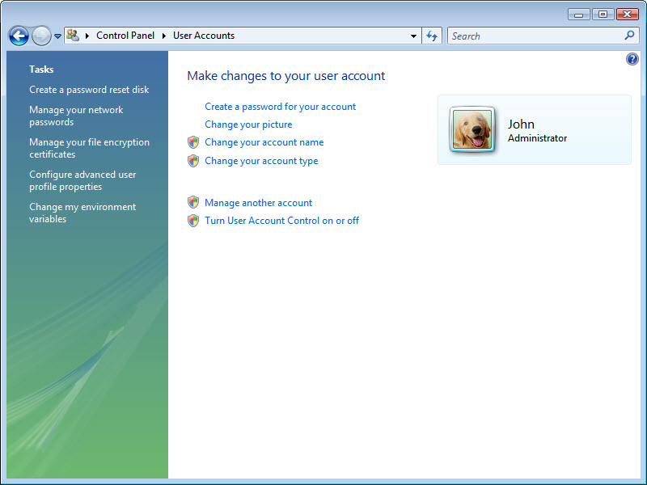

Step 7
Click Start > Control Panel.

Double-click the Windows Updates icon.

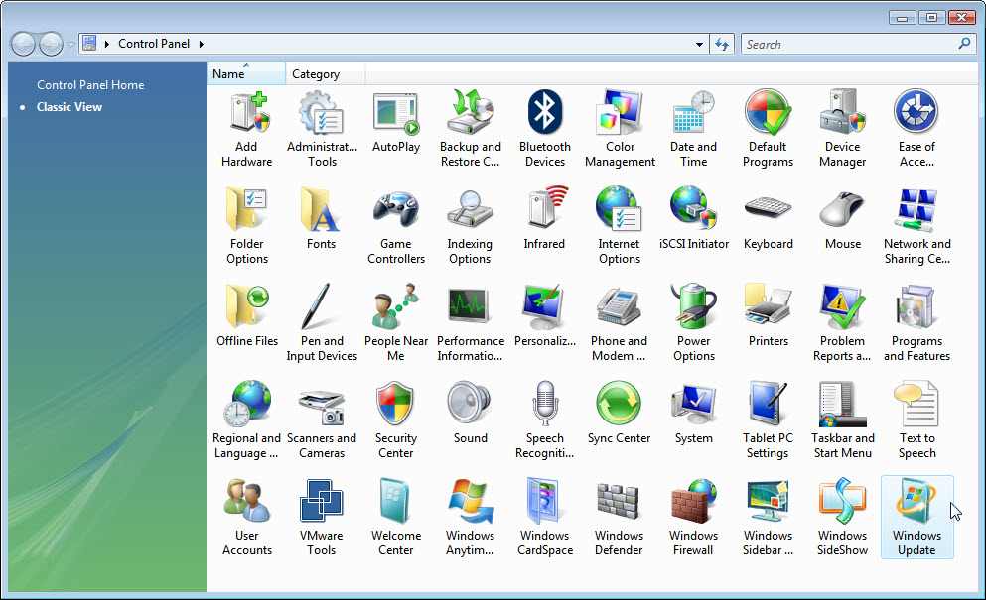

Step 8
The “Windows Updates” dialog box appears.

Click Change settings.

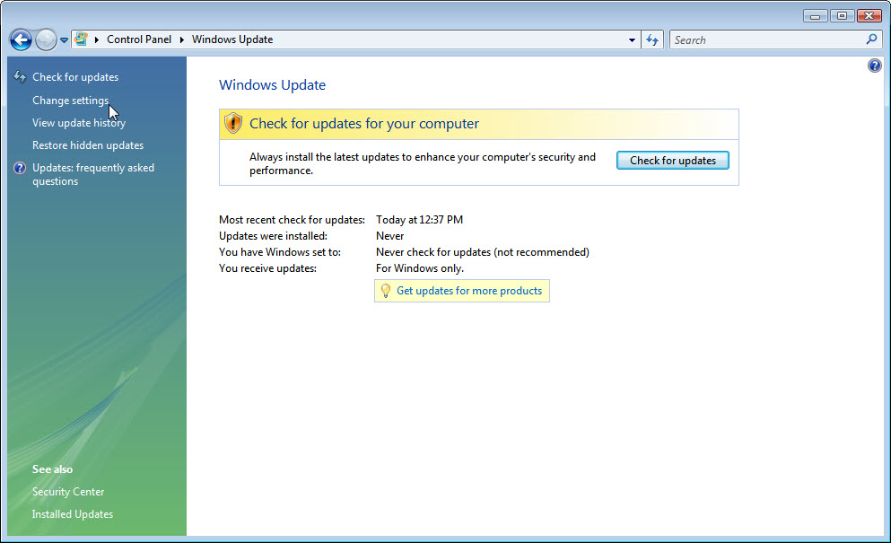

The “Choose how Windows can install updates” dialog box appears.

Click the Install updates automatic (recommended) radio button.

Click OK to accept the change.

Click Continue if asked for permission and close the dialog box.

