5.4.5 Optional Lab: Create Accounts and Check For Updates in Windows 7

Introduction

Print and complete this lab.

In this lab, you will create user accounts and configure the operating system for automatic updates after the Windows 7 installation process.

Recommended Equipment
The following equipment is required for this exercise:
• A computer with a new installation of Windows 7

Step 1
Boot the computer. Navigate to the “Control Panel” window by clicking Start > Control Panel.

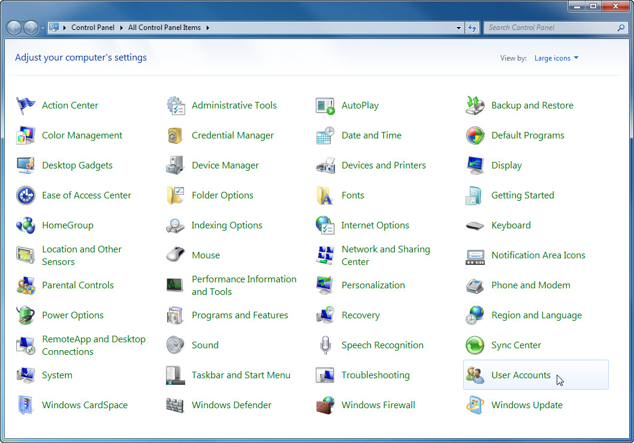

Step 2
Click the User Accounts icon or navigate to User Accounts and Family Safety > User Accounts.

The “User Accounts” window appears. Click Manage another account.

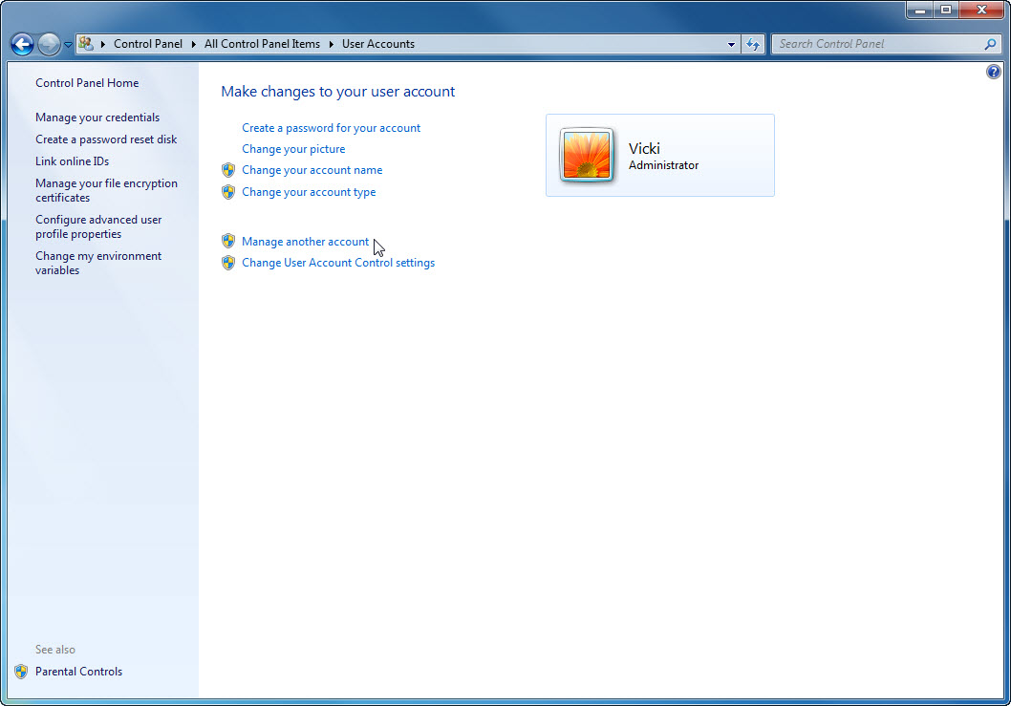

The “Manage Accounts” window appears. Click Create a new account.

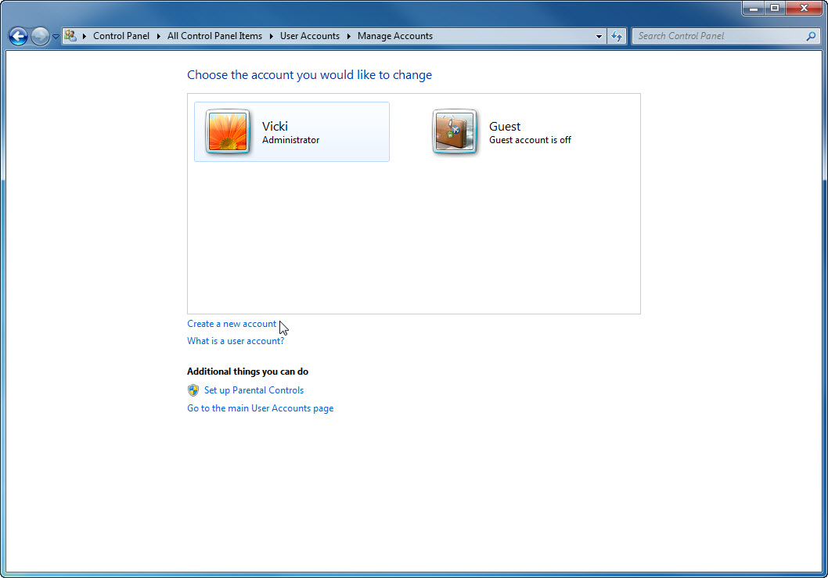

Step 3
At “Name the account and choose an account type”, type your name in the field, select Administrator as the account type and then click Create Account.

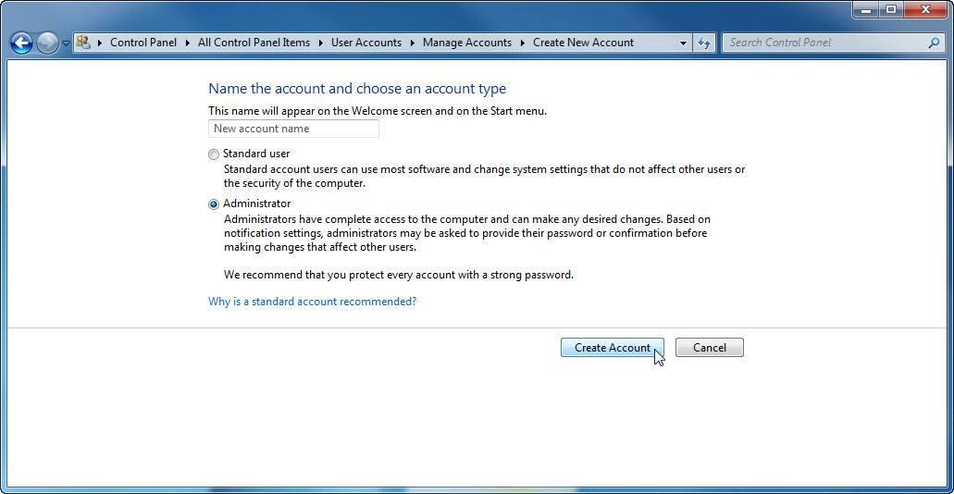

You have now finished creating a new account. Log off the computer and log back in as yourself. Leave the password field blank.

Step 4
Return to the “User Accounts” window of the control panel.

Click Create a password for your account.

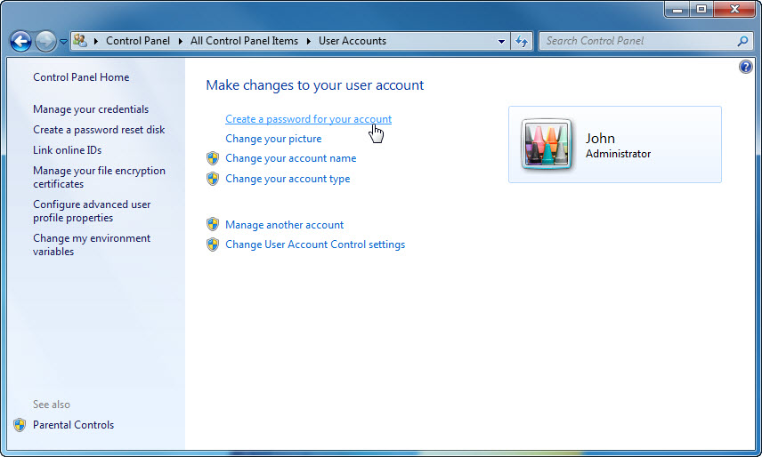

Step 5
On the “Create a password for your account” page, type your first initial and your last name in the “Type a new password:” field. Example: jsmith

Type the same password in the “Type the new password again to confirm:” field.

Type fi last name in the “Type a word or phrase to use as a password hint:” field.

Click Create password.

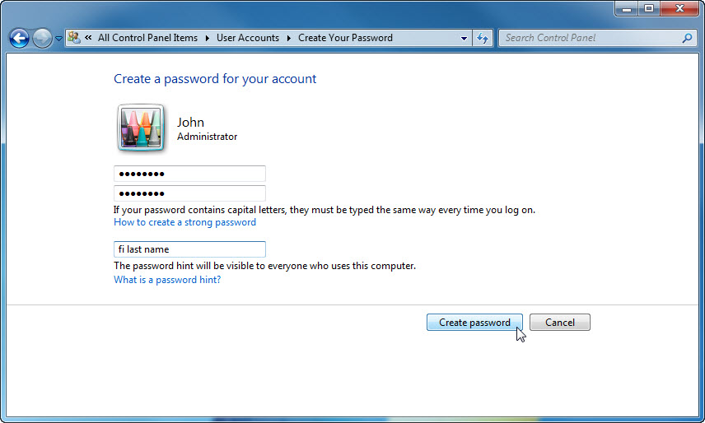

Step 6
Click the X in the Close box in the upper-right corner of the “User Accounts” window to close the window.

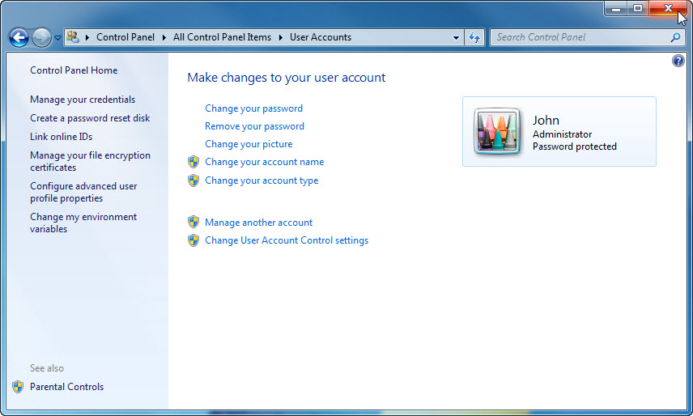

Step 7
Click Start > Control Panel.

Click the Windows Update icon or navigate to System and Security > Windows Update.

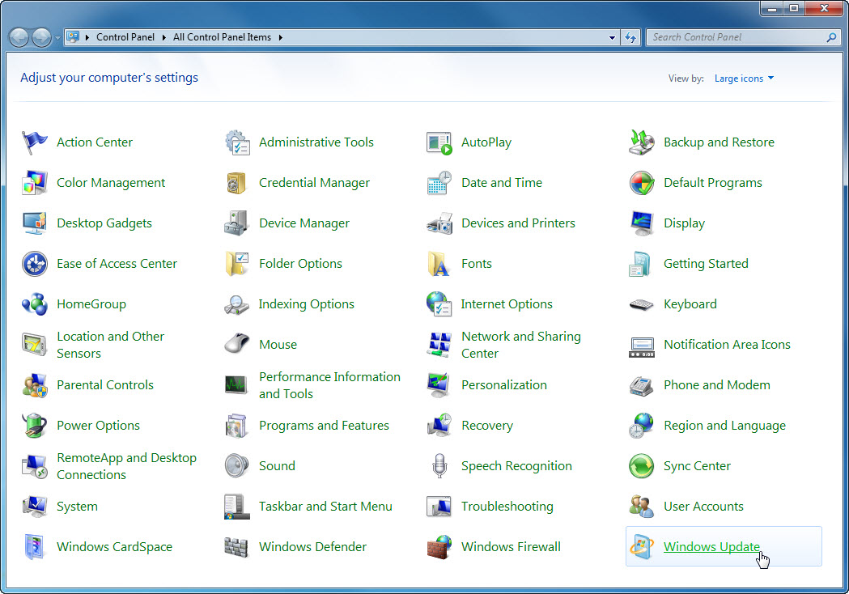

Step 8
The “Windows Update” dialog box appears.

Click Change settings.

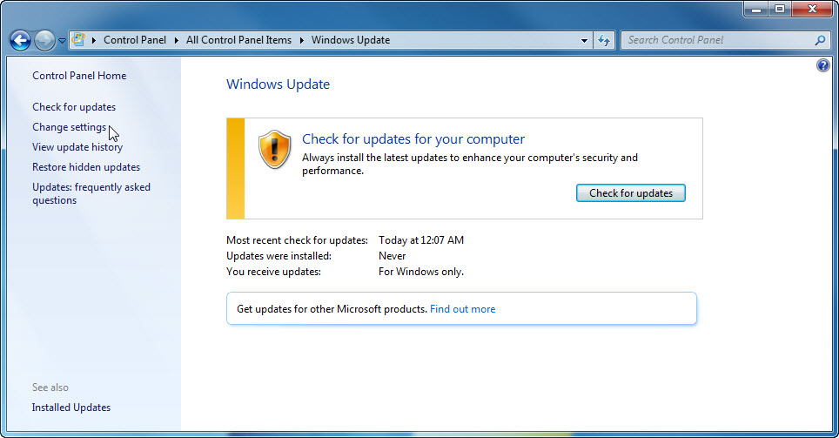

The “Choose how Windows can install updates” dialog box appears.

Choose Install updates automatically (recommended) from the drop-down menu.

Click OK to accept the change.

