5.4.2 Optional Lab: Install Windows 7

Introduction

Print and complete this lab.

In this lab, you will install the Windows 7 operating system.

Recommended Equipment
The following equipment is required for this exercise:
• A computer with a blank hard disk drive.
• Windows 7 installation DVD.

Step 1
Insert the Windows 7 installation DVD into the DVD-ROM drive.
When the system starts up, watch for the message “Press any key to boot from CD or DVD.”.

If the message appears, press any key on the keyboard to boot the system from the
DVD. If the press any key message does not appear, the computer automatically starts loading files from the DVD.

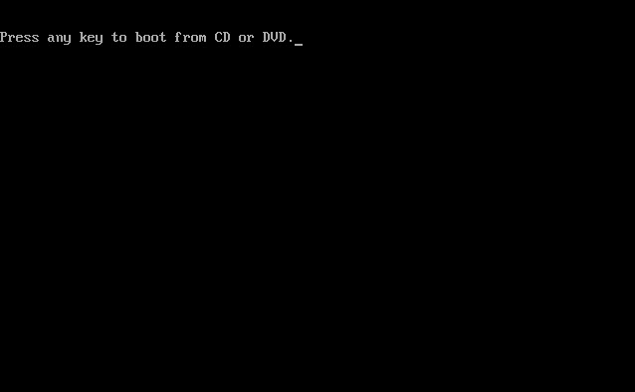

The computer starts loading files from the DVD.

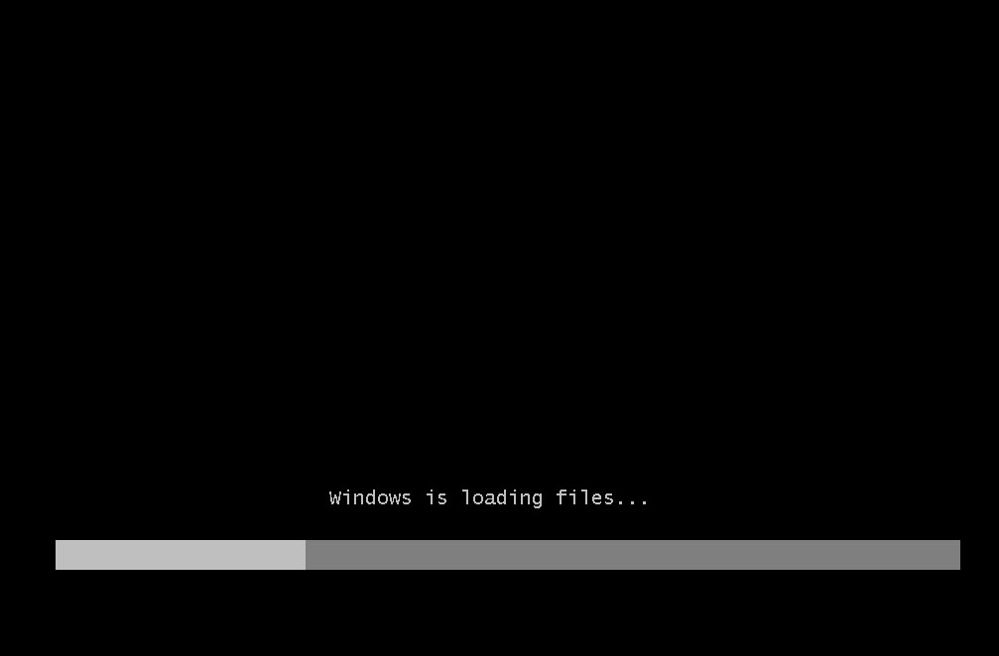

Step 2
The Windows 7 boot screen appears.

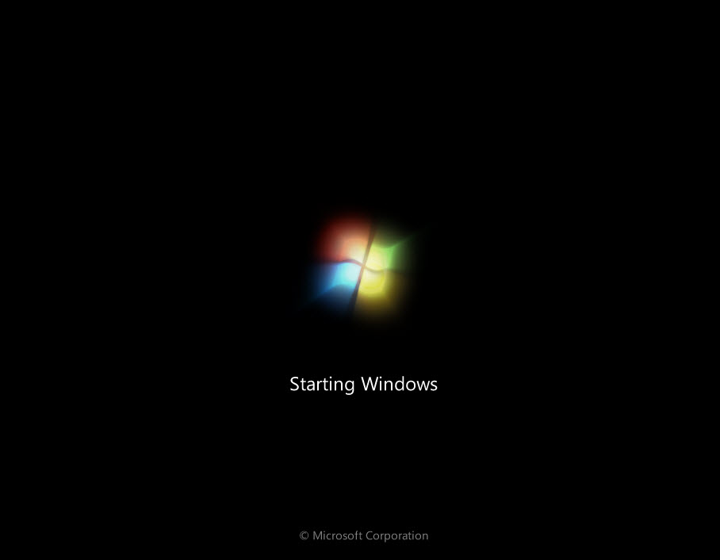

Step 3
The Install Windows screen appears. Press Next unless you need to change the defaults.

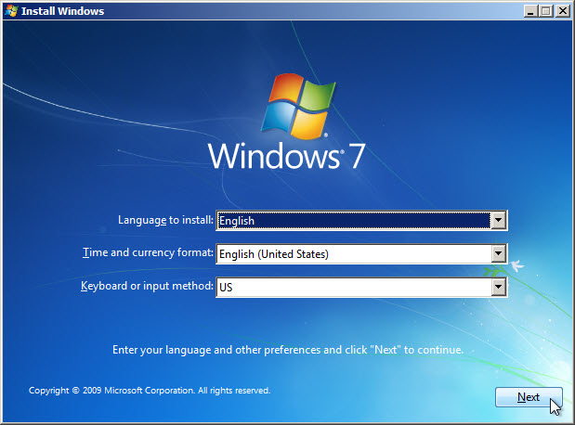

Step 4
Press Install now to continue.

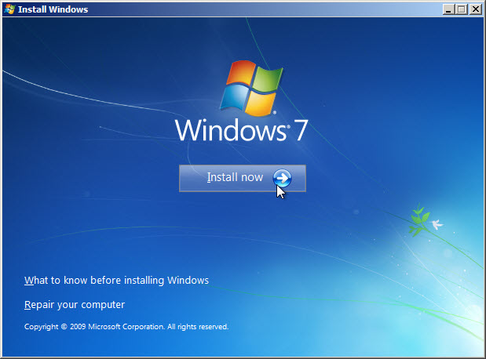

Step 5
The Collecting information section of the installation begins.

The “Setup is starting...” screen appears.

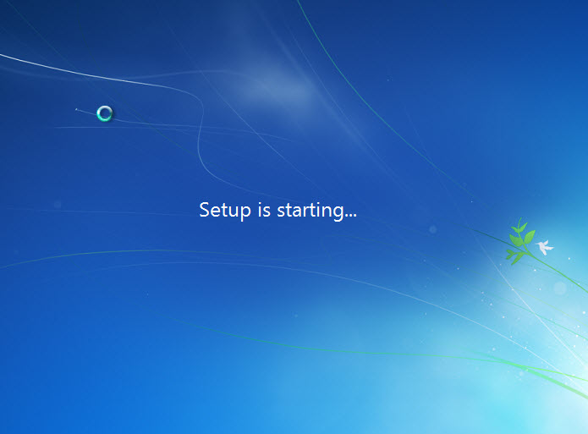

Next the “Please read the license terms” page appears. Read and confirm that you accept the license by selecting the box “I accept the license terms”. Click Next.

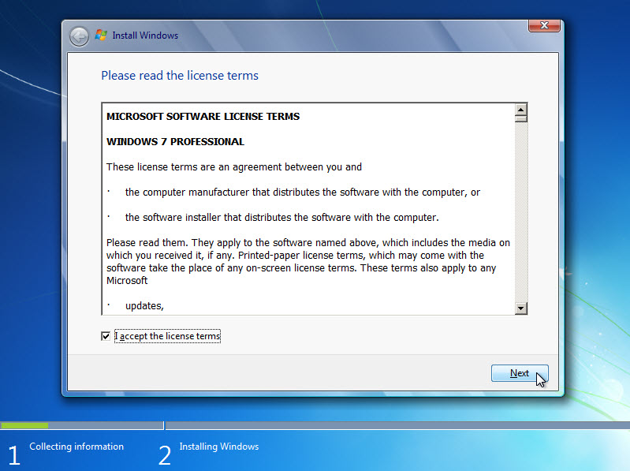

Step 6
The “Which type of installation do you want?” page appears. Click Custom (advanced).

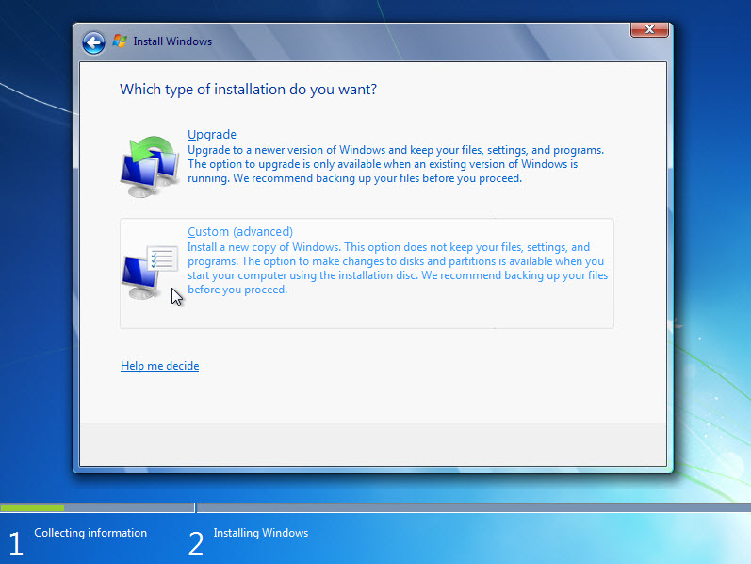

Step 7
The “Where do you want to install Windows?” page appears. Select the hard drive or partition on which Windows 7 will be installed.
Click Next to select “Disk 0 Unallocated Space”, which is the default setting.

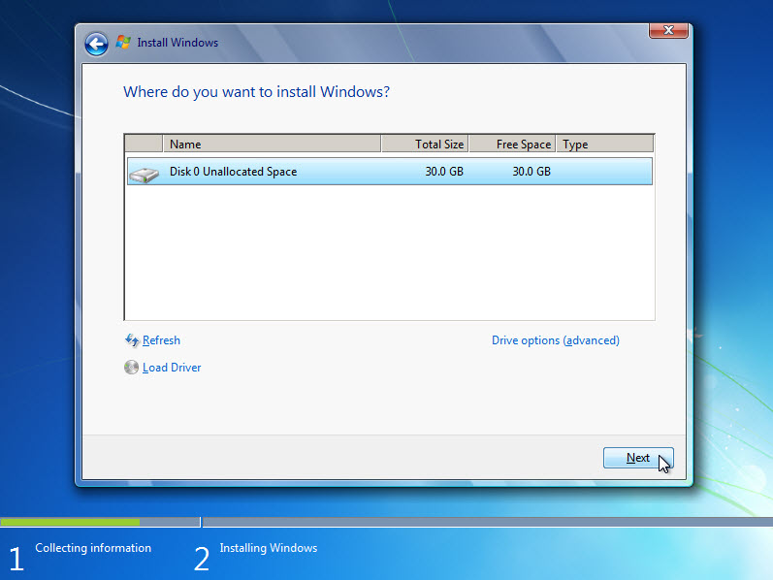

The Collecting information section of the installation ends.

Step 8
The Installing Windows section begins.

The “Installing Windows…” page appears. Windows 7 Setup may take about 50 minutes to configure your computer.

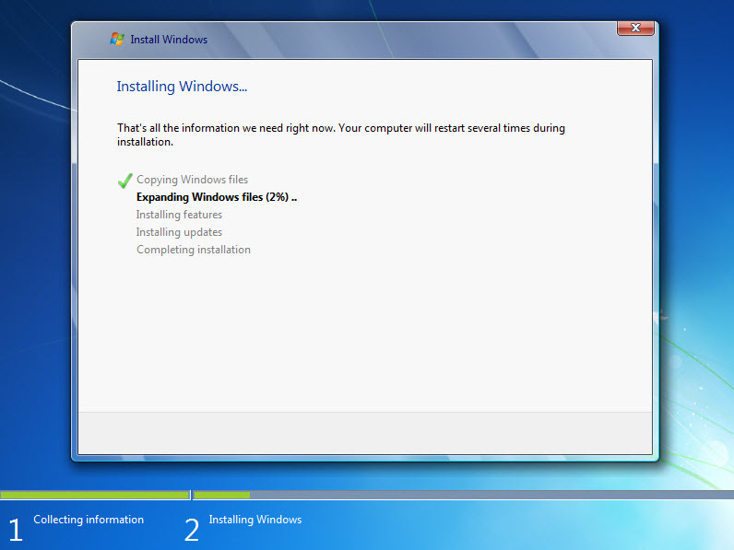

Step 9
The “Windows needs to restart to continue” page appears. Your computer will automatically restart or you can click Restart now.

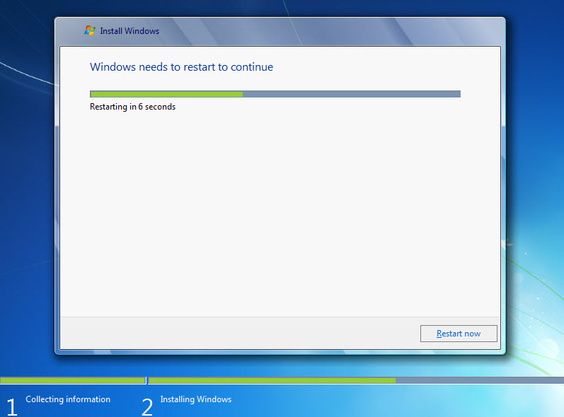

If you get the message “Press any key to boot from CD or DVD.”, do not press any key and Windows will boot from the hard disk to continue the installation.

Step 10
The “Setup is updating registry settings” page appears.

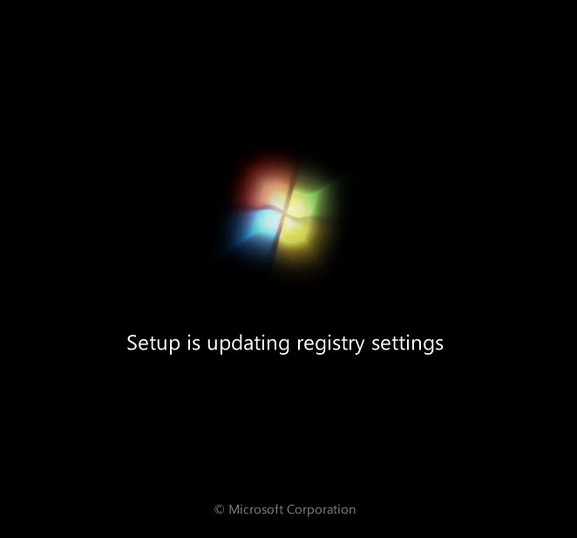

Step 11
The “Setup is starting services” page appears.

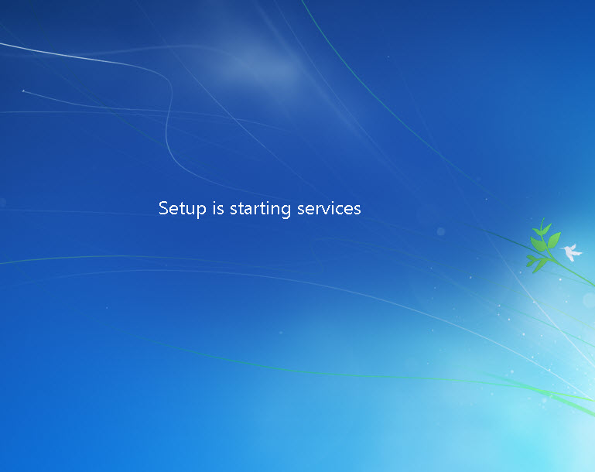

Step 12
The “Installing Windows…” page appears again. Windows may reboot a few more times. This may take several minutes.

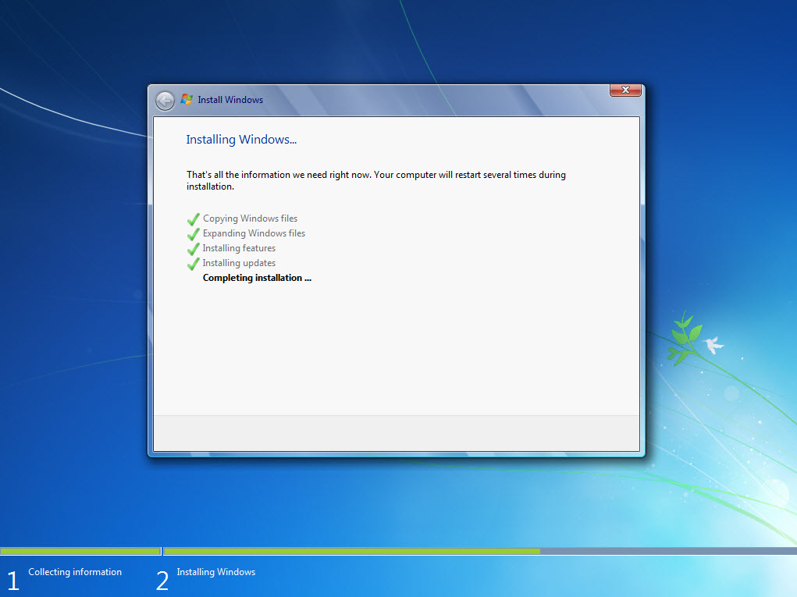

The Installing Windows section of the installation is completed.

Step 13
The Set Up Windows section begins.

Type the user name and computer name provided by your instructor. Click Next.

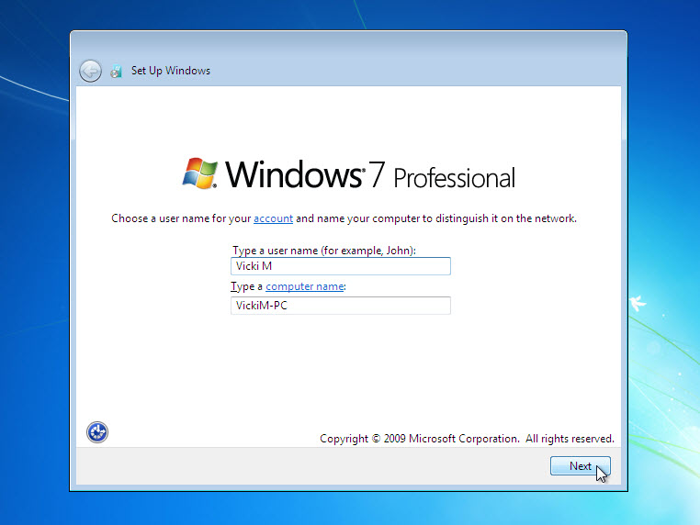

Step 14
The “Set a password for your account” page appears. Type the password provided by your instructor. Retype the password and enter the password hint. Click Next.

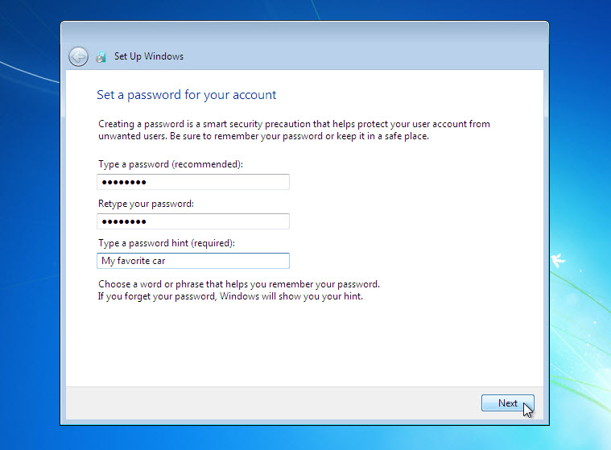

Step 15
The “Type your product key” page appears. On this page, type your product key as it appears on your Windows 7 DVD case. Click Next.

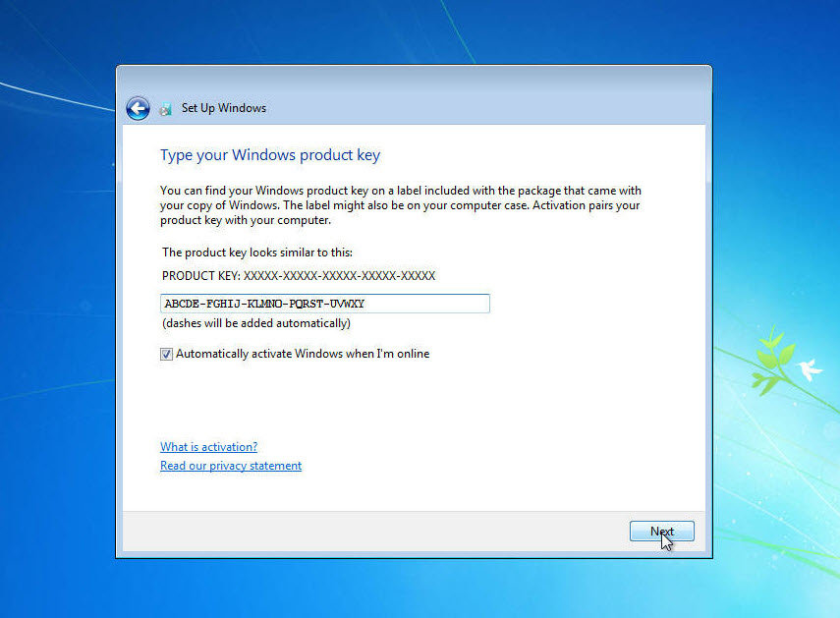

Note: If you entered your product key, Setup will not ask you the following:

“Do you want to enter your product key now?” window appears. If you were instructed not to enter a product key, click No.

Step 16
On the “Help protect your computer and improve Windows automatically” screen, click Use recommended setting.

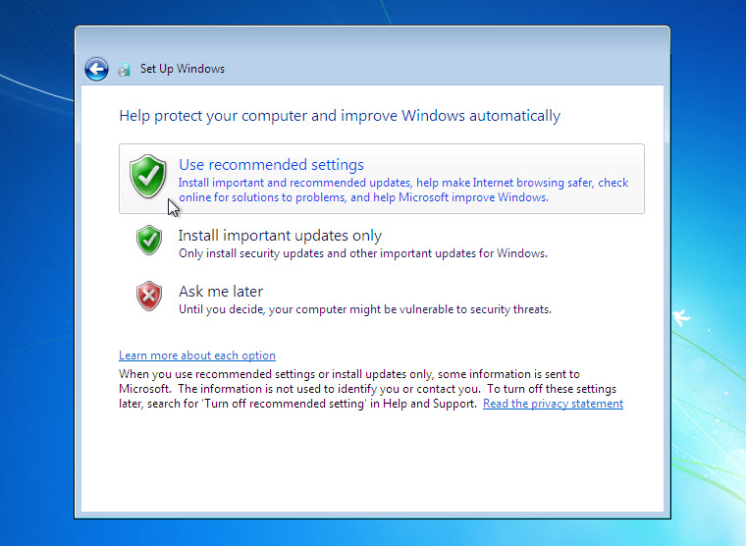

Step 17
On the “Review your time and date settings” screen, configure the computer clock to match your local date, time, and time zone. Click Next.

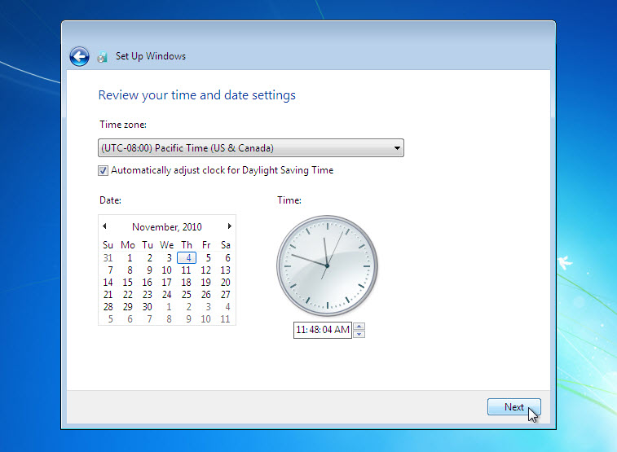

Step 18
The “Select your computer’s current location” page appears. Select the option provided by your instructor.

Note: This screen will not show up if the installation did not correctly install drivers for the network card.

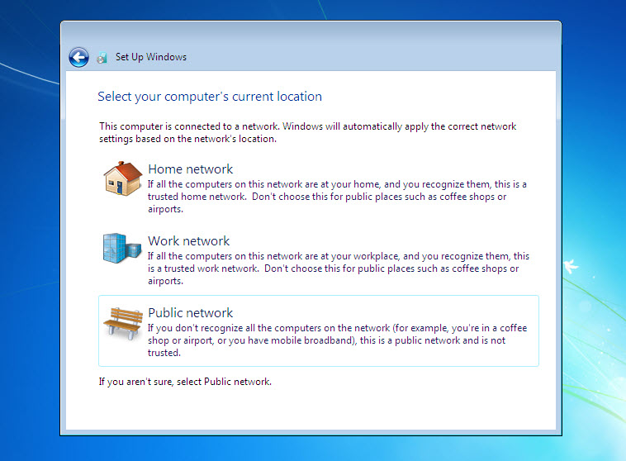

Step 19
The “Windows is finalizing your settings” screen appears.

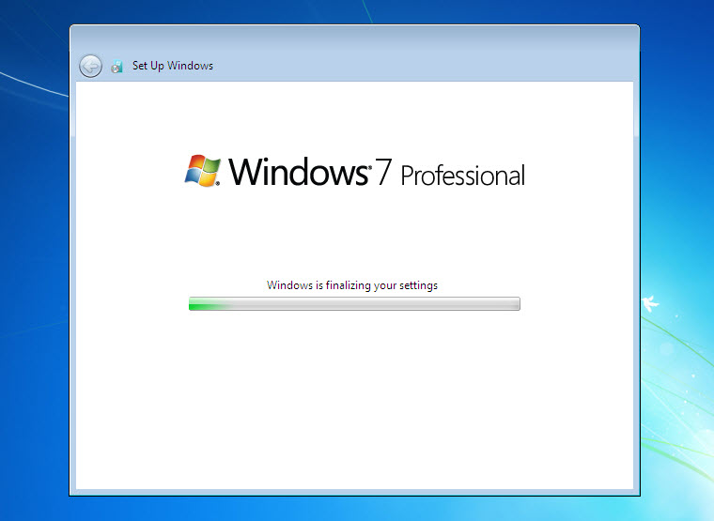

The Set Up Windows section is completed.

Step 20
The “Welcome” page appears.

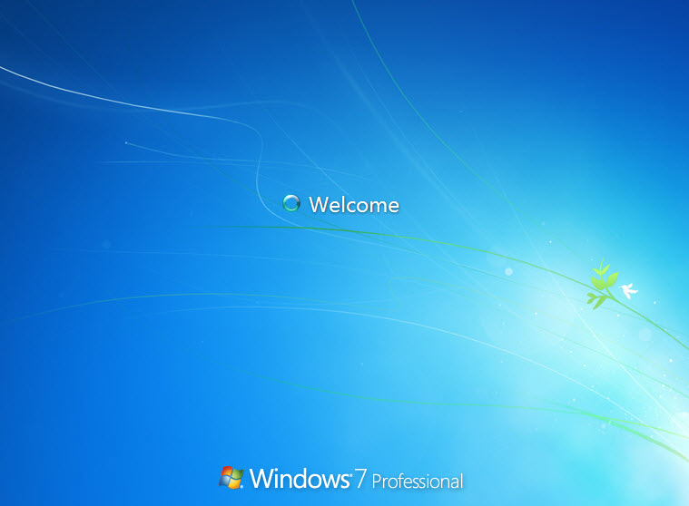

Step 21
The “Preparing your desktop…” page appears.

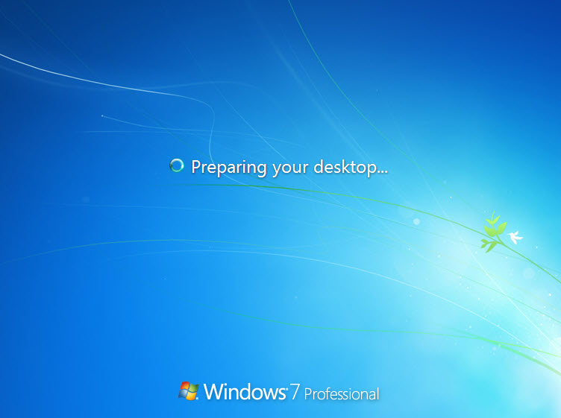

Step 22
You are logged in to Windows 7 for the first time.

