5.4.2 Lab: Install Windows XP

Print and complete this lab.

In this lab, you will install the Windows XP Professional operating system.

Recommended Equipment
The following equipment is required for this exercise:
- A computer with a blank hard disk drive.
- Windows XP Professional installation CD.

Step 1
Insert the Windows XP installation CD into the CD-ROM drive.
When the system starts up, watch for the message “Press any key to boot from CD..”.

If the message appears, press any key on the keyboard to boot the system from the
CD. The system will now begin inspecting the hardware configuration. If the message does not appear, the hard drive is empty and the system will now begin inspecting the hardware configuration.



Step 2
The Windows XP Professional Setup screen appears. During this part of setup, the mouse will not work, so you must use the keyboard. On the Welcome to Setup page, press Enter to continue.

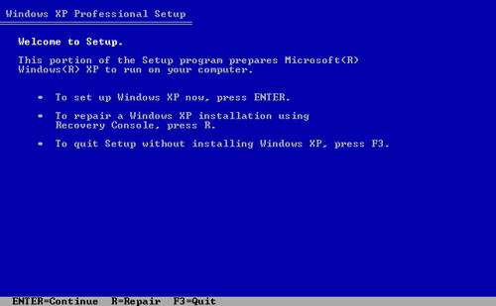

Step 3
The “Windows XP Licensing Agreement” page appears. Press the Page Down key to scroll to the bottom of the license agreement. Press the F8 key to agree to the license.

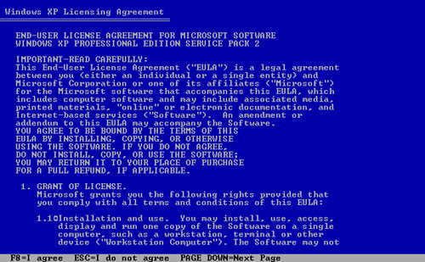

Step 4
Select the hard drive or partition on which Windows XP will be installed.
Press Enter to select “Unpartitioned space”, which is the default setting.

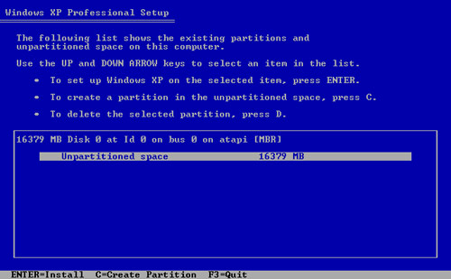

Step 5
Press Enter again to select “Format the partition using the NTFS file system”, which is the default setting.

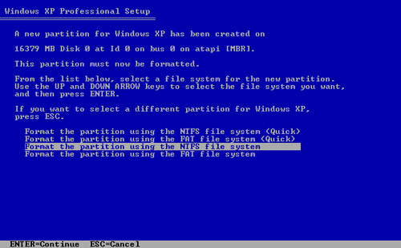
Windows XP Professional Setup erases the hard disk drive, formats the hard disk drive, and copies the setup files from the installation CD to the hard disk drive. This process should take between 20 and 30 minutes to complete.

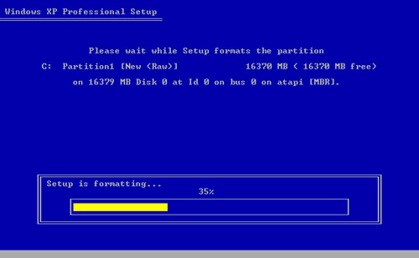

Step 6
After the formatting process, Windows XP restarts and continues with the installation process. At this point, the mouse can be used to make selections. The “Regional and Language Options” page appears. Click Next to accept the default settings. Regional and language options can be configured after setup is complete.

The “Personalize Your Software” page appears. Type the name and the organization name provided by your instructor. Click Next.

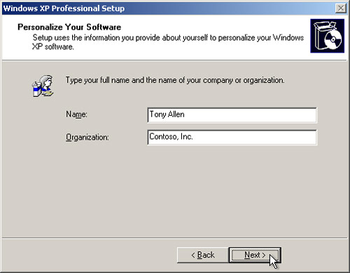

Step 7
The “Your Product Key” page appears. On this page, type your product key as it appears on your Windows XP CD case. Click Next.

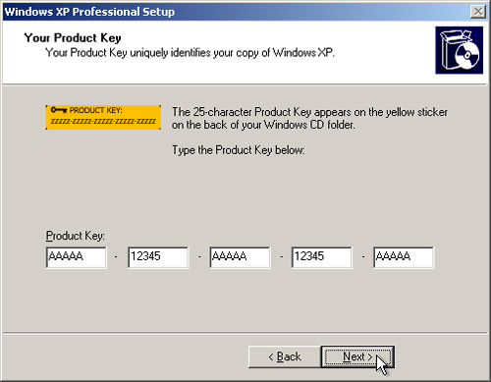

On the “Computer Name and Administrator Password screen”, type the computer name provided by your instructor. Type the Administrator password provided by your instructor, and retype it in the Confirm password section. Click Next.

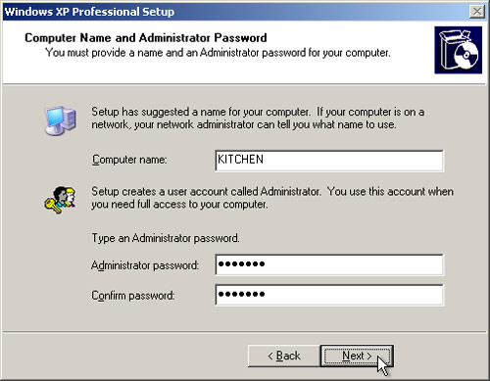

Step 8
On the “Date and Time Settings” screen, configure the computer clock to match your local date, time, and time zone. Click Next.

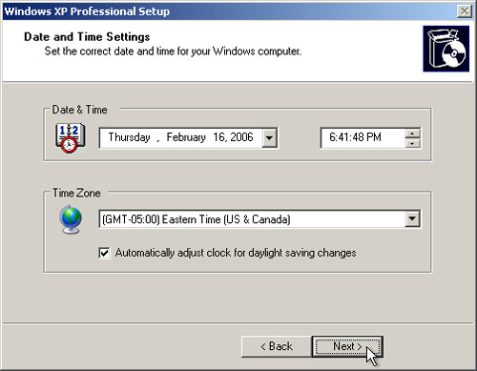

Step 9
On the “Networking Settings” page, click Next to accept “Typical settings”. “Custom settings” can be configured after setup is complete.

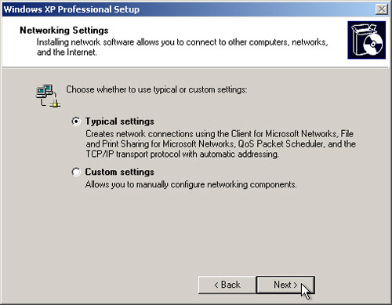

Step 10
On the “Workgroup or Computer Domain” page, accept the default settings and click Next.

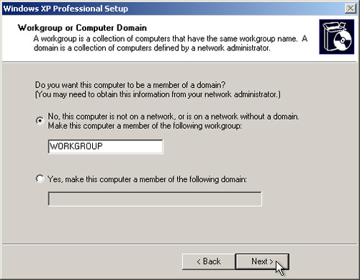

Step 11
Windows XP Professional Setup may take about 25 minutes to configure your computer. Your computer will automatically restart when the setup program is complete. When the “Display Settings” dialog box appears, click OK.

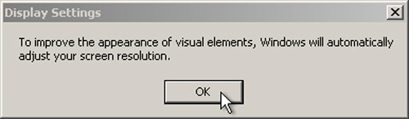

Step 12
When the “Monitor Settings” dialog box appears, click OK.

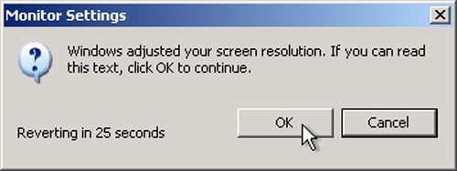

Step 13
The final phase of Windows XP Professional Setup begins. On the “Welcome to Microsoft Windows” page, click Next.

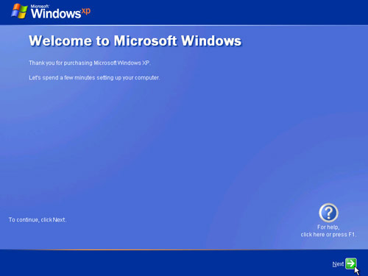

Step 14
On the “Help protect your PC screen”, select “Help protect my PC by turning on Automatic Updates now”. Click Next.

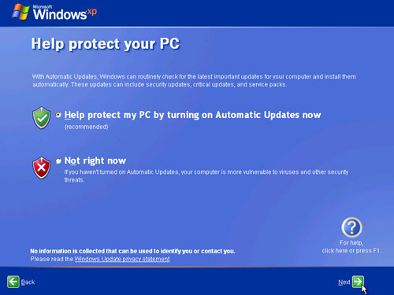

Step 15
Windows XP will now check to make sure that you are connected to the Internet. If you are already connected to the Internet, select the choice that represents your network connection. If you are unsure of the connection type, accept the default selection, and click Next.

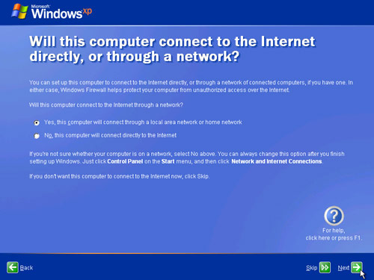

Step 16
If you use dial-up Internet access, or if Windows XP Professional Setup cannot connect to the Internet, you can connect to the Internet after setup is complete. Click Skip to continue.

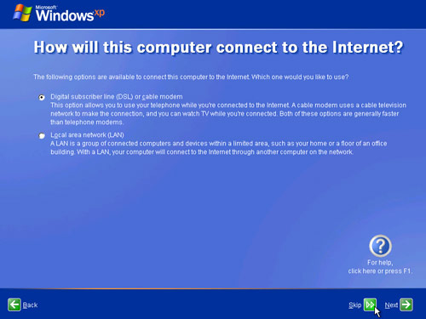

Step 17
Windows XP Professional Setup displays the “Ready to activate Windows?” screen.

If you are already connected to the Internet, click Yes, and then click Next.

If you are not yet connected to the Internet, click No, and then click Next.

After setup is complete, Windows XP setup program will remind you to activate and register your copy of Windows XP.

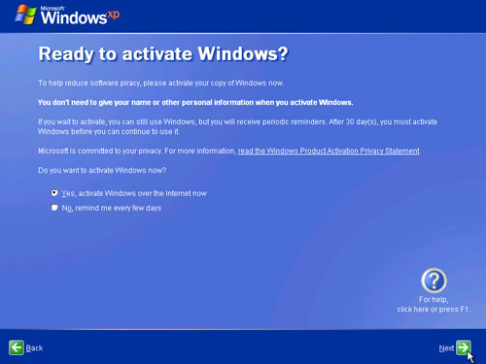

Step 18
If you have an Internet connection, click “Yes, I’d like to register with Microsoft now”.

If you do not have an Internet connection, click “No, not at this time”.

Click Next.

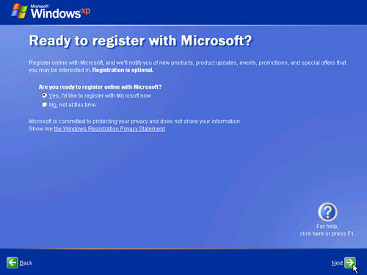

Step 19

On the “Collecting Registration Information screen”, fill in the fields using the information provided by your instructor and click Next.

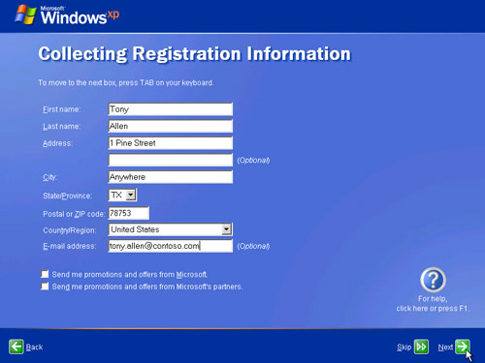

Step 20

On the “Who will use this computer?” screen, enter the information provided by your instructor. Click Next.

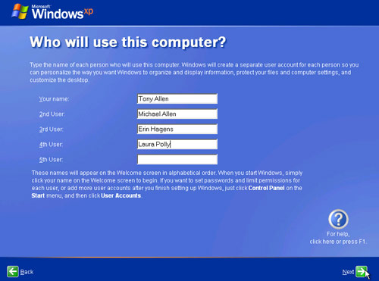

Step 21
On the “Thank you!” screen, click Finish to complete the installation.

